ExtSecure Implementation Code Screenshot Portfolio
Hasan | 21 October 2026 | Extension version 0.8.41
This portfolio presents the implementation of the retained database and extension tasks. Each task has its own named code screenshots, captions, source locations and links to the recorded source revision. The interface examples show how selected controls appear in the extension.
The companion screenshot archive contains complete source captures for the implementation files indexed under each task. The Word portfolio selects readable excerpts from those captures. Screenshots cover code and the extension interface only.
Code lines wrap for readability. A continuation marker refers to the same original source line. Source snapshots identify the implementation revision rather than claiming exclusive authorship of shared integration files.
Project source: ExtSecure on GitHub

Task index
01 Database design
02 Security record storage
03 Database integrity
04 Security and reporting queries
05 Backup and recovery
06 Database performance
07 Controlled schema migrations
08 Safe evidence export
09 Risk scoring and severity
10 Dashboard interface
11 Device and extension inventory
12 Security event logging
13 Accounts and access privileges
14 Two factor authentication
15 Website approval requests
16 Whitelist and overrides
17 Downloaded file scanning
18 AI threat explanations
19 Weekly and monthly reporting
20 Machine learning activity review
21 High severity alerts
22 Immediate threat blocking
23 Incident response and case management
24 Privacy and data governance
25 Detection quality evaluation
26 Usability and accessibility
27 Security guidance
28 User security feedback
29 User suggestions
30 Personalisation and display settings
31 Animation and reduced motion
32 Modern add and remove controls

01 Database design
Define relational records for devices, extensions and security evidence.

Picture 01.01 models.py source lines 24 to 52
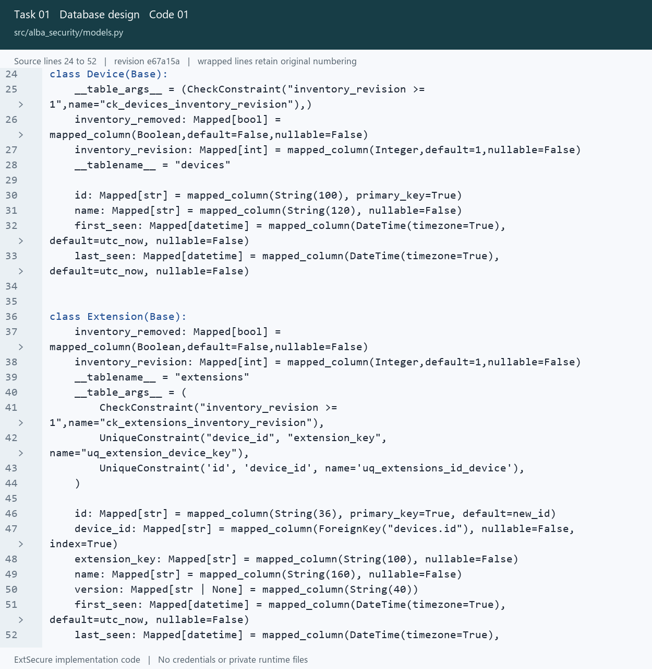
01_Database_design_01_models_Lines_24_52.png
Open src/alba_security/models.py at the captured revision

01 Database design
Define relational records for devices, extensions and security evidence.

Picture 01.02 schema.sql source lines 341 to 373
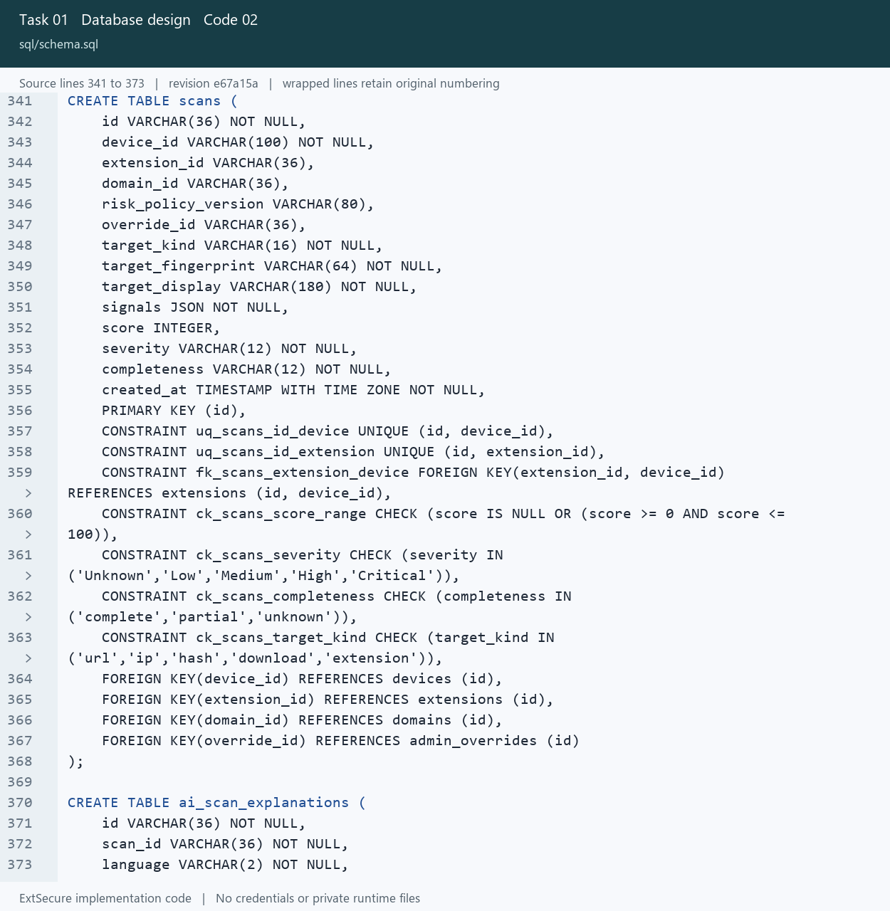
01_Database_design_02_schema_Lines_341_373.png
Open sql/schema.sql at the captured revision

02 Security record storage
Persist scan findings, alerts and the evidence needed for review.

Picture 02.01 models.py source lines 55 to 83
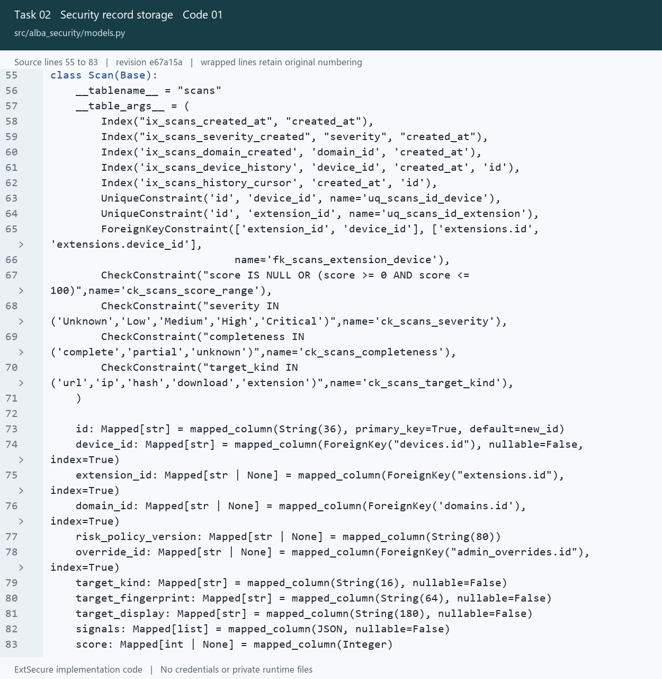
02_Security_record_storage_01_models_Lines_55_83.png
Open src/alba_security/models.py at the captured revision

02 Security record storage
Persist scan findings, alerts and the evidence needed for review.

Picture 02.02 models.py source lines 149 to 168
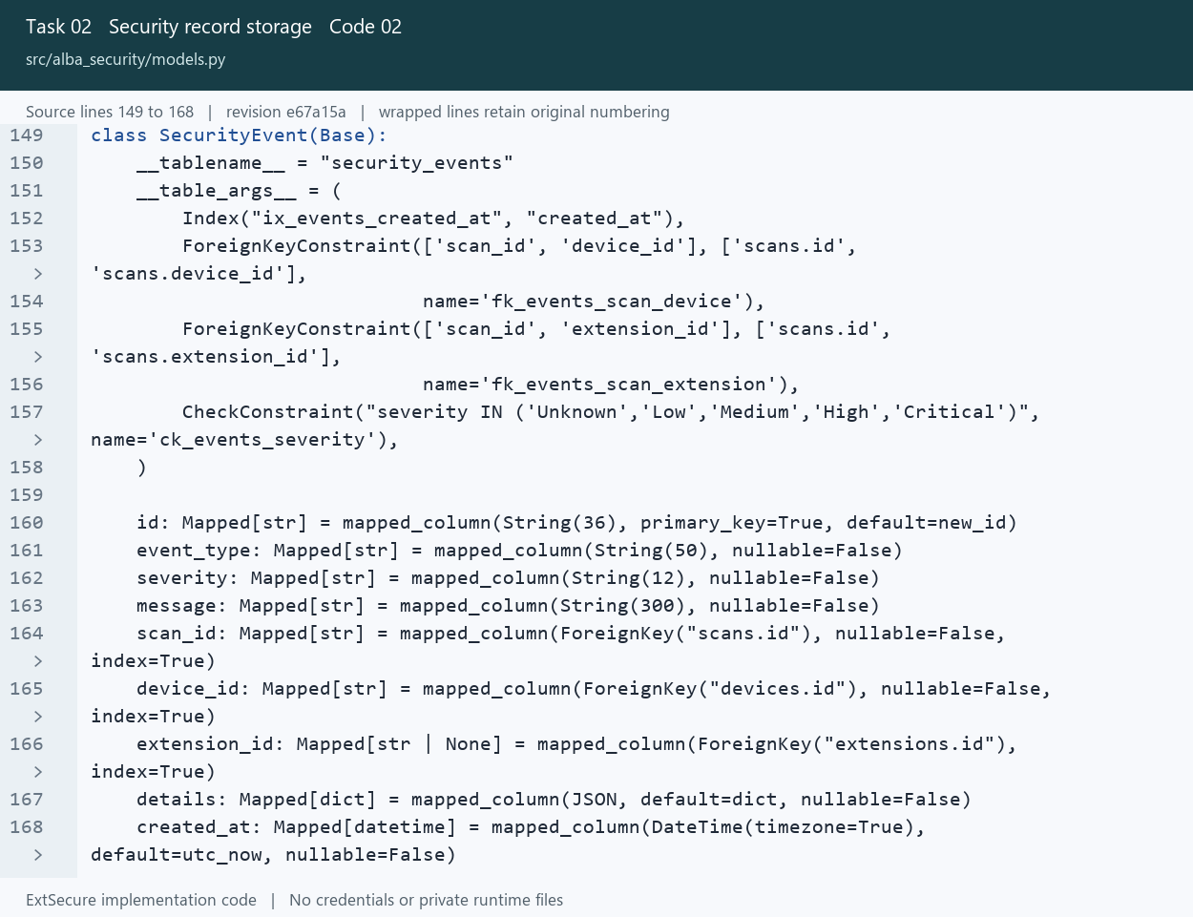
02_Security_record_storage_02_models_Lines_149_168.png
Open src/alba_security/models.py at the captured revision

03 Database integrity
Keep related evidence consistent using constraints and transactional writes.

Picture 03.01 models.py source lines 65 to 91
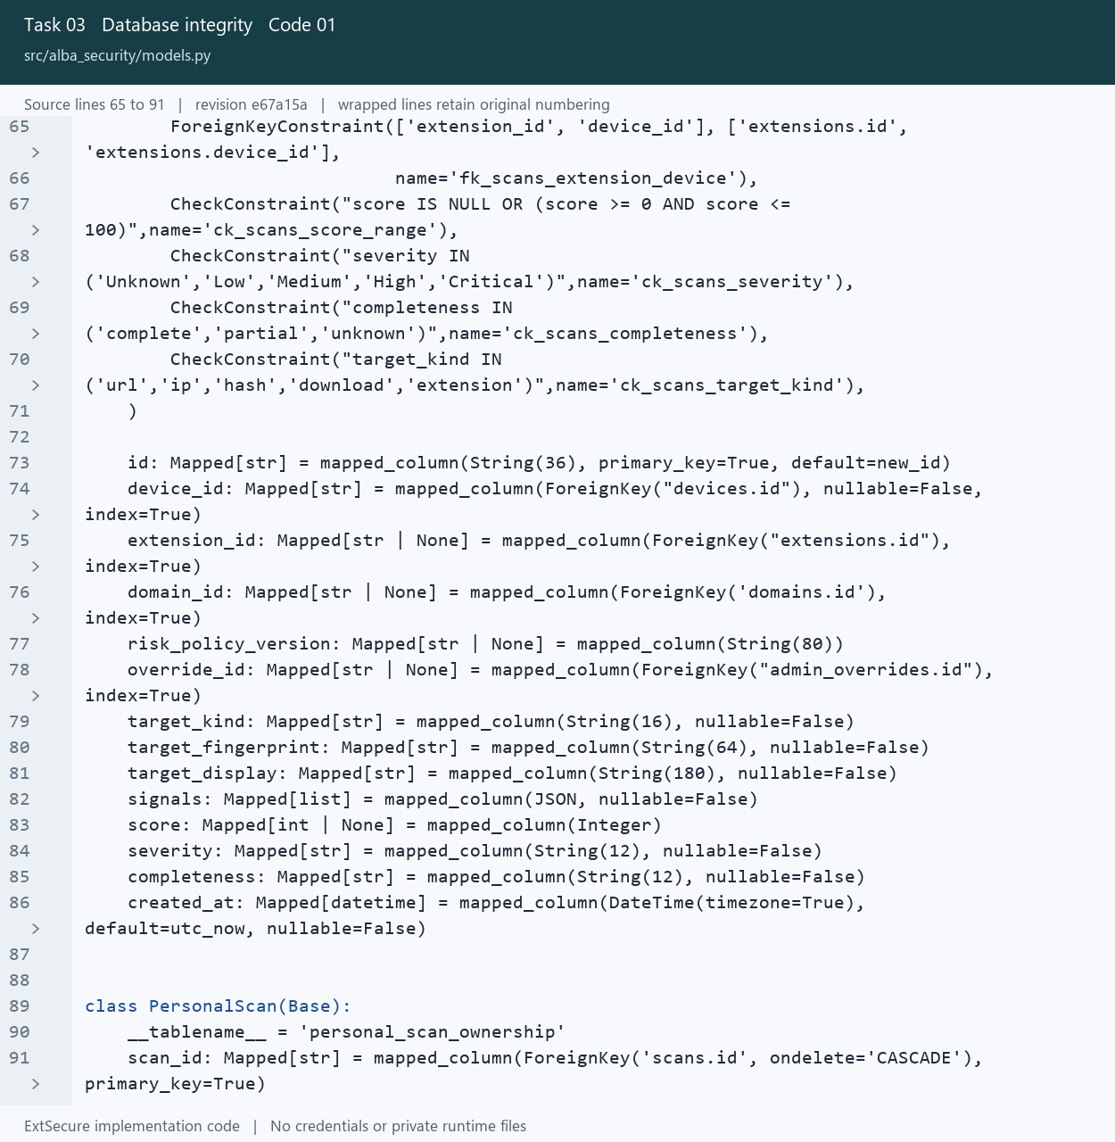
03_Database_integrity_01_models_Lines_65_91.png
Open src/alba_security/models.py at the captured revision

03 Database integrity
Keep related evidence consistent using constraints and transactional writes.

Picture 03.02 postgresql.py source lines 42 to 70
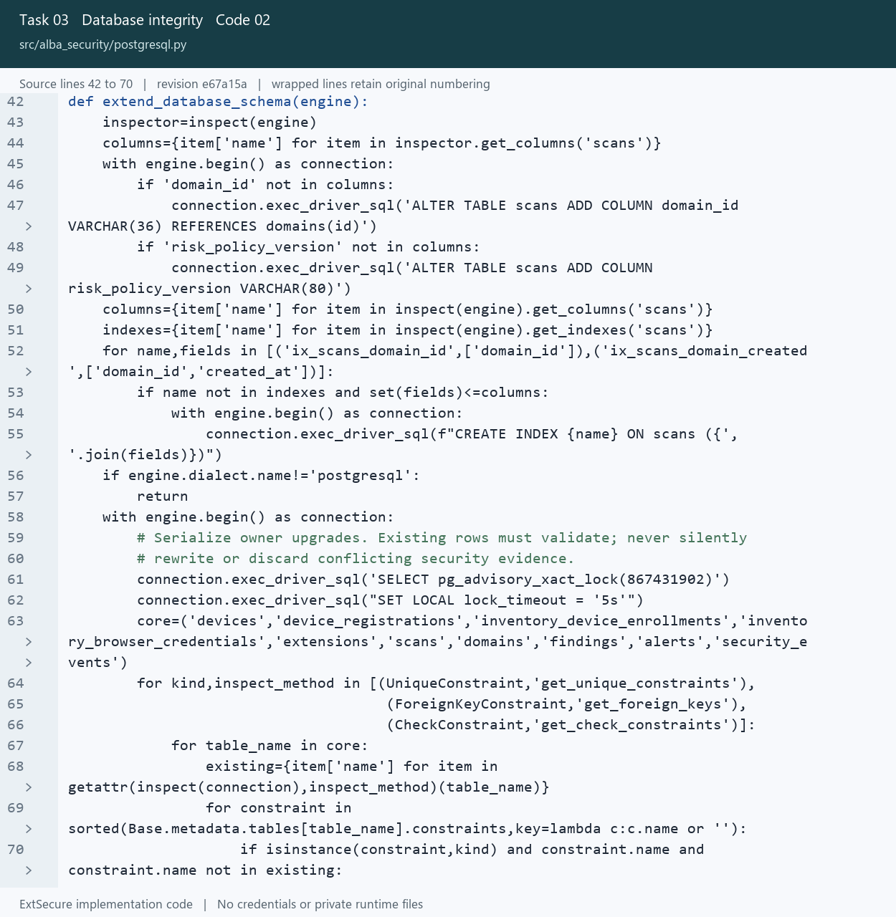
03_Database_integrity_02_postgresql_Lines_42_70.png
Open src/alba_security/postgresql.py at the captured revision

04 Security and reporting queries
Retrieve bounded scan history and aggregate statistics for the extension.

Picture 04.01 database_queries.py source lines 63 to 97
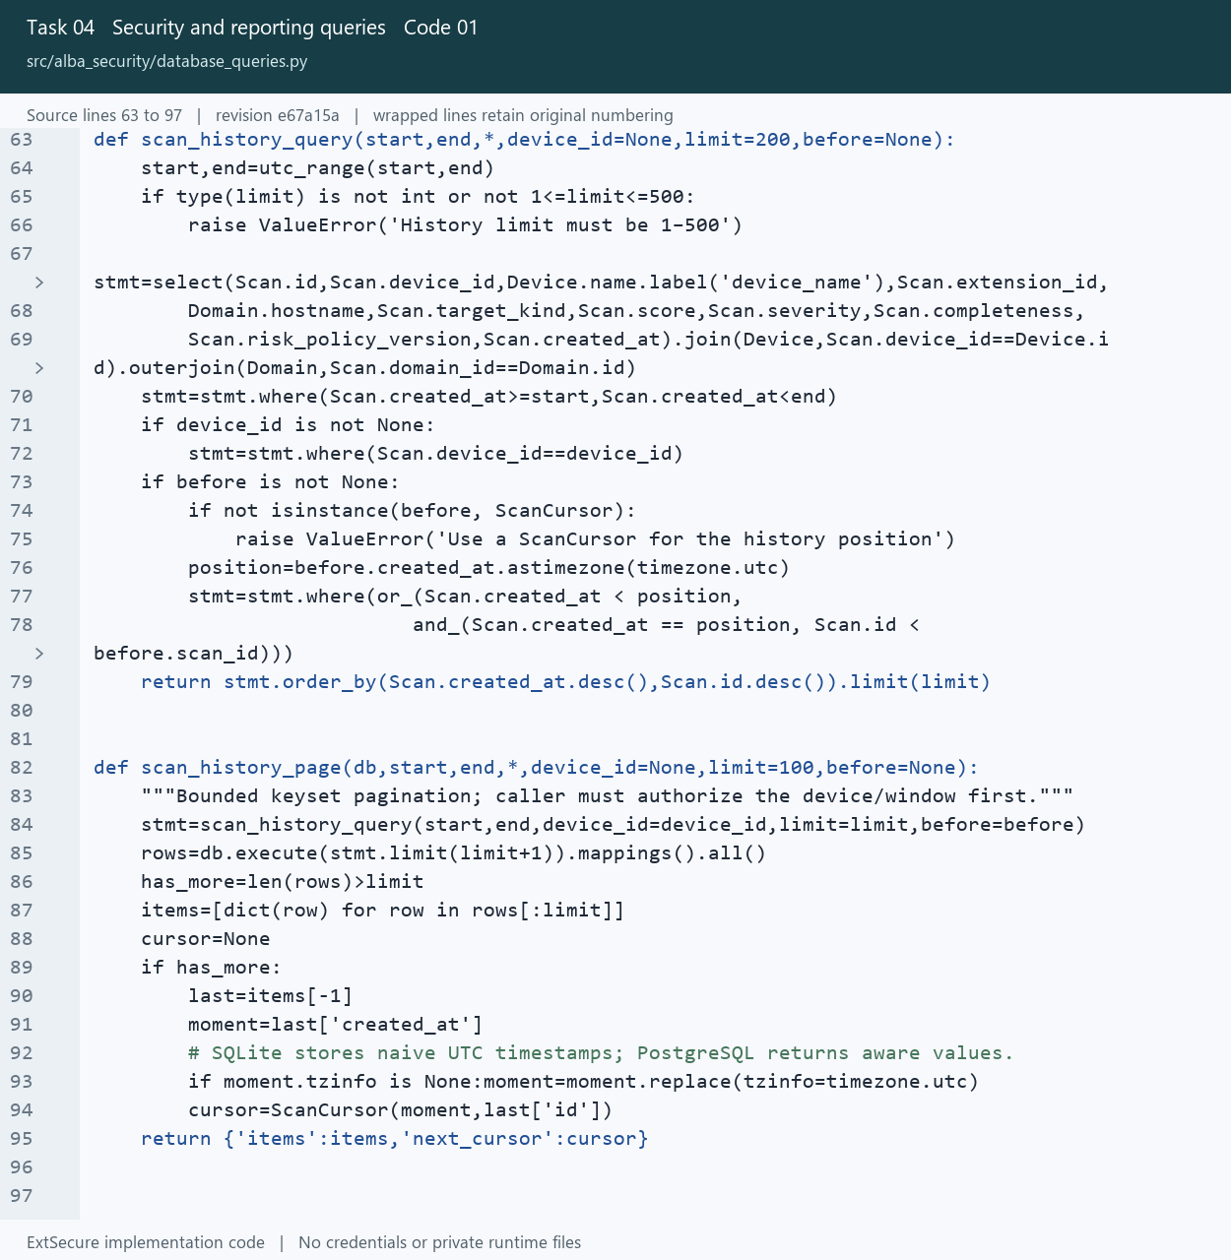
04_Security_and_reporting_queries_01_database_queries_Lines_63_97.png
Open src/alba_security/database_queries.py at the captured revision

04 Security and reporting queries
Retrieve bounded scan history and aggregate statistics for the extension.

Picture 04.02 queries.sql source lines 8 to 45
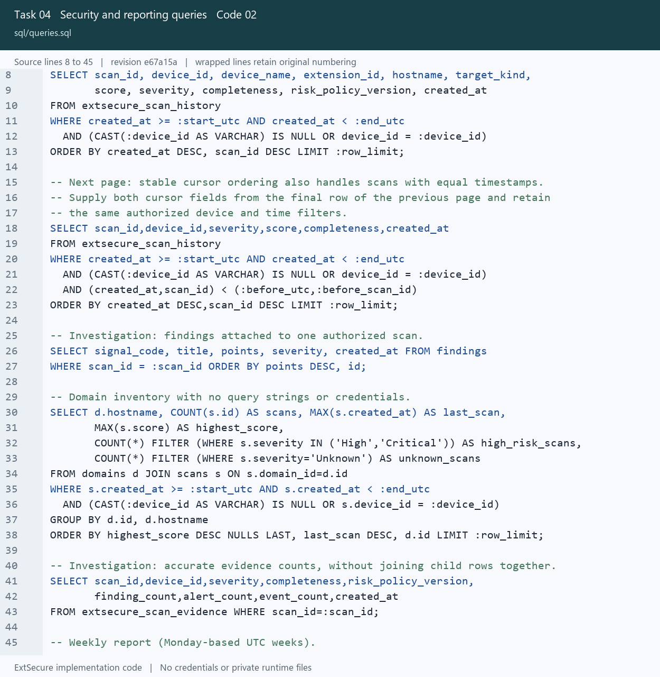
04_Security_and_reporting_queries_02_queries_Lines_8_45.png
Open sql/queries.sql at the captured revision

05 Backup and recovery
Create database backups and verify restoration in an isolated database.

Picture 05.01 backup.py source lines 7 to 37
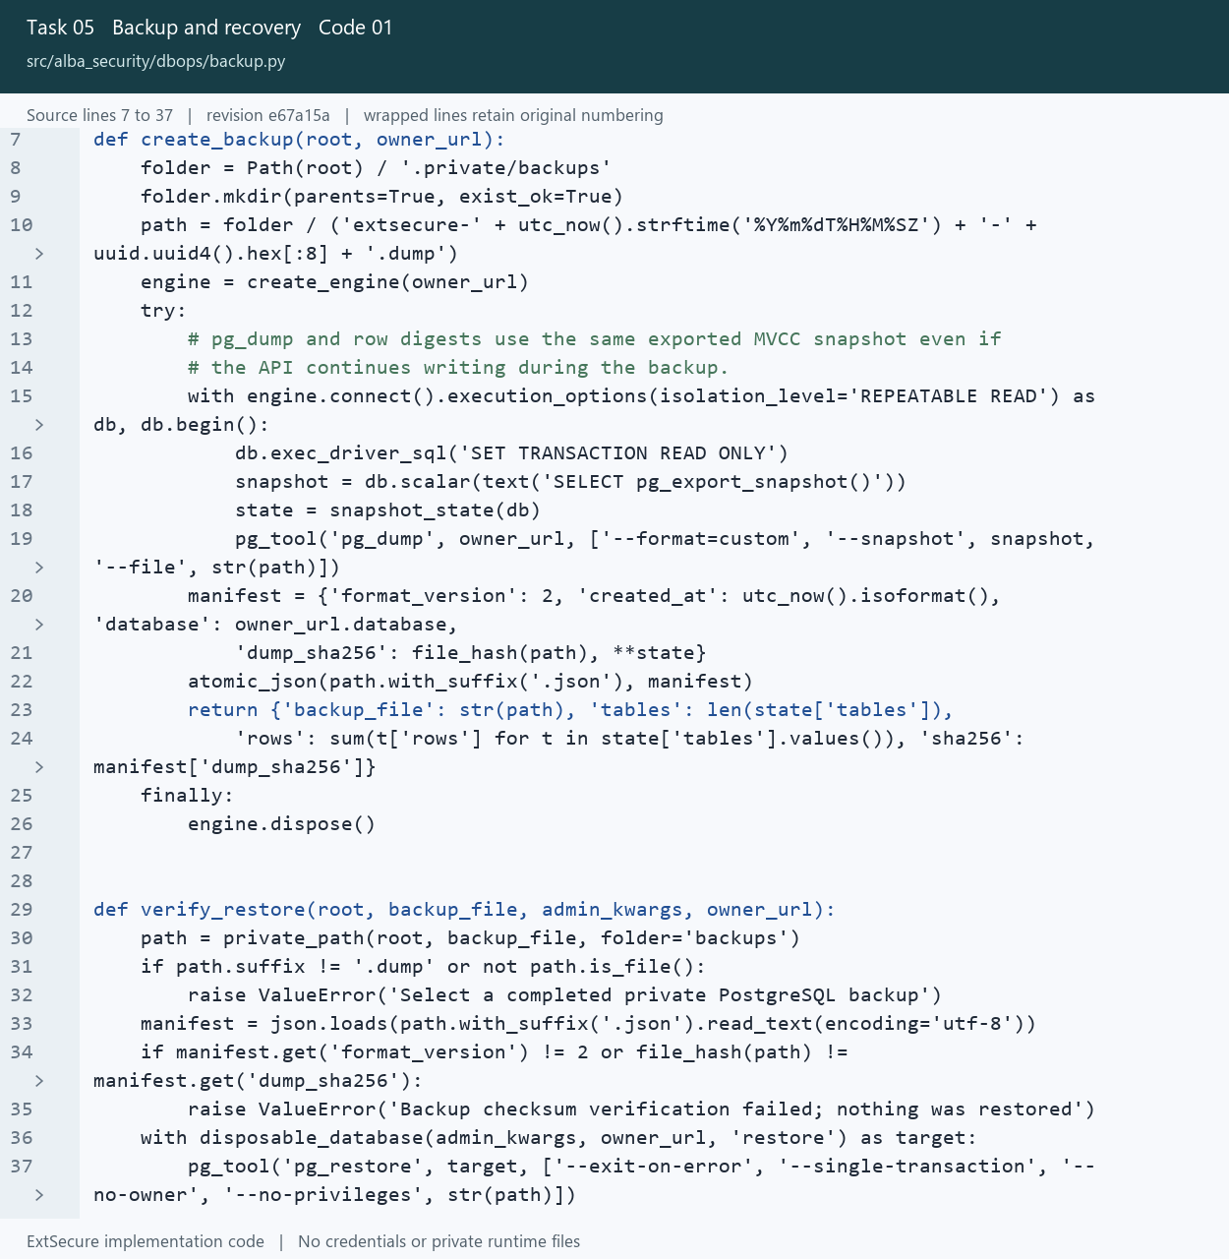
05_Backup_and_recovery_01_backup_Lines_7_37.png
Open src/alba_security/dbops/backup.py at the captured revision

05 Backup and recovery
Create database backups and verify restoration in an isolated database.

Picture 05.02 backup.py source lines 29 to 50
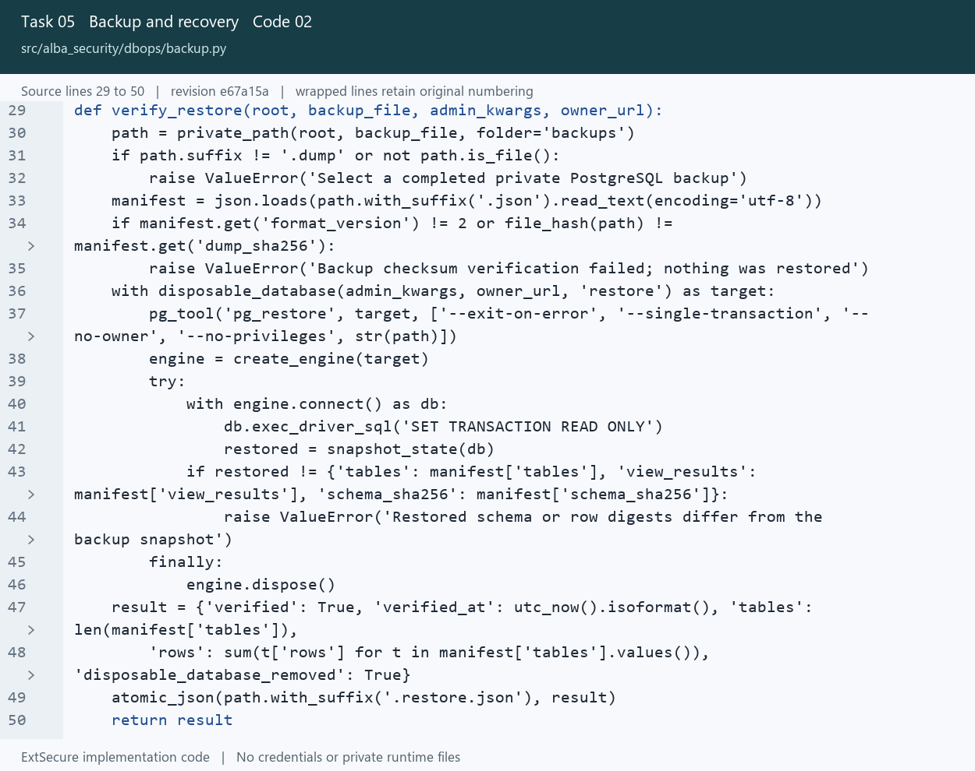
05_Backup_and_recovery_02_backup_Lines_29_50.png
Open src/alba_security/dbops/backup.py at the captured revision

06 Database performance
Use targeted indexes and inspect query plans against generated test data.

Picture 06.01 benchmark.py source lines 12 to 38
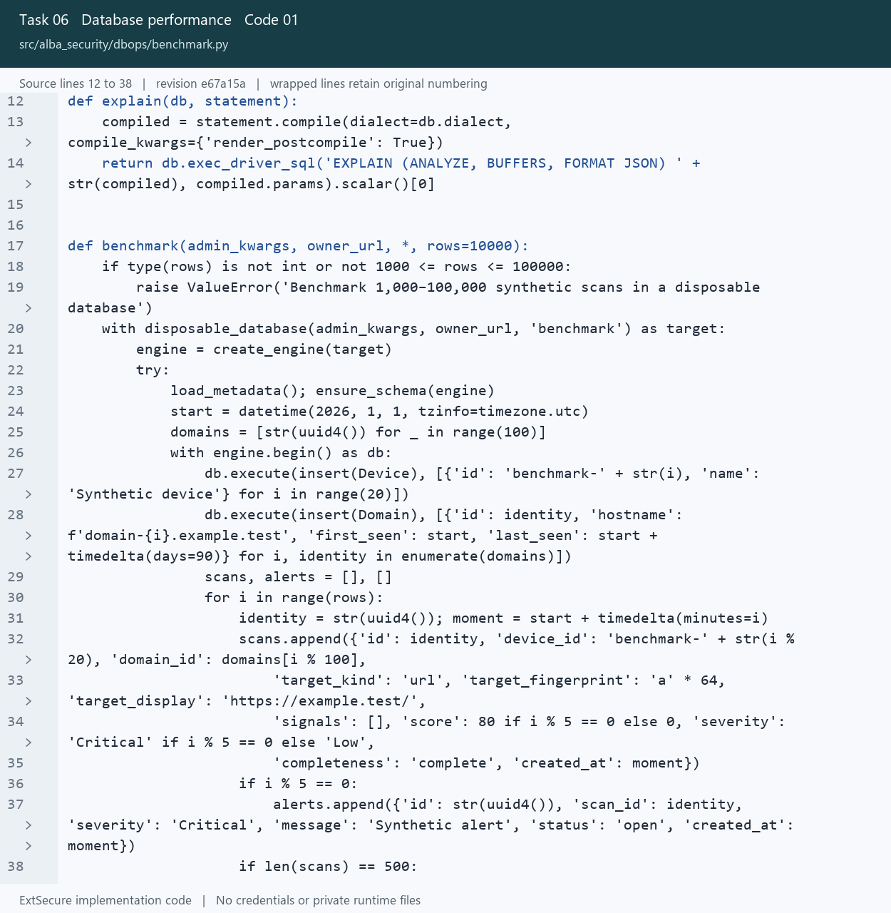
06_Database_performance_01_benchmark_Lines_12_38.png
Open src/alba_security/dbops/benchmark.py at the captured revision

06 Database performance
Use targeted indexes and inspect query plans against generated test data.

Picture 06.02 0008_active_inventory_index.sql source lines 1 to 4
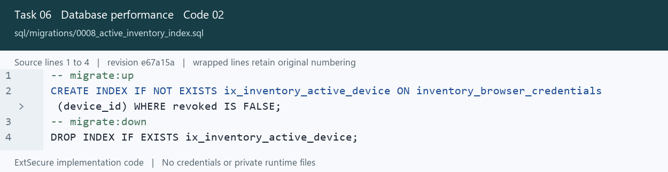
06_Database_performance_02_0008_active_inventory_index_Lines_1_4.png
Open sql/migrations/0008_active_inventory_index.sql at the captured revision

07 Controlled schema migrations
Apply ordered schema changes through transactions.

Picture 07.01 migrations.py source lines 8 to 40
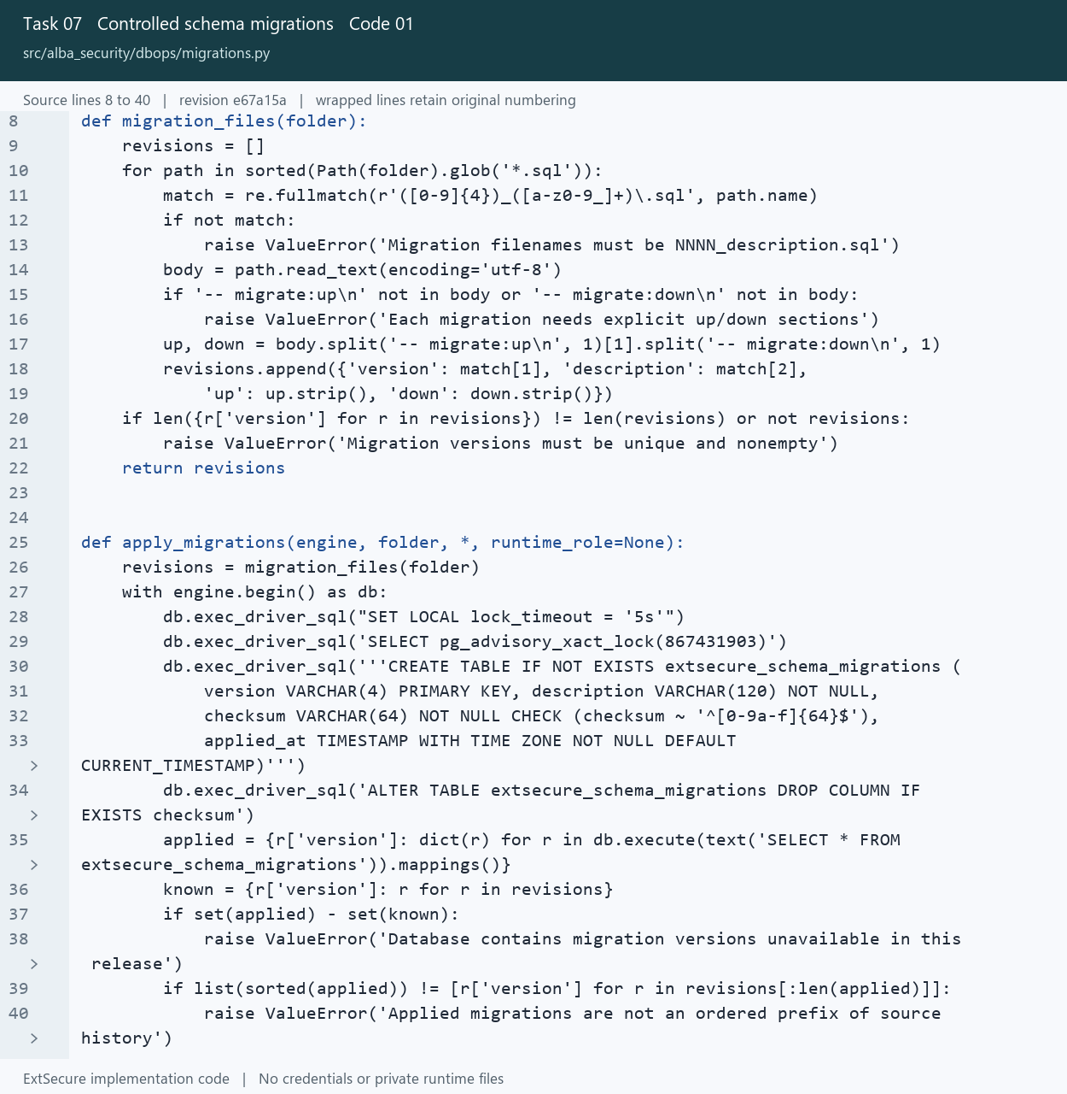
07_Controlled_schema_migrations_01_migrations_Lines_8_40.png
Open src/alba_security/dbops/migrations.py at the captured revision

07 Controlled schema migrations
Apply ordered schema changes through transactions.

Picture 07.02 migrations.py source lines 25 to 53
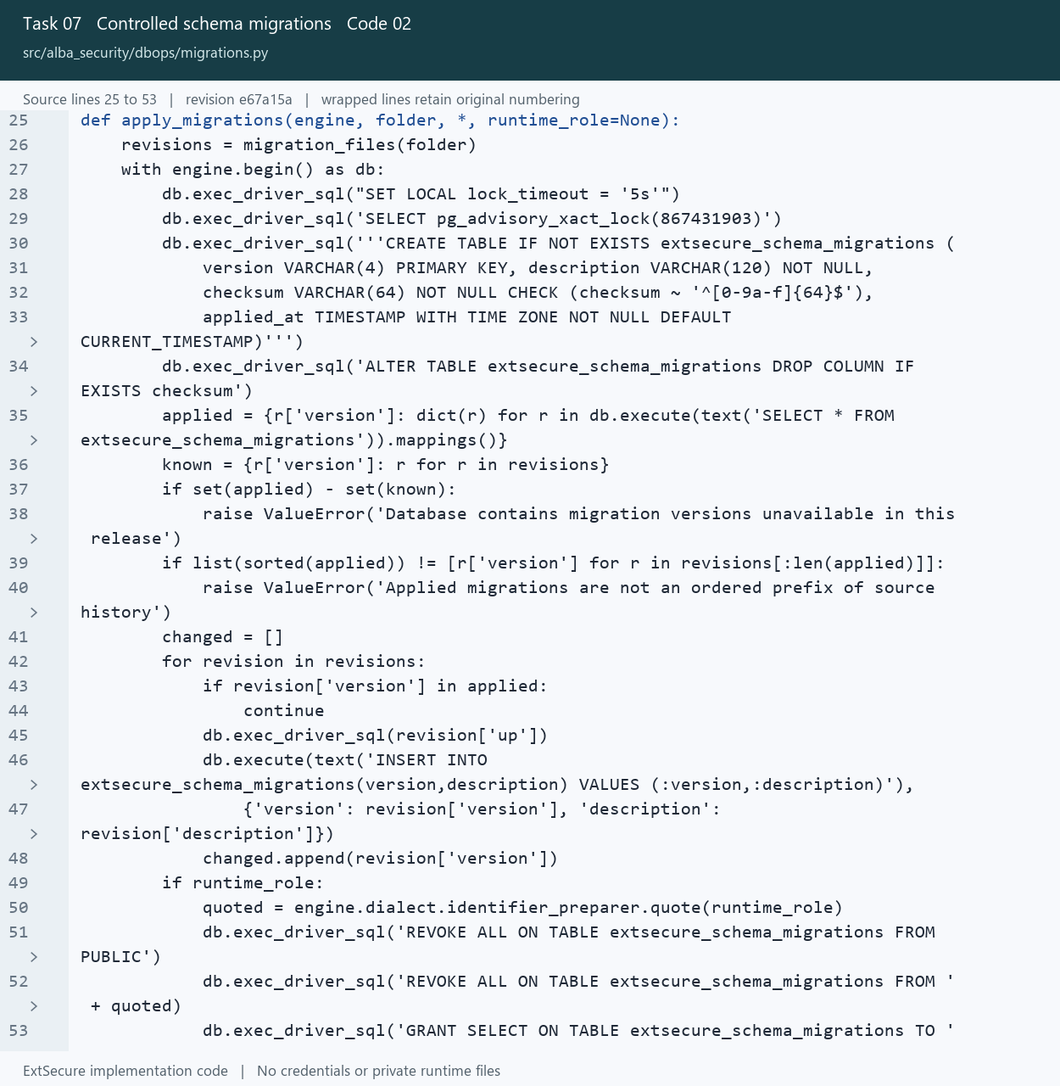
07_Controlled_schema_migrations_02_migrations_Lines_25_53.png
Open src/alba_security/dbops/migrations.py at the captured revision

08 Safe evidence export
Restrict exported evidence to approved datasets and fields.

Picture 08.01 transfer.py source lines 34 to 64
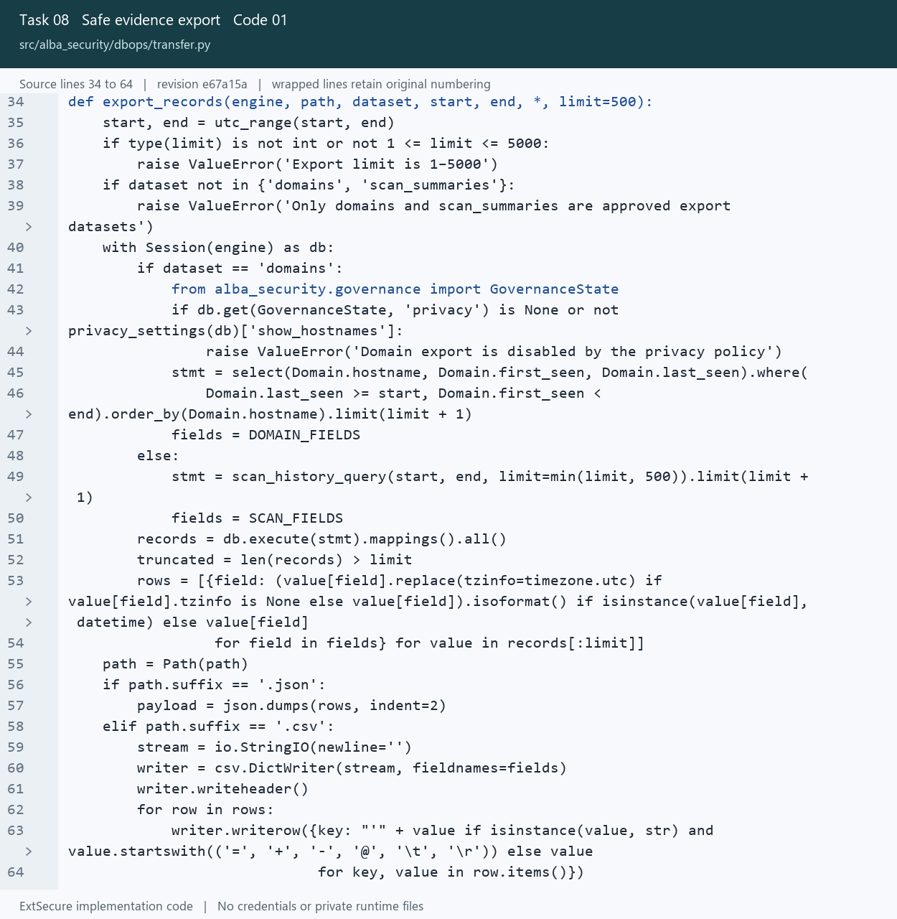
08_Safe_evidence_export_01_transfer_Lines_34_64.png
Open src/alba_security/dbops/transfer.py at the captured revision

08 Safe evidence export
Restrict exported evidence to approved datasets and fields.

Picture 08.02 evidence-export.js source lines 1 to 8
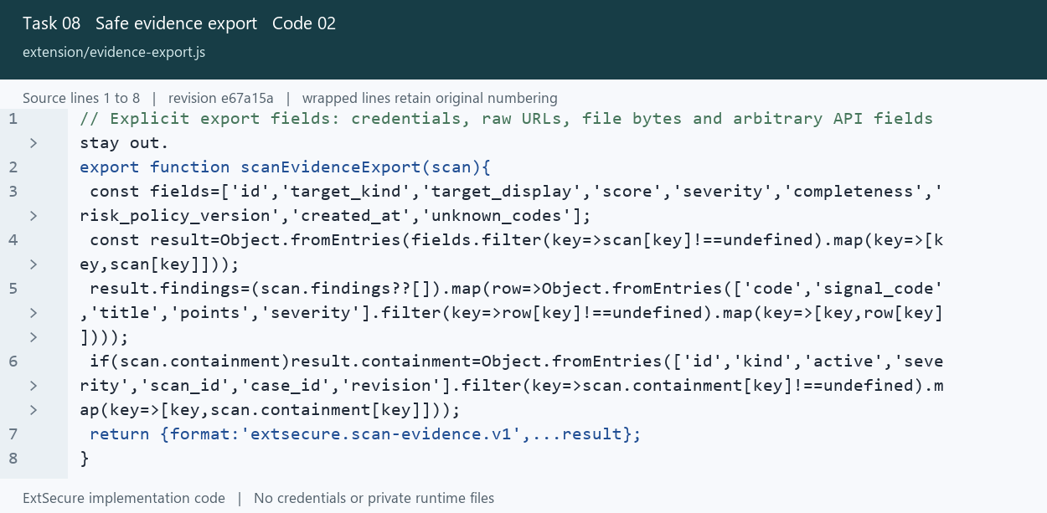
08_Safe_evidence_export_02_evidence_export_Lines_1_8.png
Open extension/evidence-export.js at the captured revision

09 Risk scoring and severity
Calculate evidence based severity while distinguishing Unknown from Low.

Picture 09.01 risk.py source lines 57 to 93
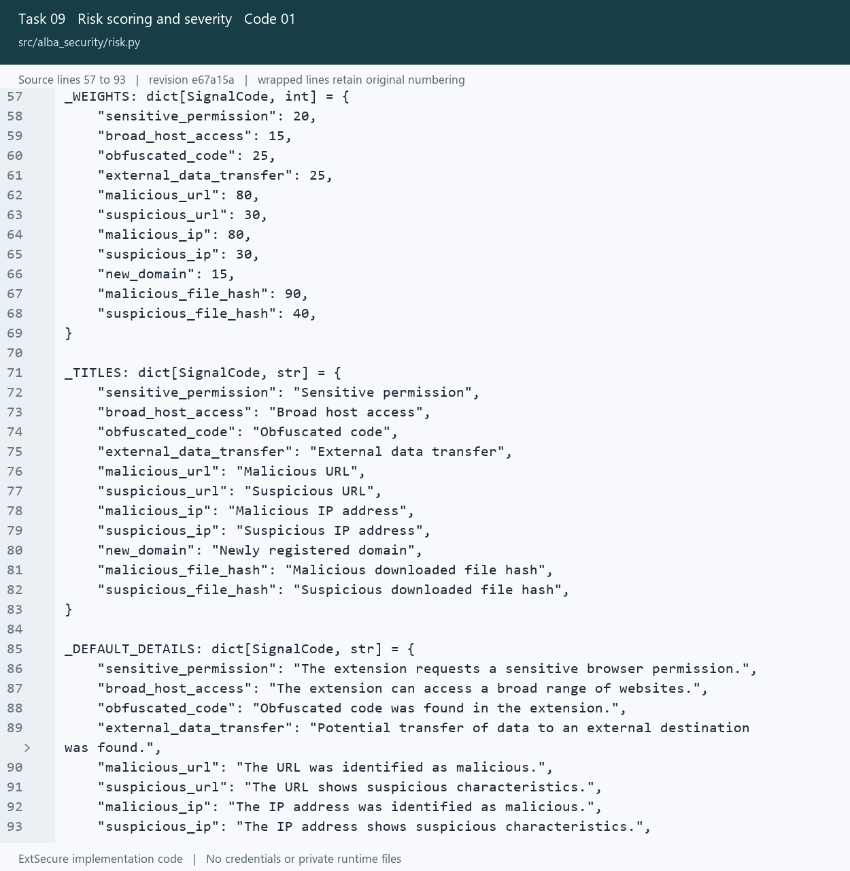
09_Risk_scoring_and_severity_01_risk_Lines_57_93.png
Open src/alba_security/risk.py at the captured revision

09 Risk scoring and severity
Calculate evidence based severity while distinguishing Unknown from Low.

Picture 09.02 risk.py source lines 100 to 135
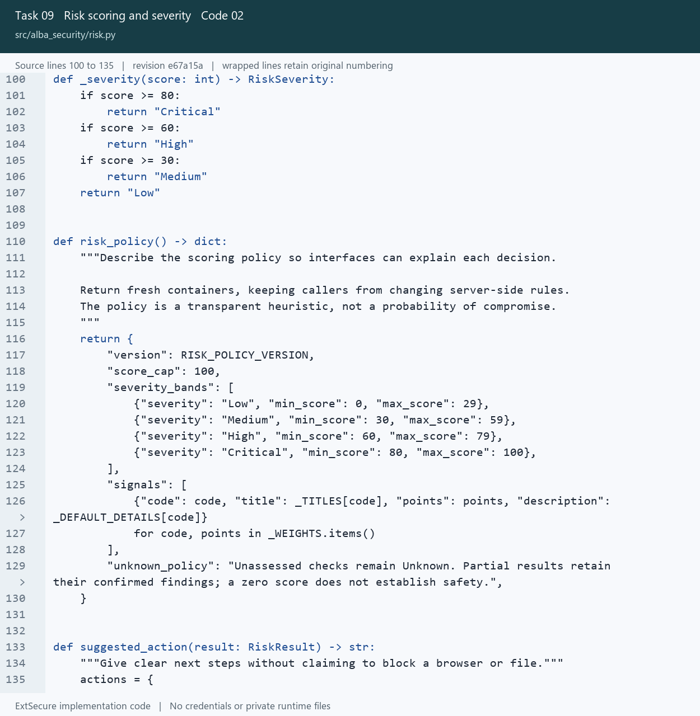
09_Risk_scoring_and_severity_02_risk_Lines_100_135.png
Open src/alba_security/risk.py at the captured revision

10 Dashboard interface
Present security information through the Chrome extension console.

Picture 10.01 ui.js source lines 278 to 296
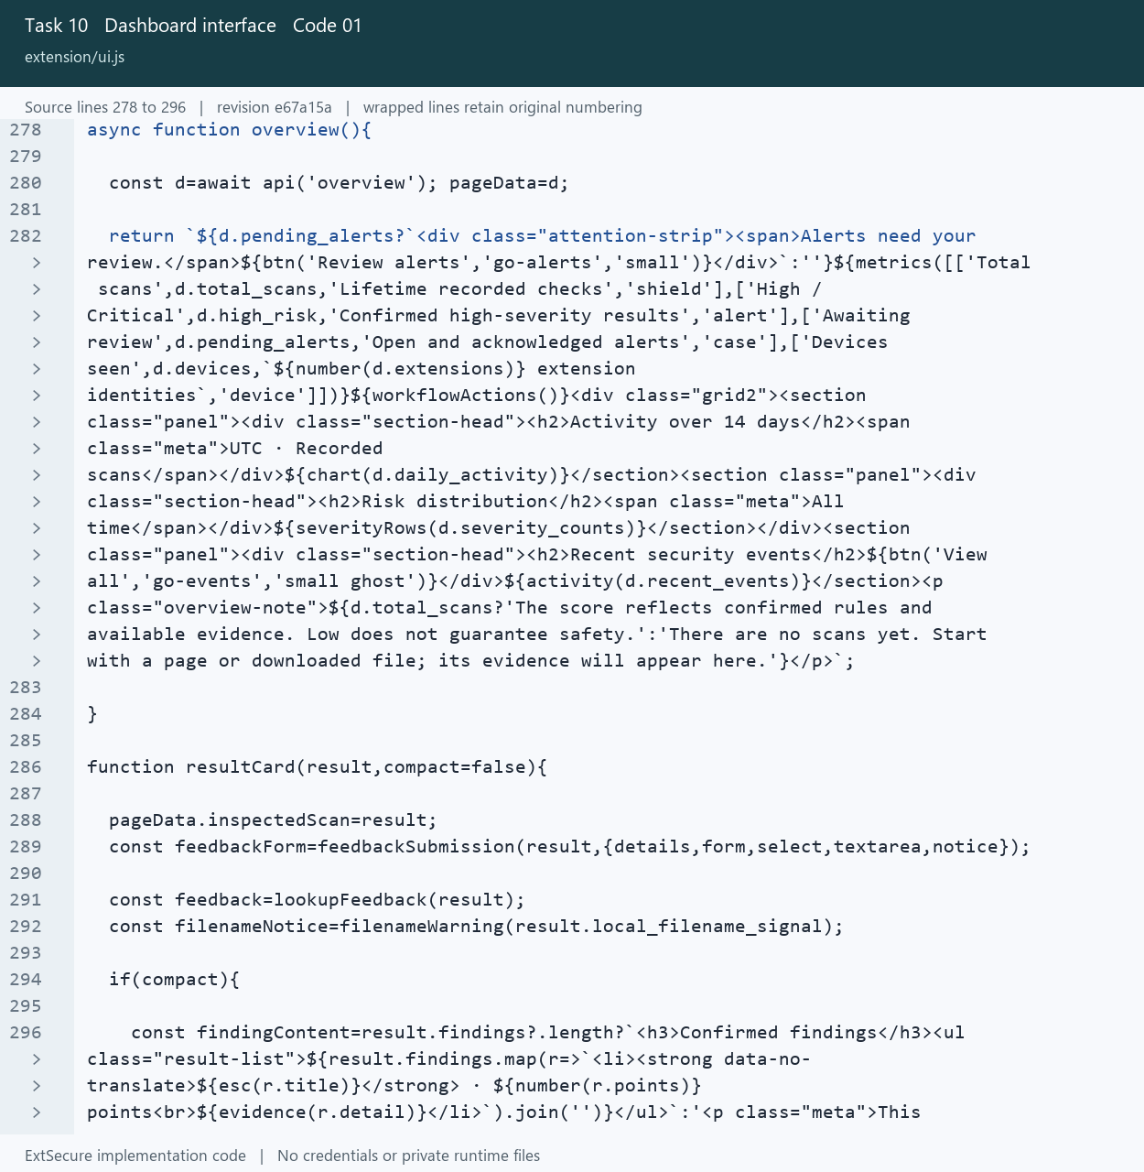
10_Dashboard_interface_01_ui_Lines_278_296.png
Open extension/ui.js at the captured revision

10 Dashboard interface
Present security information through the Chrome extension console.

Picture 10.02 modern.css source lines 1 to 27
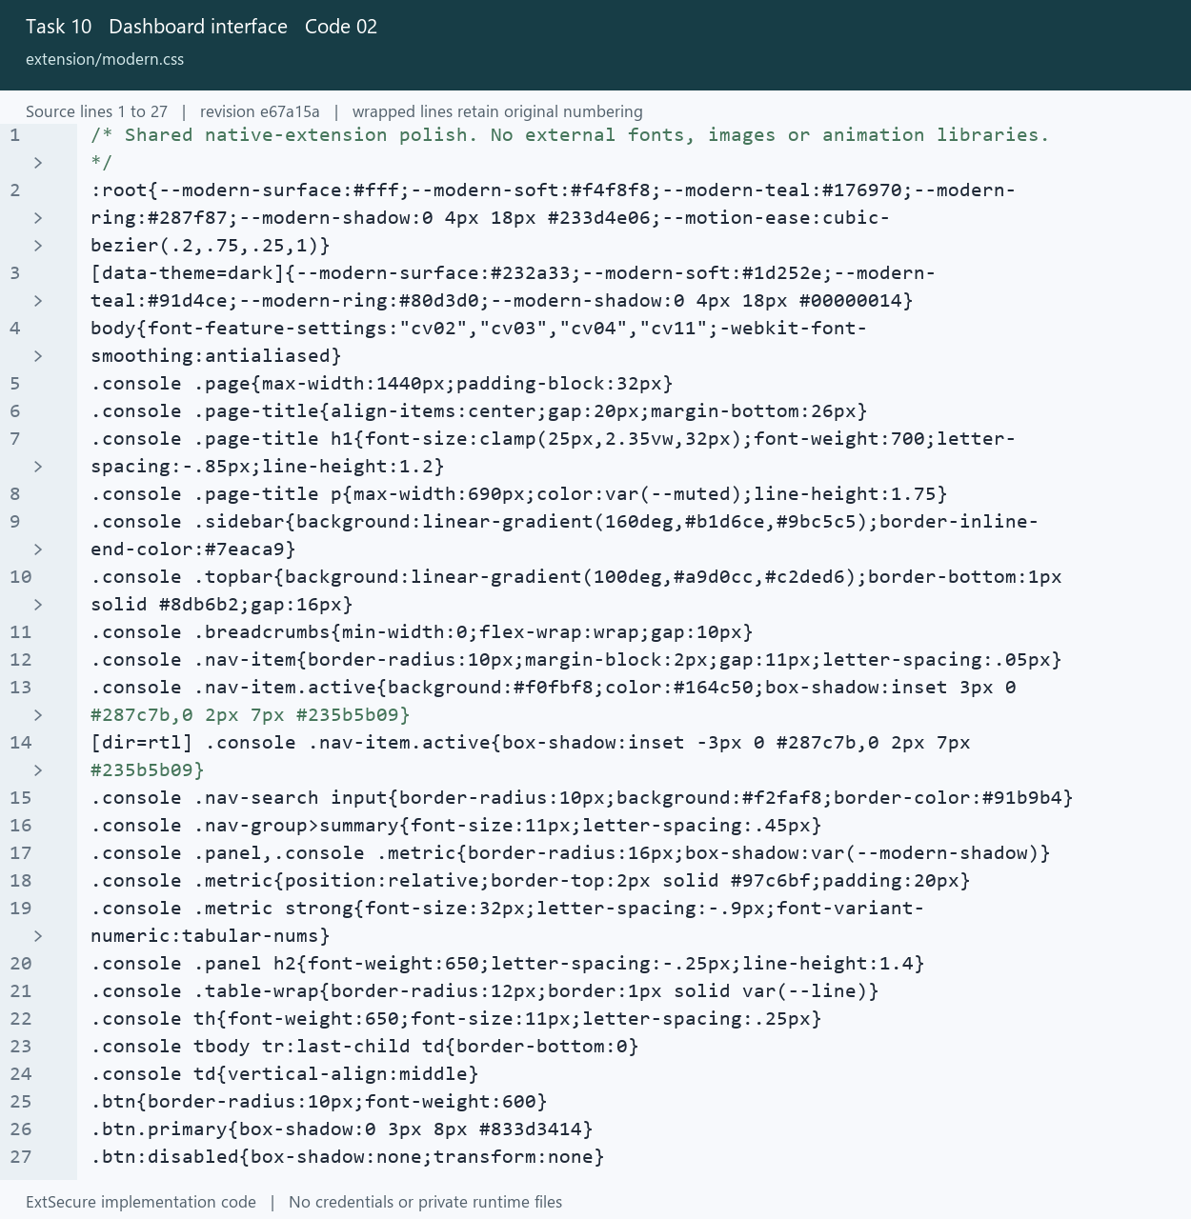
10_Dashboard_interface_02_modern_Lines_1_27.png
Open extension/modern.css at the captured revision

11 Device and extension inventory
List connected devices and manage the extensions on the selected device.

Picture 11.01 inventory.js source lines 1 to 22
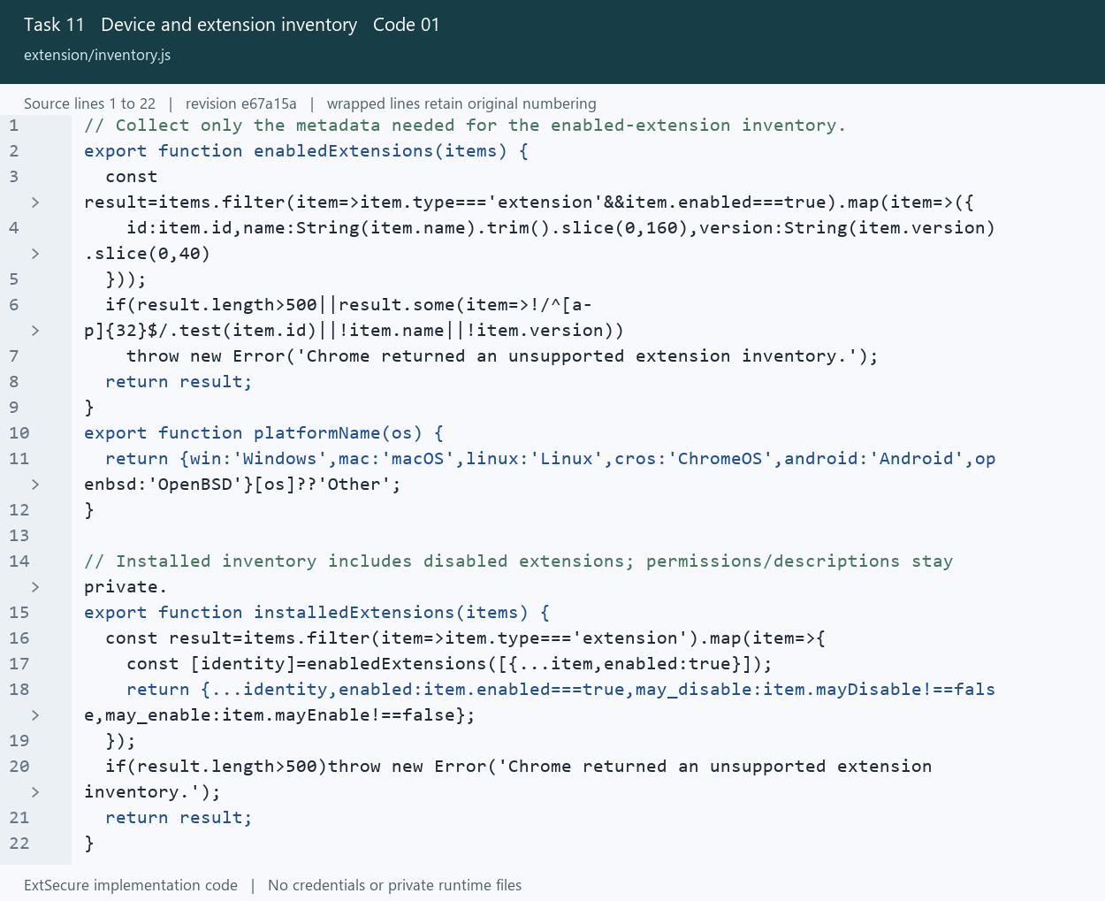
11_Device_and_extension_inventory_01_inventory_Lines_1_22.png
Open extension/inventory.js at the captured revision

11 Device and extension inventory
List connected devices and manage the extensions on the selected device.

Picture 11.02 extension-controls.js source lines 2 to 26
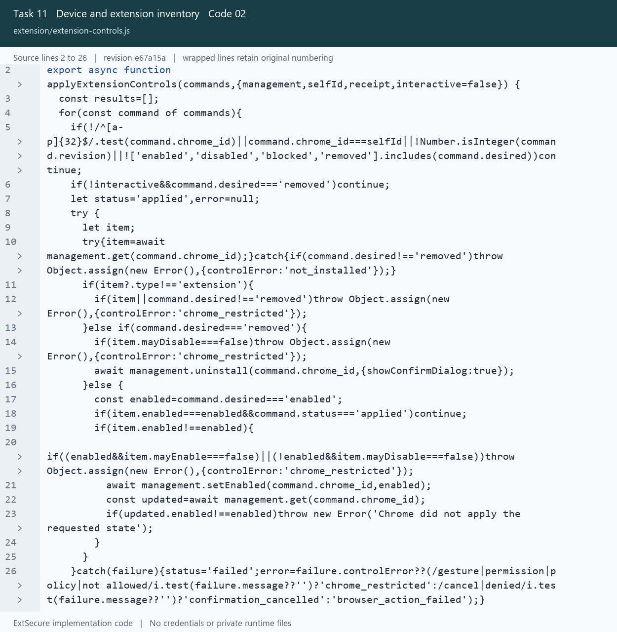
11_Device_and_extension_inventory_02_extension_controls_Lines_2_26.png
Open extension/extension-controls.js at the captured revision

12 Security event logging
Attach scan events and detected threats to their original security evidence.

Picture 12.01 api.py source lines 444 to 473
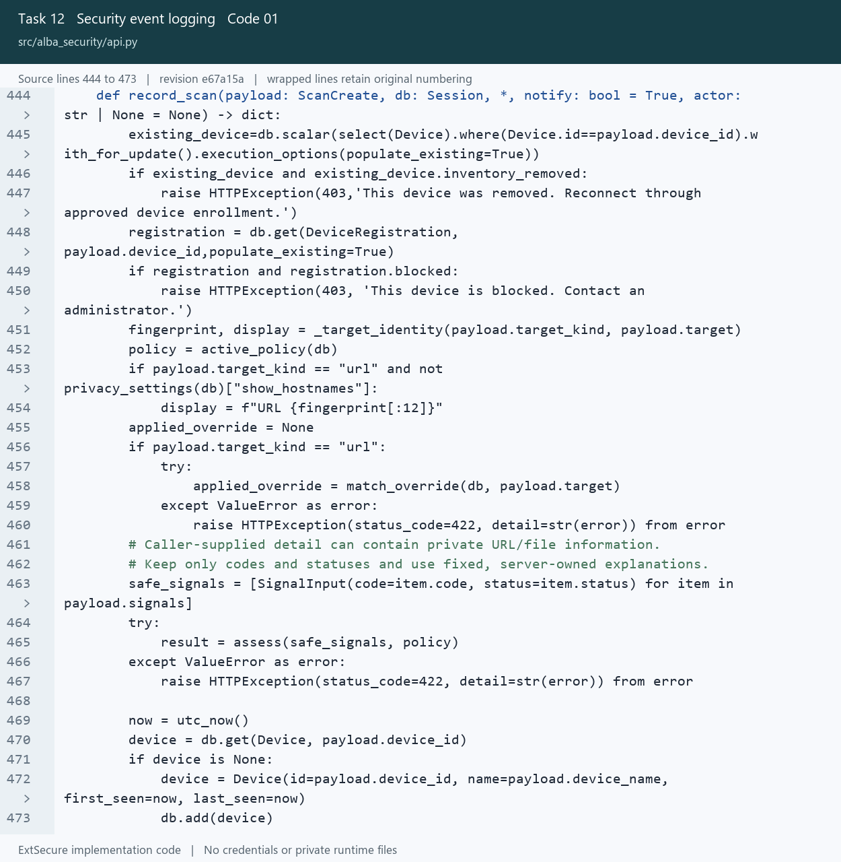
12_Security_event_logging_01_api_Lines_444_473.png
Open src/alba_security/api.py at the captured revision

12 Security event logging
Attach scan events and detected threats to their original security evidence.

Picture 12.02 models.py source lines 149 to 168
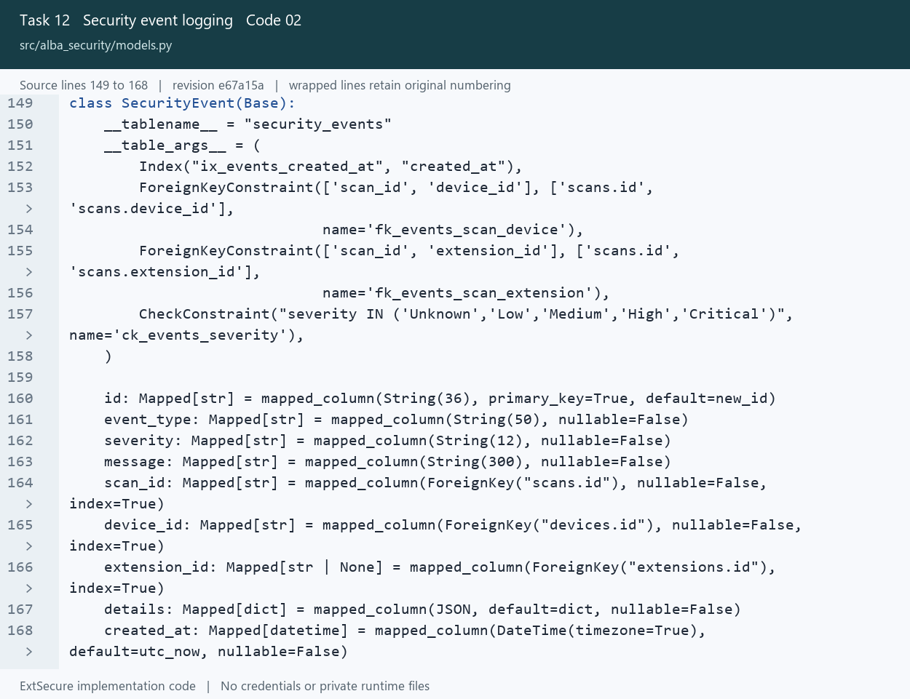
12_Security_event_logging_02_models_Lines_149_168.png
Open src/alba_security/models.py at the captured revision

13 Accounts and access privileges
Apply role permissions and the reviewer hierarchy to account actions.

Picture 13.01 permissions.py source lines 11 to 44
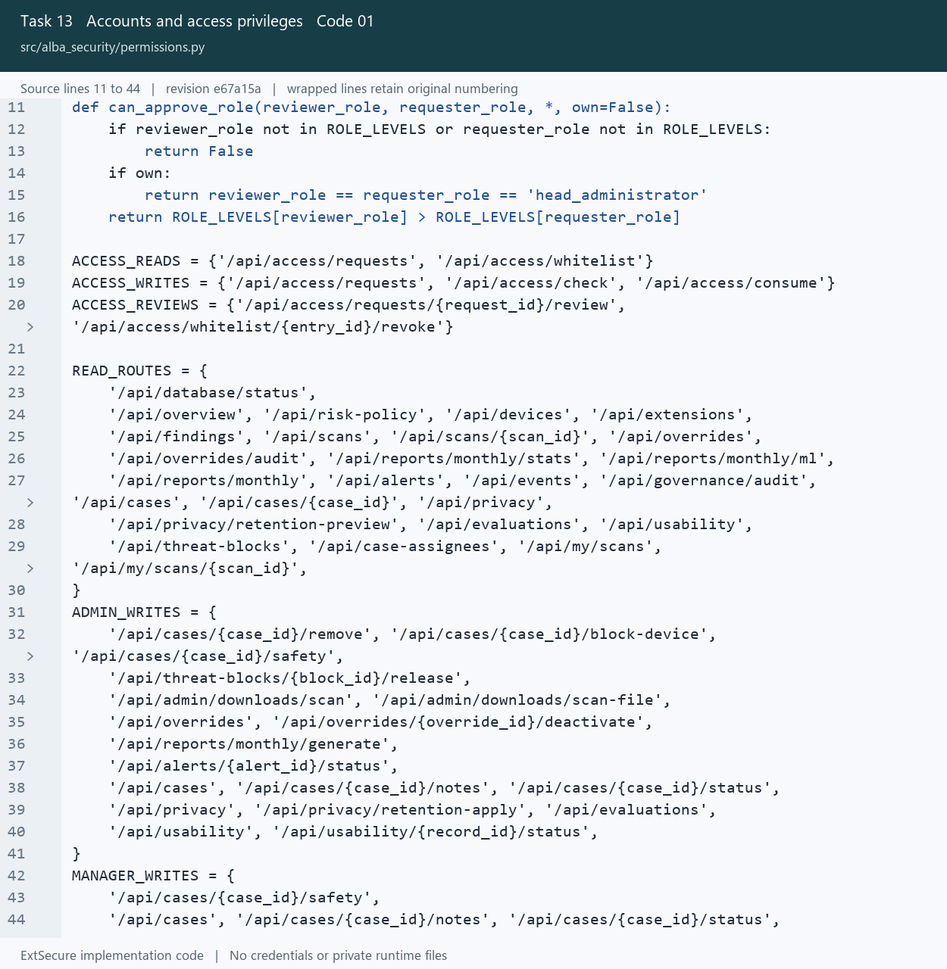
13_Accounts_and_access_privileges_01_permissions_Lines_11_44.png
Open src/alba_security/permissions.py at the captured revision

13 Accounts and access privileges
Apply role permissions and the reviewer hierarchy to account actions.

Picture 13.02 registration.py source lines 17 to 53
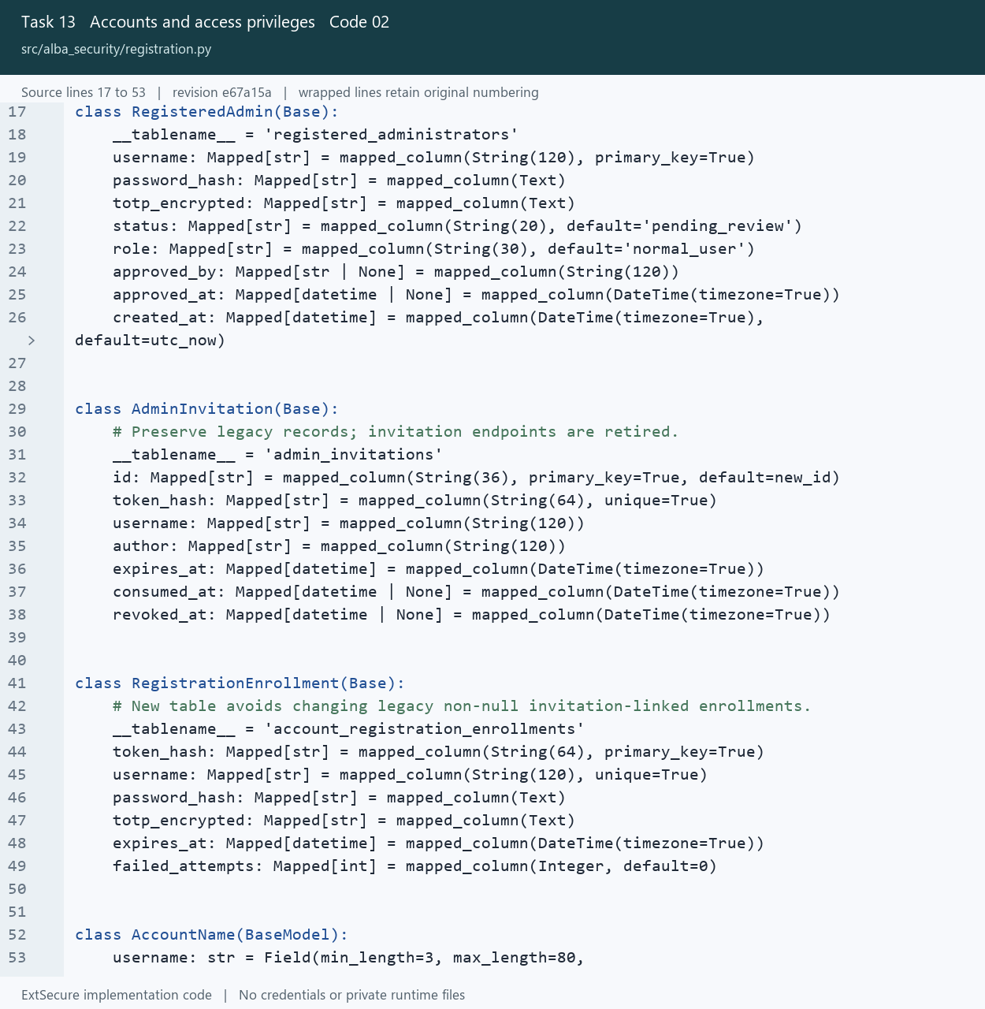
13_Accounts_and_access_privileges_02_registration_Lines_17_53.png
Open src/alba_security/registration.py at the captured revision

14 Two factor authentication
Verify password challenges and authenticator codes on the backend.

Picture 14.01 admin_auth.py source lines 189 to 221
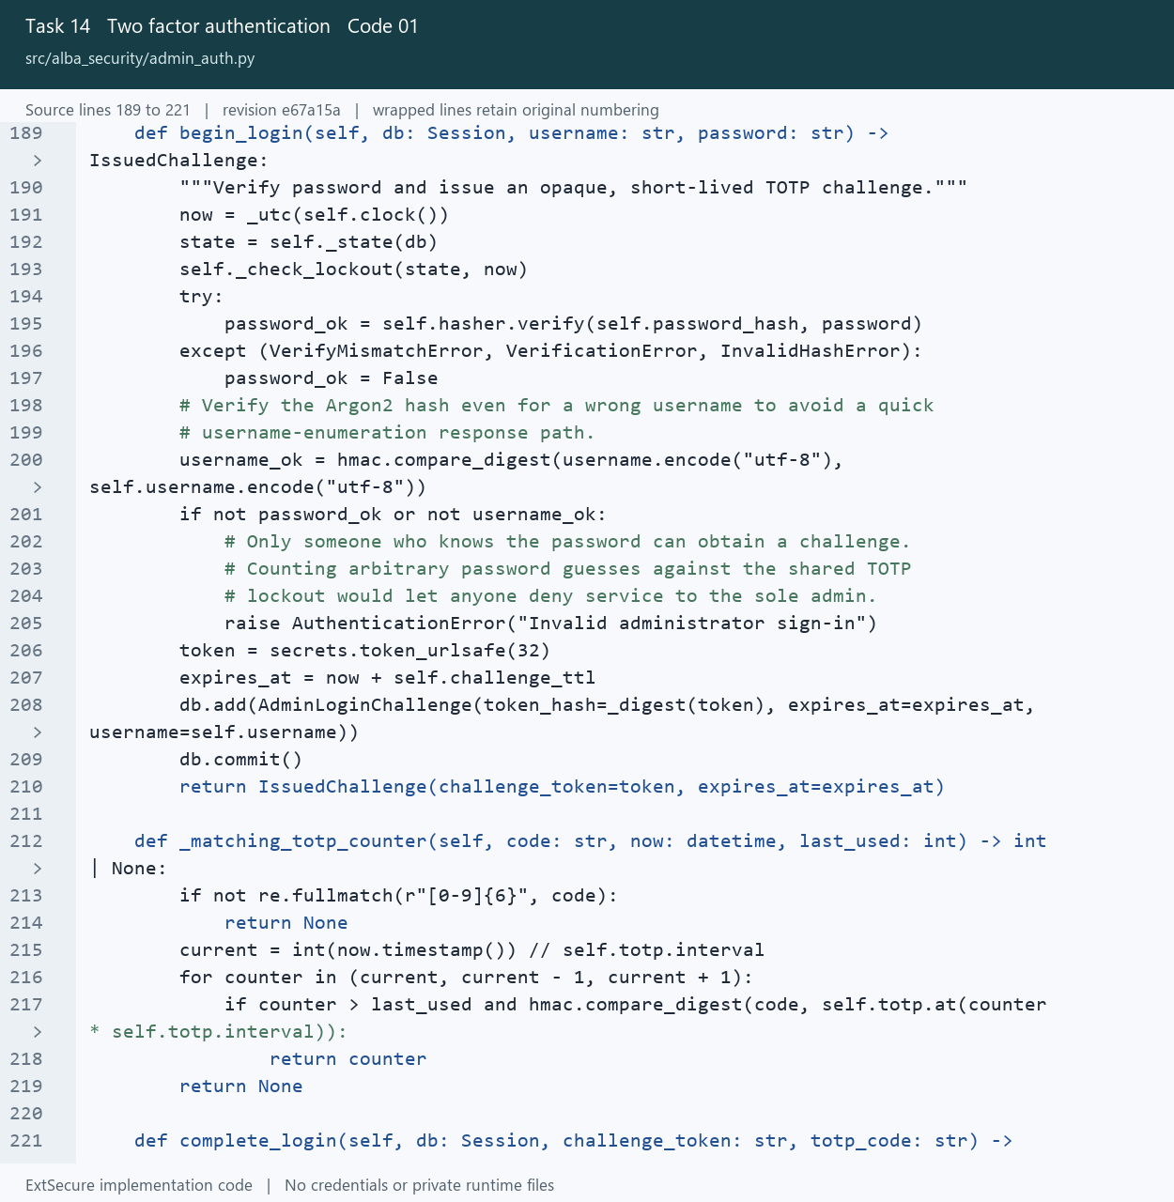
14_Two_factor_authentication_01_admin_auth_Lines_189_221.png
Open src/alba_security/admin_auth.py at the captured revision

14 Two factor authentication
Verify password challenges and authenticator codes on the backend.

Picture 14.02 admin_auth.py source lines 221 to 254
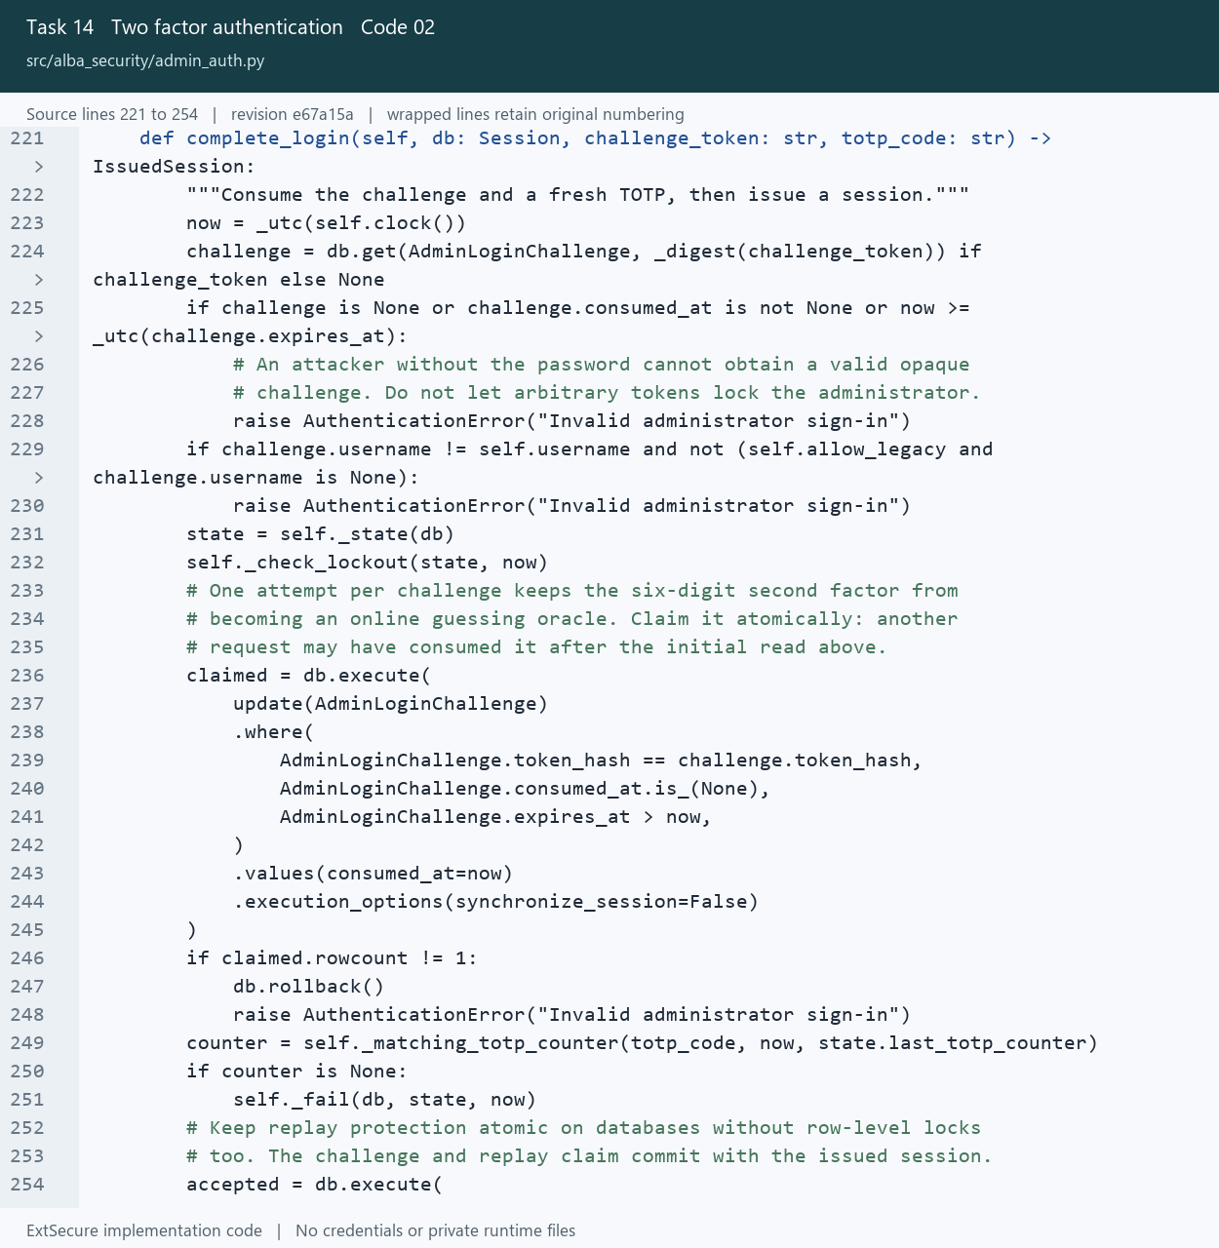
14_Two_factor_authentication_02_admin_auth_Lines_221_254.png
Open src/alba_security/admin_auth.py at the captured revision

15 Website approval requests
Require review confirmation and apply the chosen approval duration.

Picture 15.01 core.js source lines 6 to 33
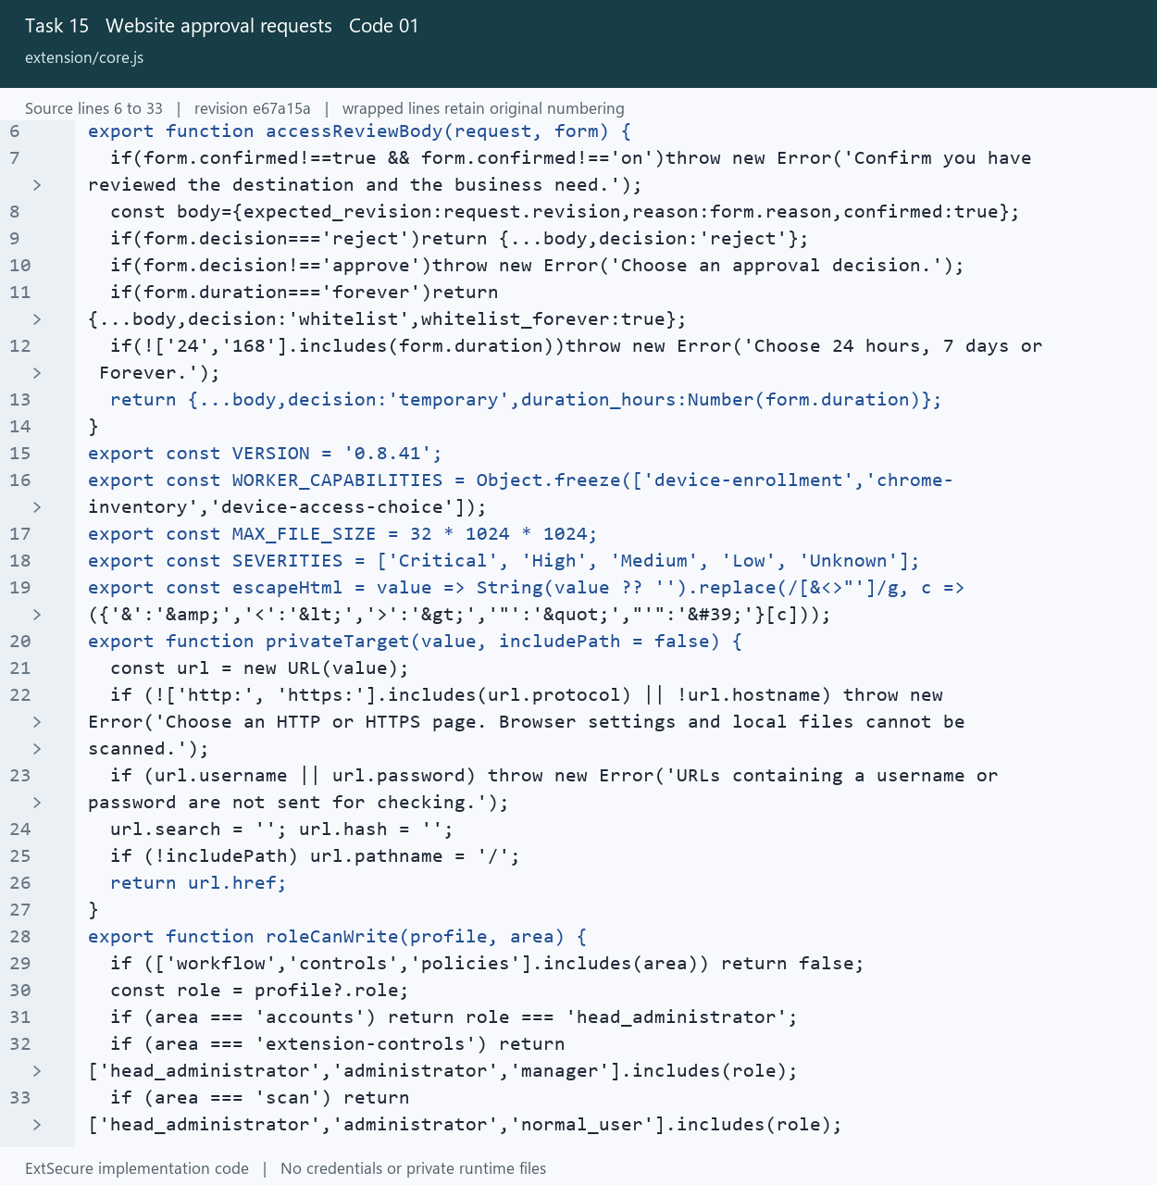
15_Website_approval_requests_01_core_Lines_6_33.png
Open extension/core.js at the captured revision

15 Website approval requests
Require review confirmation and apply the chosen approval duration.

Picture 15.02 website_access.py source lines 161 to 188
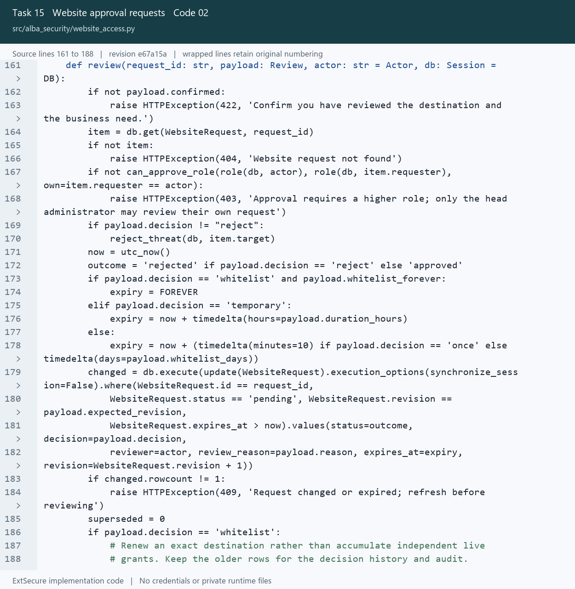
15_Website_approval_requests_02_website_access_Lines_161_188.png
Open src/alba_security/website_access.py at the captured revision

16 Whitelist and overrides
Manage approved exceptions while keeping security decisions traceable.

Picture 16.01 website_access.py source lines 63 to 99
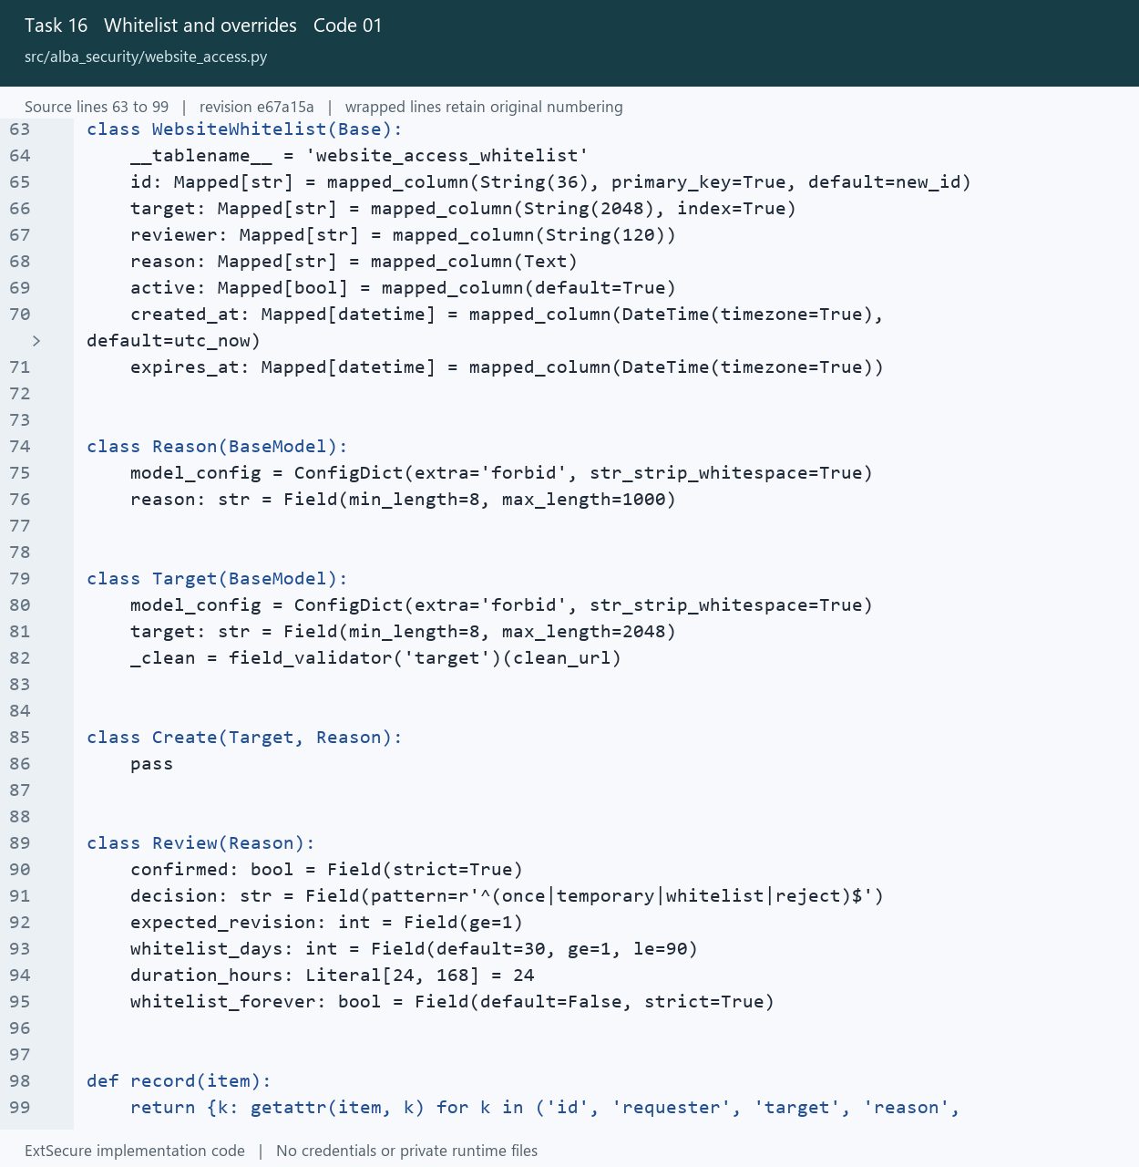
16_Whitelist_and_overrides_01_website_access_Lines_63_99.png
Open src/alba_security/website_access.py at the captured revision

16 Whitelist and overrides
Manage approved exceptions while keeping security decisions traceable.

Picture 16.02 overrides.py source lines 28 to 62
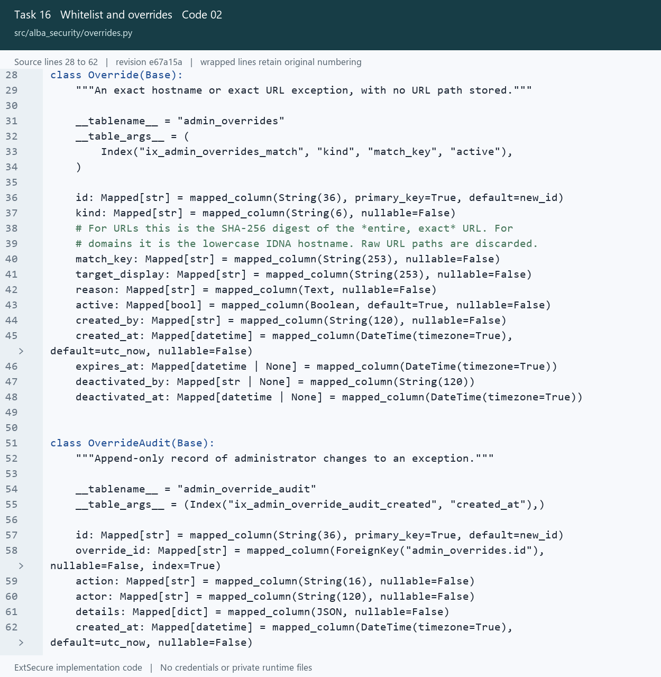
16_Whitelist_and_overrides_02_overrides_Lines_28_62.png
Open src/alba_security/overrides.py at the captured revision

17 Downloaded file scanning
Look up file hashes and include file reputation findings in scan results.

Picture 17.01 file_lookup.py source lines 50 to 86
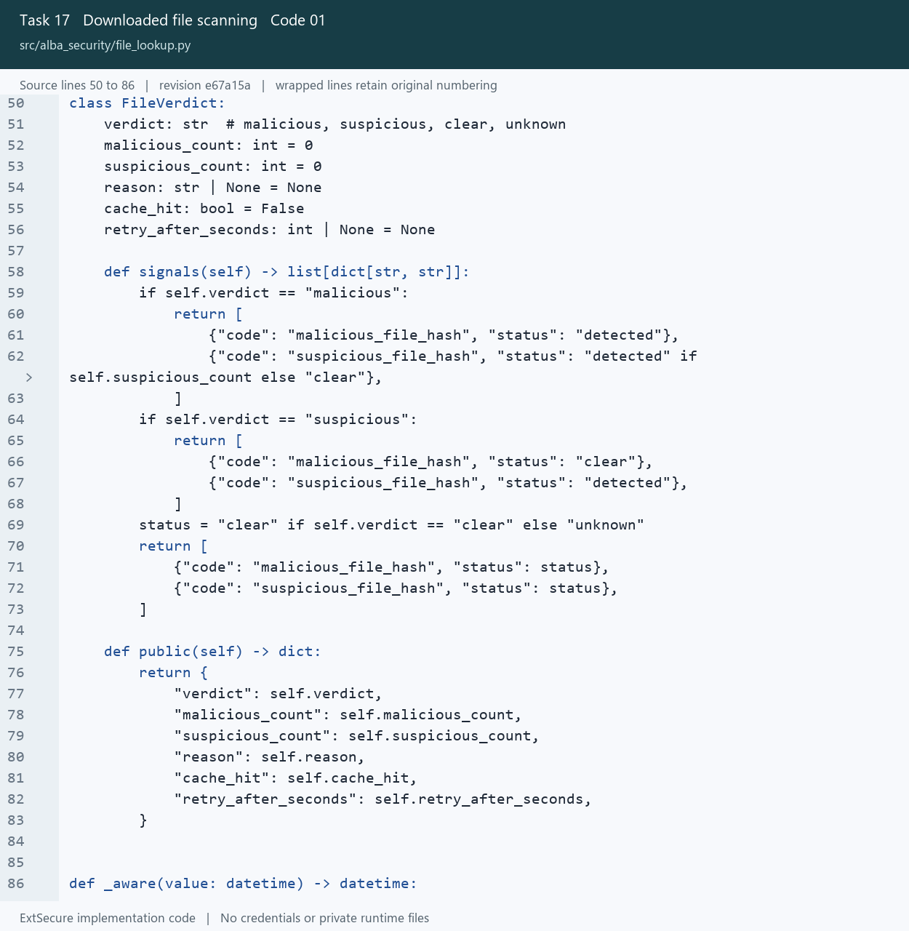
17_Downloaded_file_scanning_01_file_lookup_Lines_50_86.png
Open src/alba_security/file_lookup.py at the captured revision

17 Downloaded file scanning
Look up file hashes and include file reputation findings in scan results.

Picture 17.02 api.py source lines 665 to 698
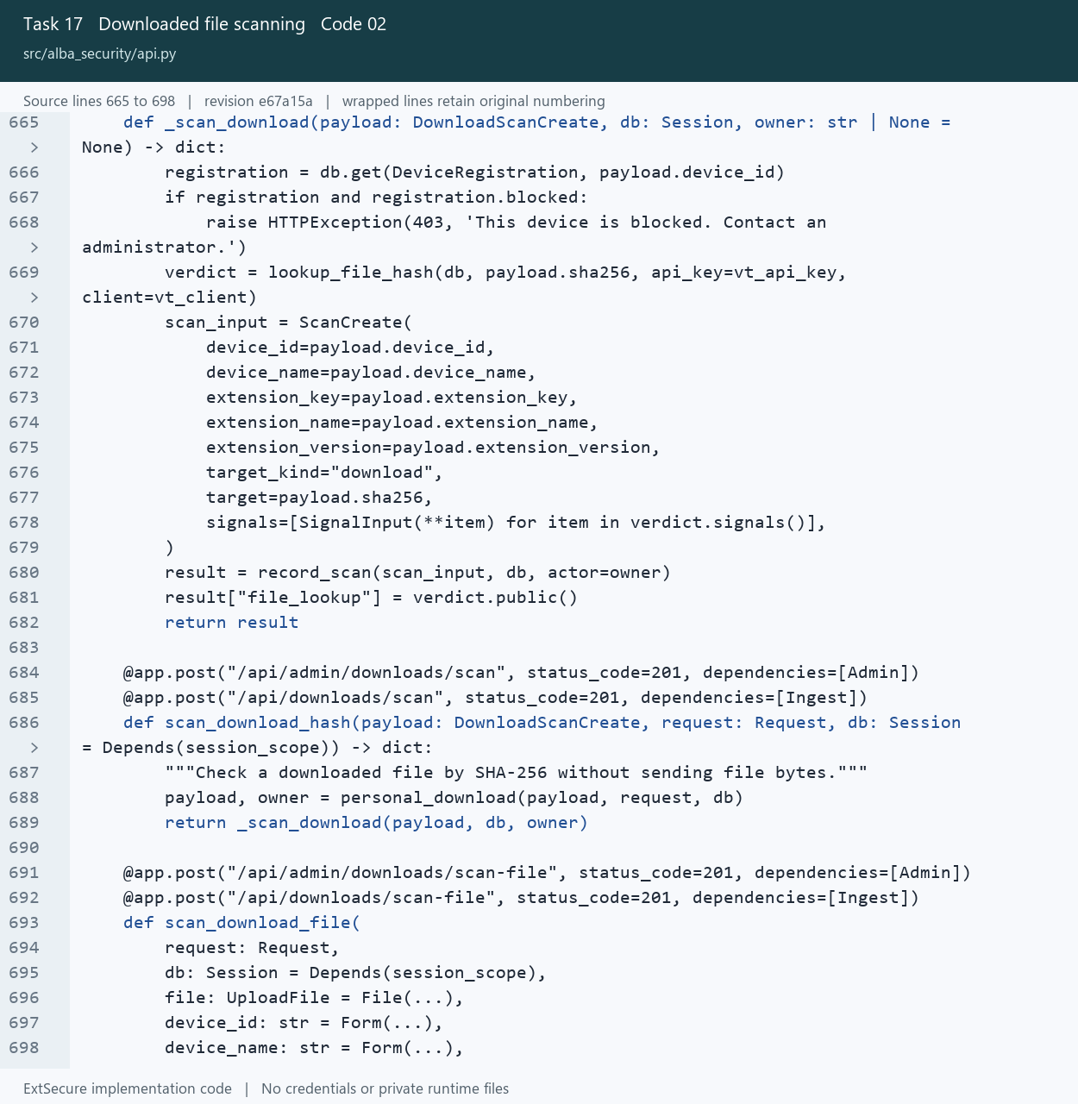
17_Downloaded_file_scanning_02_api_Lines_665_698.png
Open src/alba_security/api.py at the captured revision

18 AI threat explanations
Prepare scan evidence for a bounded local model explanation.

Picture 18.01 intelligence.py source lines 86 to 110
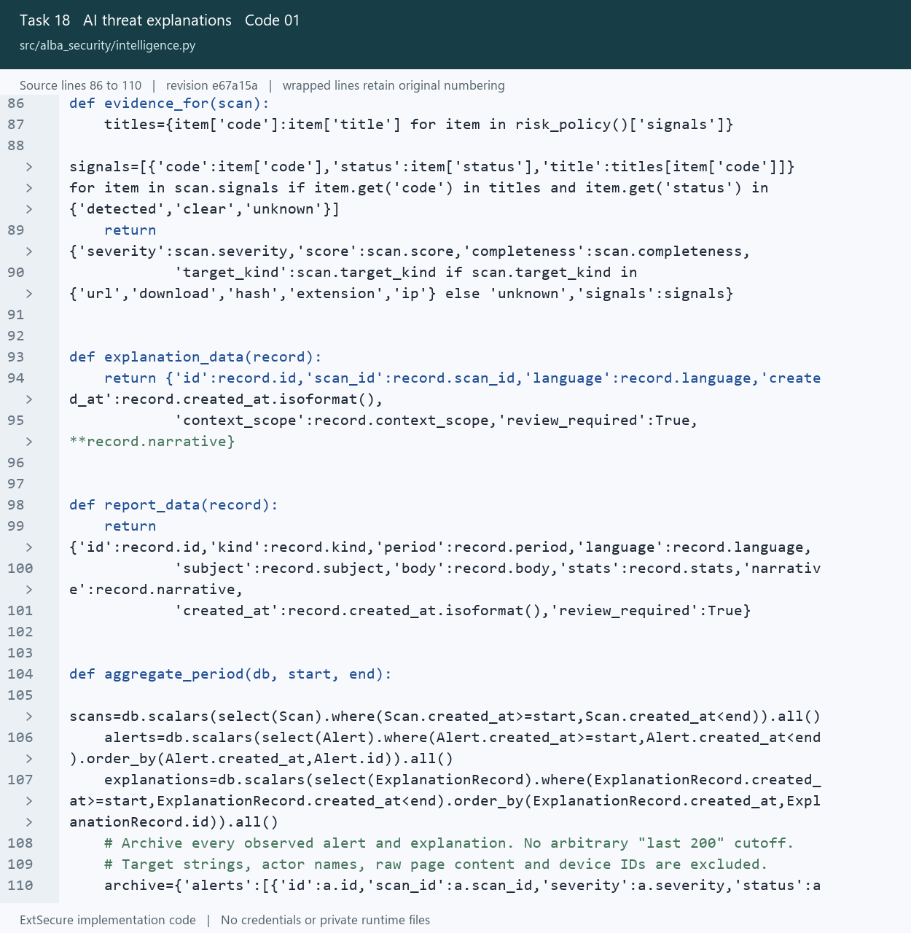
18_AI_threat_explanations_01_intelligence_Lines_86_110.png
Open src/alba_security/intelligence.py at the captured revision

18 AI threat explanations
Prepare scan evidence for a bounded local model explanation.

Picture 18.02 llm.py source lines 1 to 31
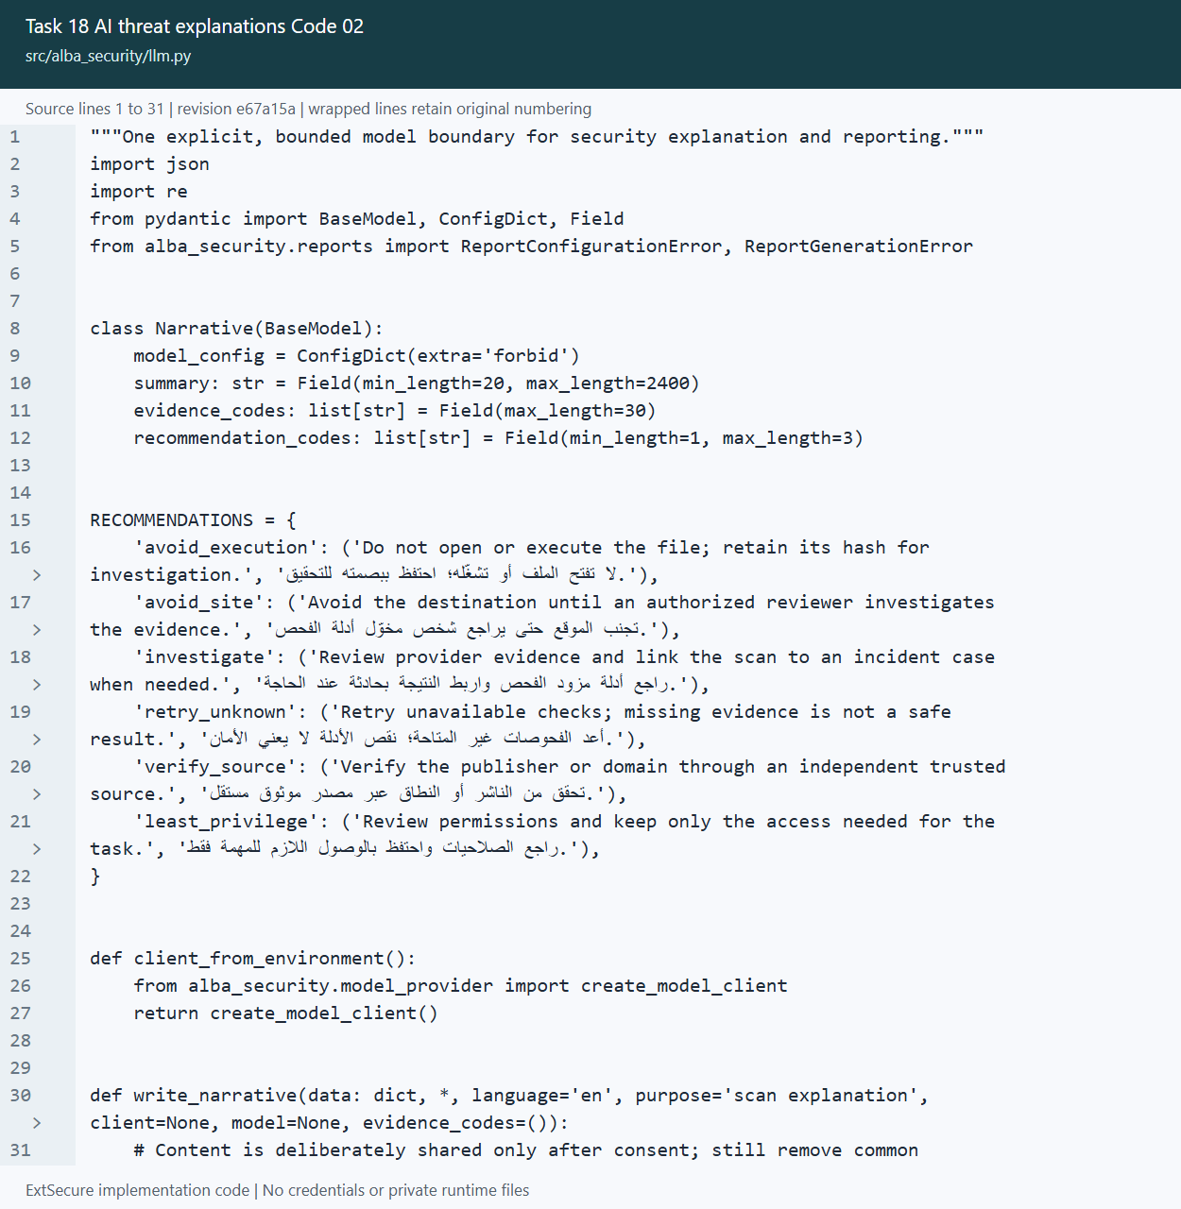
18_AI_threat_explanations_02_llm_Lines_1_31.png
Open src/alba_security/llm.py at the captured revision

19 Weekly and monthly reporting
Aggregate period statistics and generate scheduled reports for review.

Picture 19.01 intelligence.py source lines 104 to 124
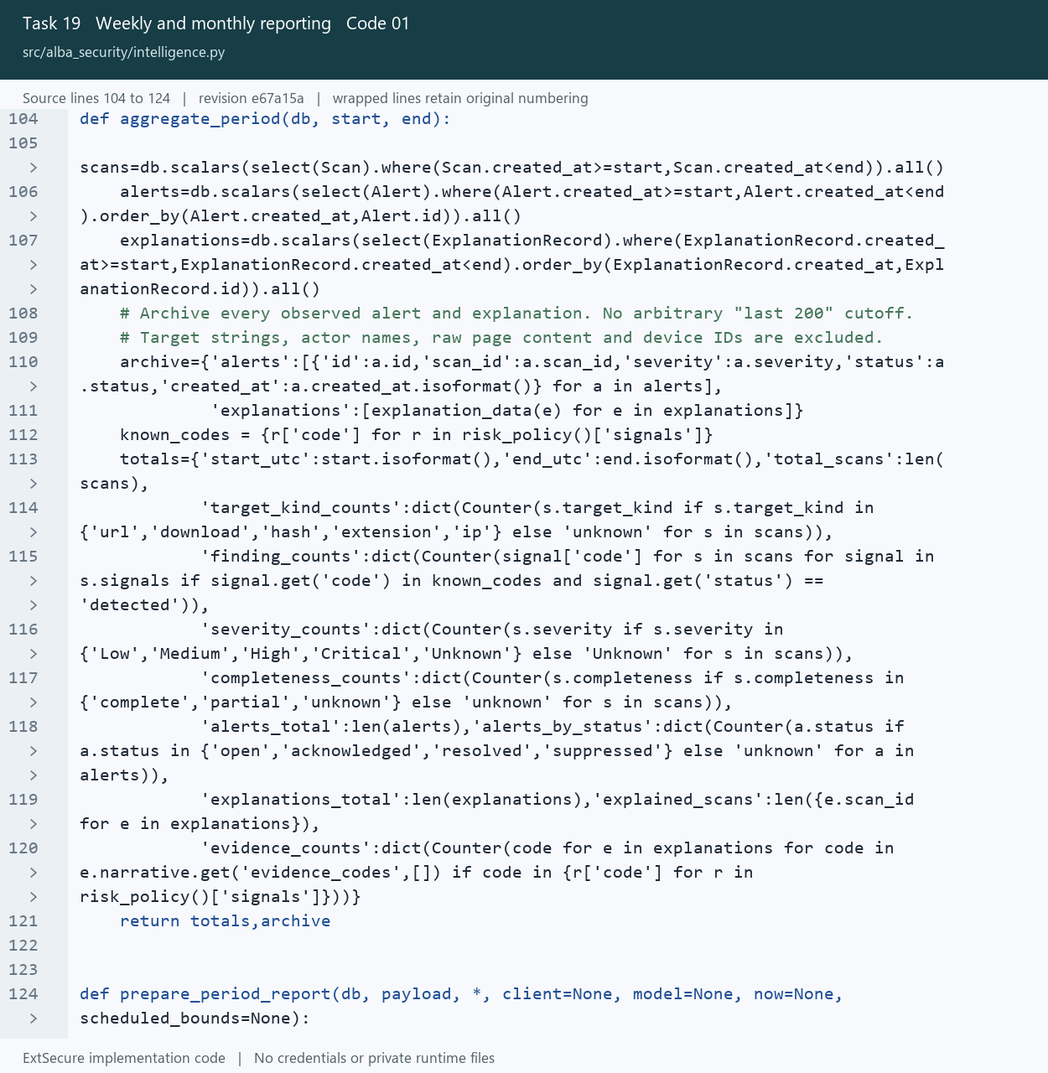
19_Weekly_and_monthly_reporting_01_intelligence_Lines_104_124.png
Open src/alba_security/intelligence.py at the captured revision

19 Weekly and monthly reporting
Aggregate period statistics and generate scheduled reports for review.

Picture 19.02 automatic_reports.py source lines 8 to 35
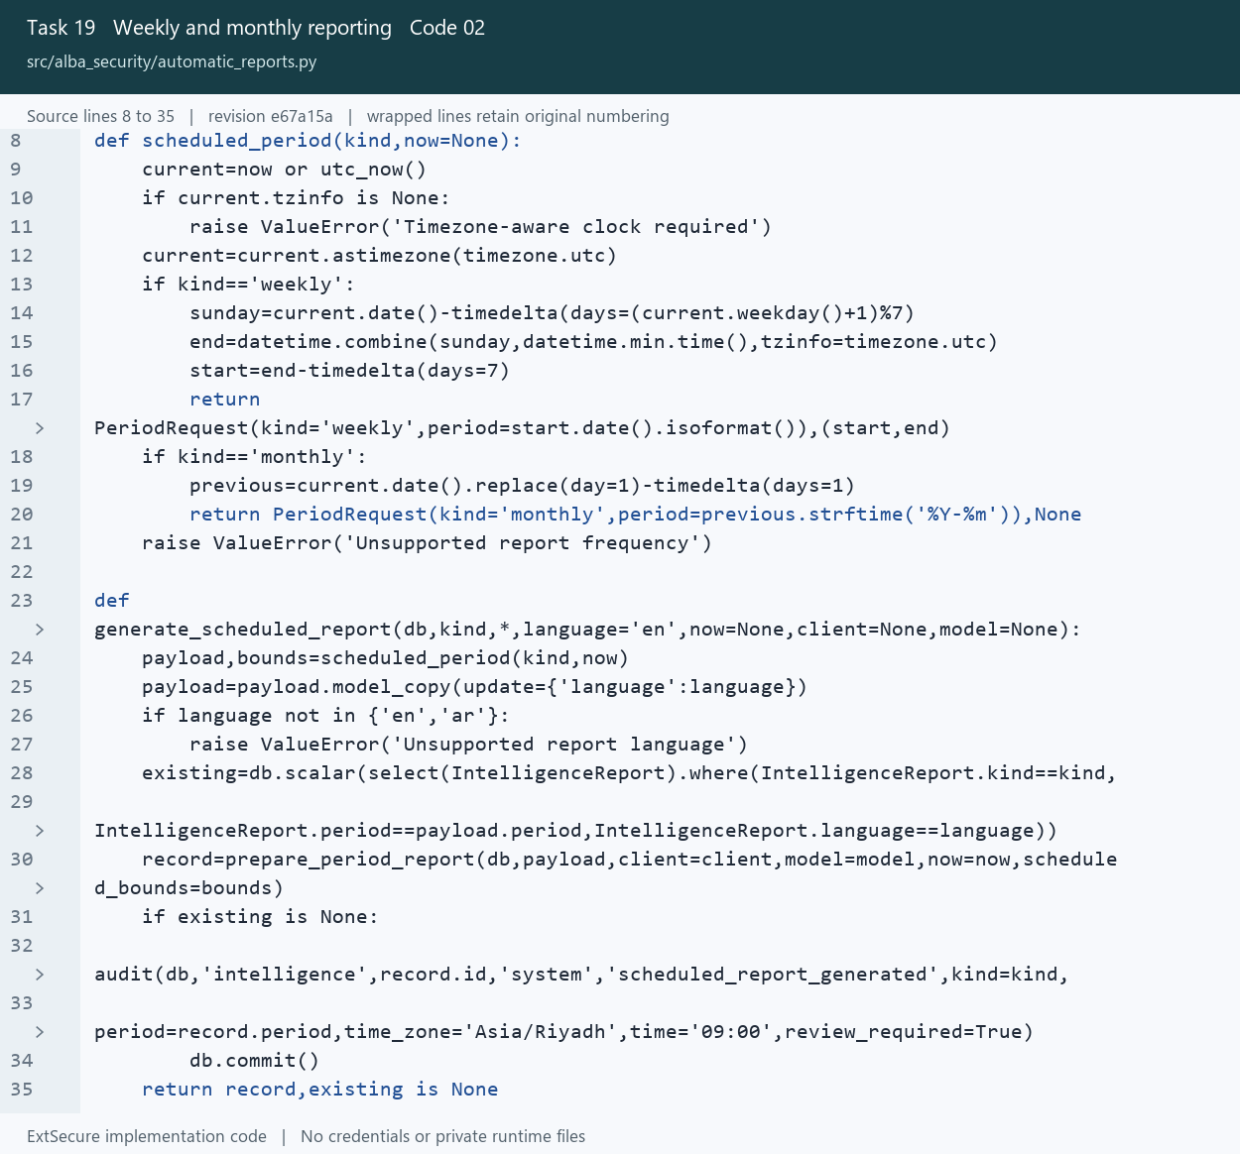
19_Weekly_and_monthly_reporting_02_automatic_reports_Lines_8_35.png
Open src/alba_security/automatic_reports.py at the captured revision

20 Machine learning activity review
Derive activity features and identify unusual periods for review.

Picture 20.01 monthly_ml.py source lines 26 to 54
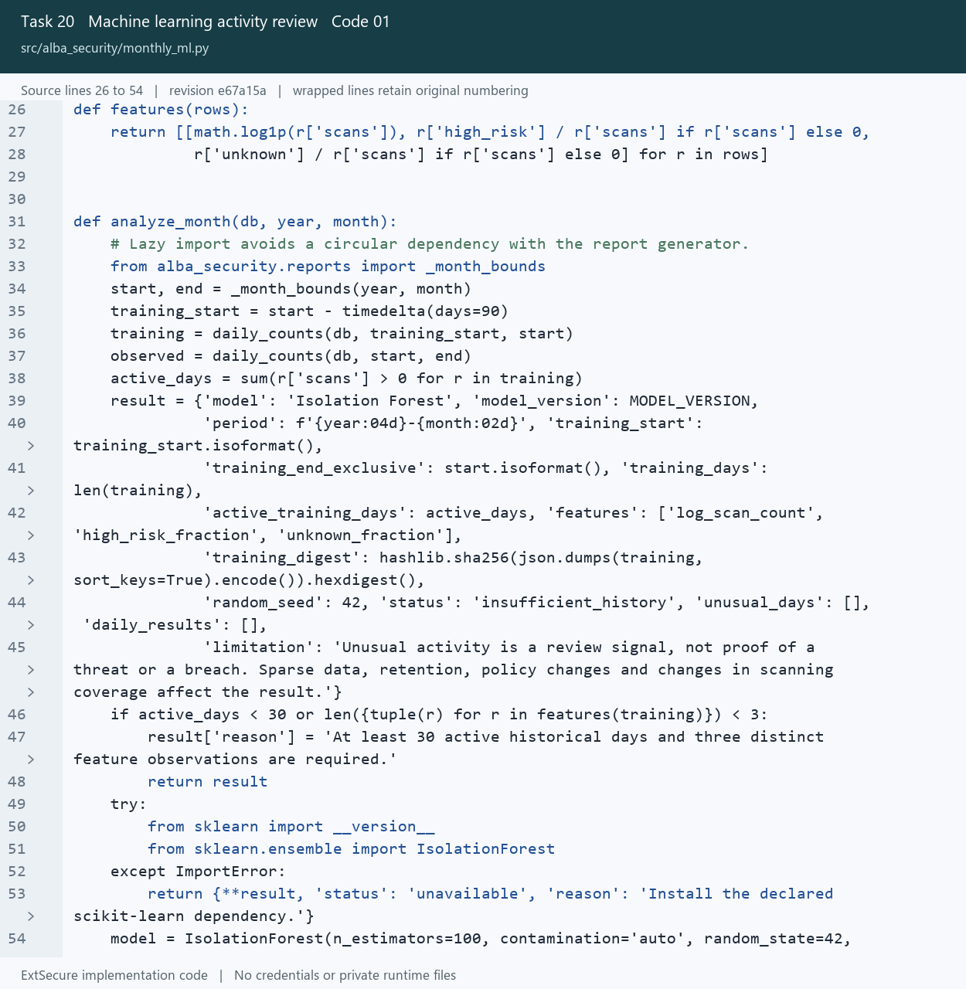
20_Machine_learning_activity_review_01_monthly_ml_Lines_26_54.png
Open src/alba_security/monthly_ml.py at the captured revision

20 Machine learning activity review
Derive activity features and identify unusual periods for review.

Picture 20.02 monthly_ml.py source lines 31 to 58
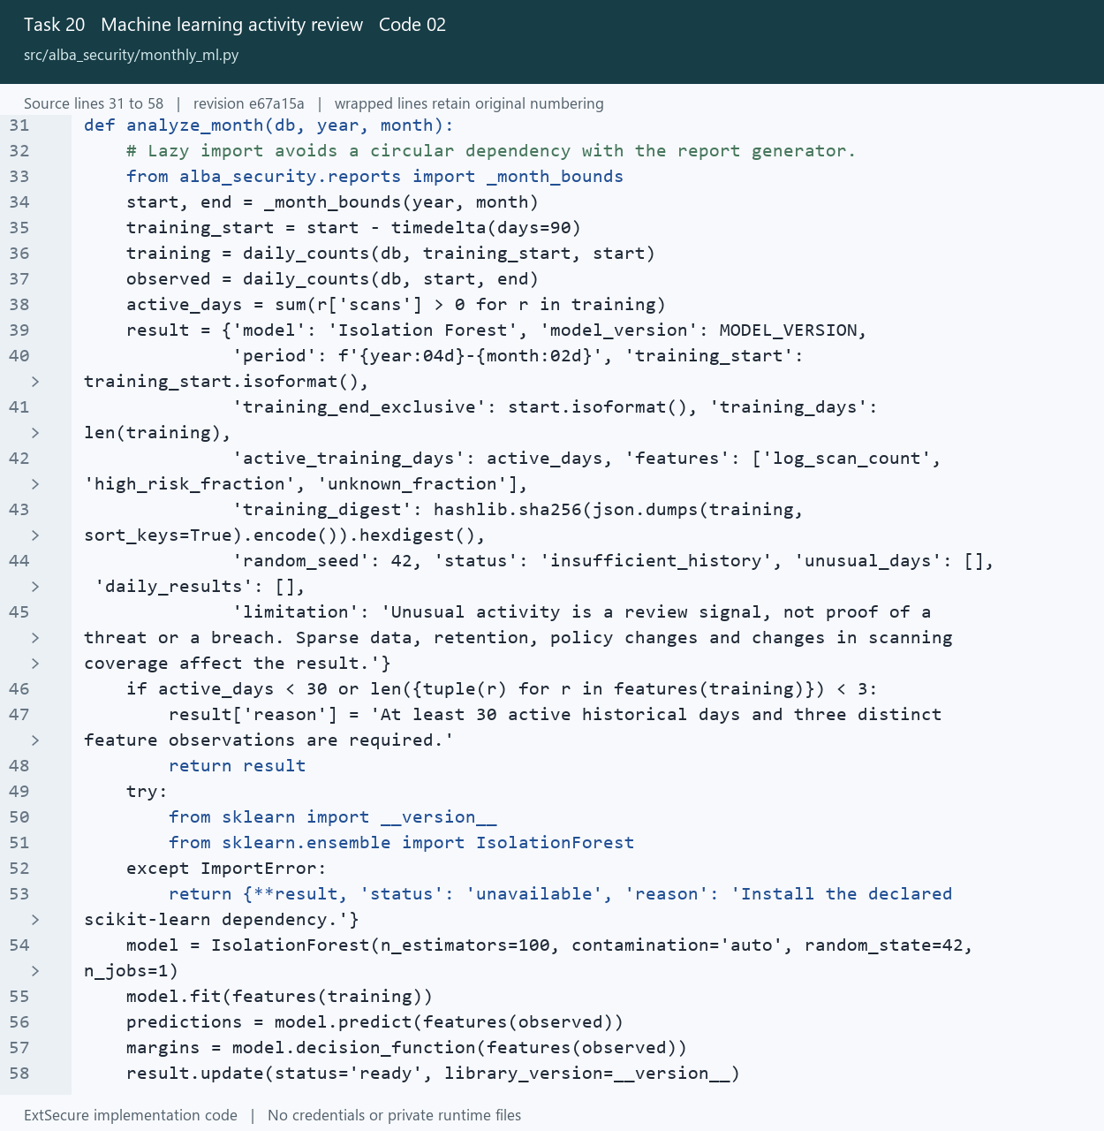
20_Machine_learning_activity_review_02_monthly_ml_Lines_31_58.png
Open src/alba_security/monthly_ml.py at the captured revision

21 High severity alerts
Keep high severity detections visible and support optional HTTPS webhooks.

Picture 21.01 notifications.py source lines 60 to 96
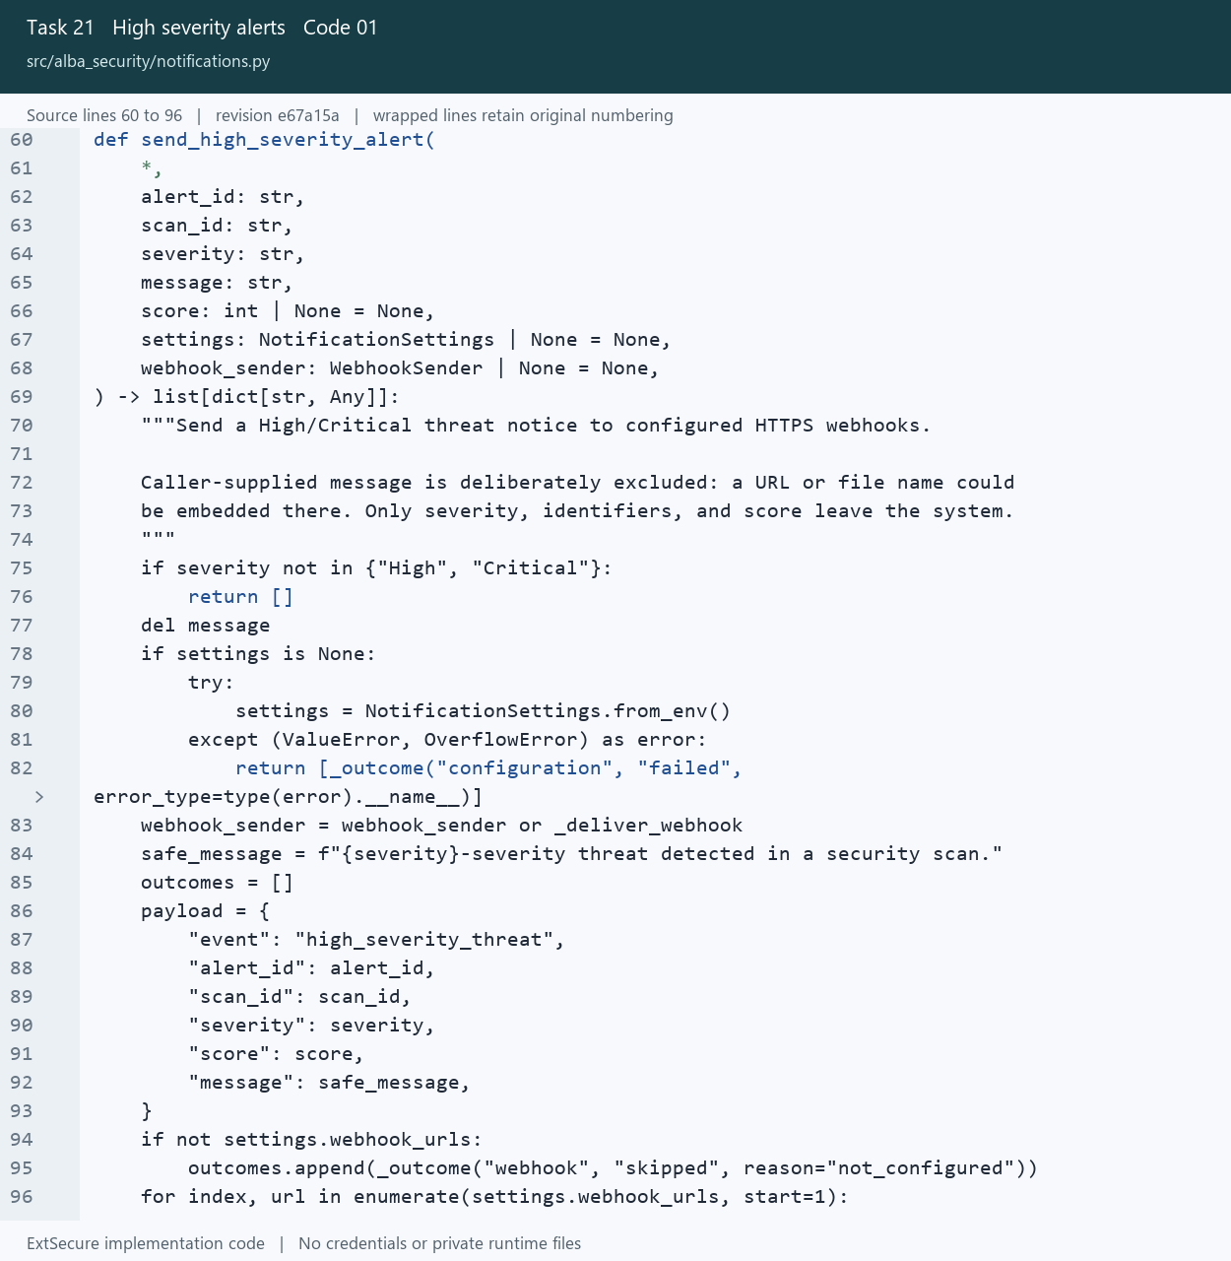
21_High_severity_alerts_01_notifications_Lines_60_96.png
Open src/alba_security/notifications.py at the captured revision

21 High severity alerts
Keep high severity detections visible and support optional HTTPS webhooks.

Picture 21.02 models.py source lines 132 to 162
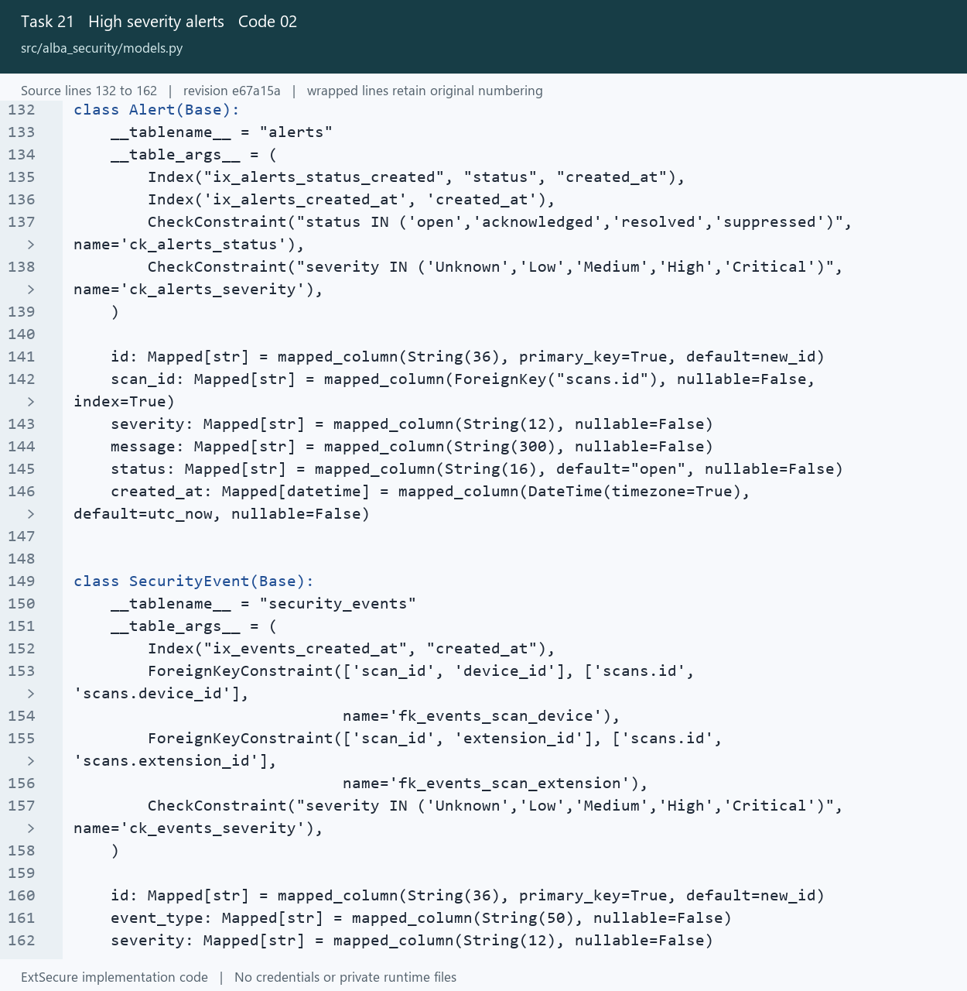
21_High_severity_alerts_02_models_Lines_132_162.png
Open src/alba_security/models.py at the captured revision

22 Immediate threat blocking
Create persistent containment records and apply browser blocking rules.

Picture 22.01 threat_blocks.py source lines 60 to 91
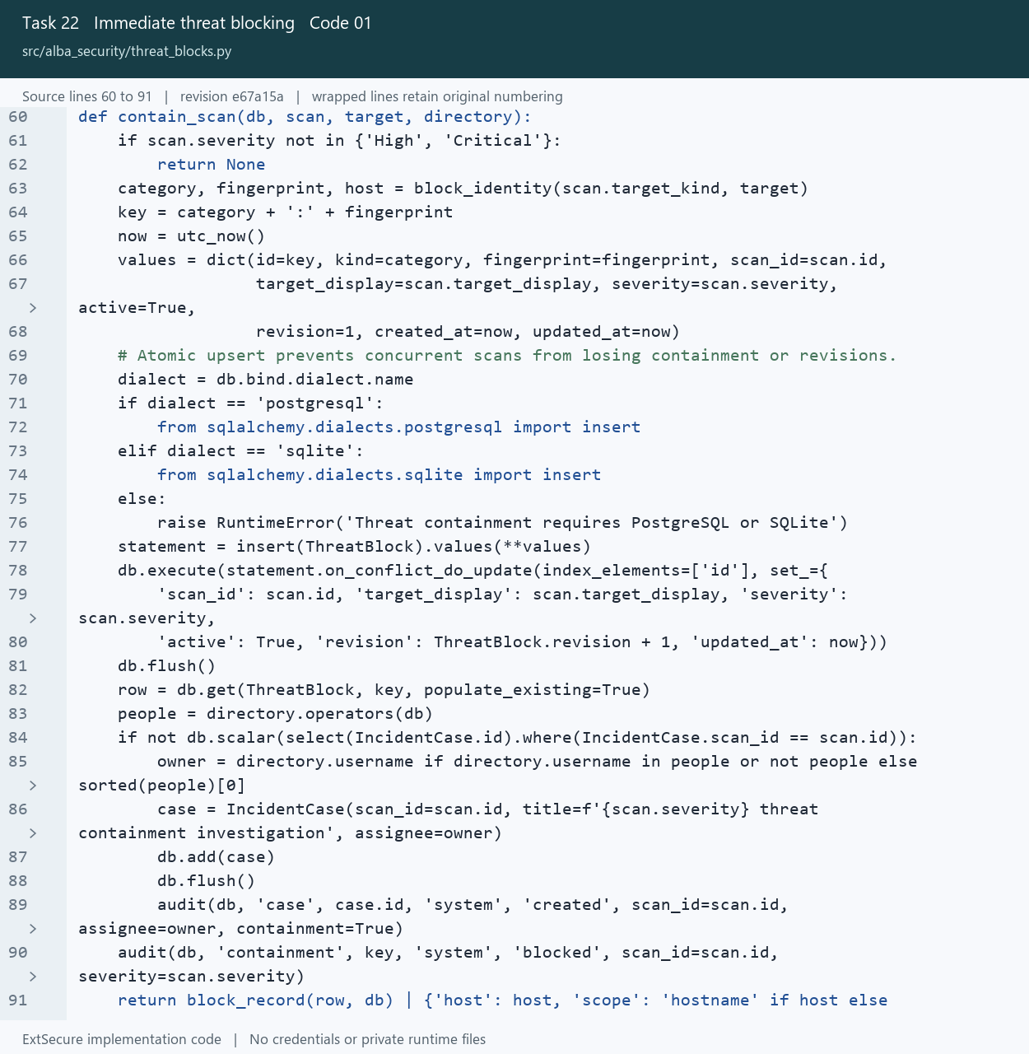
22_Immediate_threat_blocking_01_threat_blocks_Lines_60_91.png
Open src/alba_security/threat_blocks.py at the captured revision

22 Immediate threat blocking
Create persistent containment records and apply browser blocking rules.

Picture 22.02 threat-containment.js source lines 25 to 54
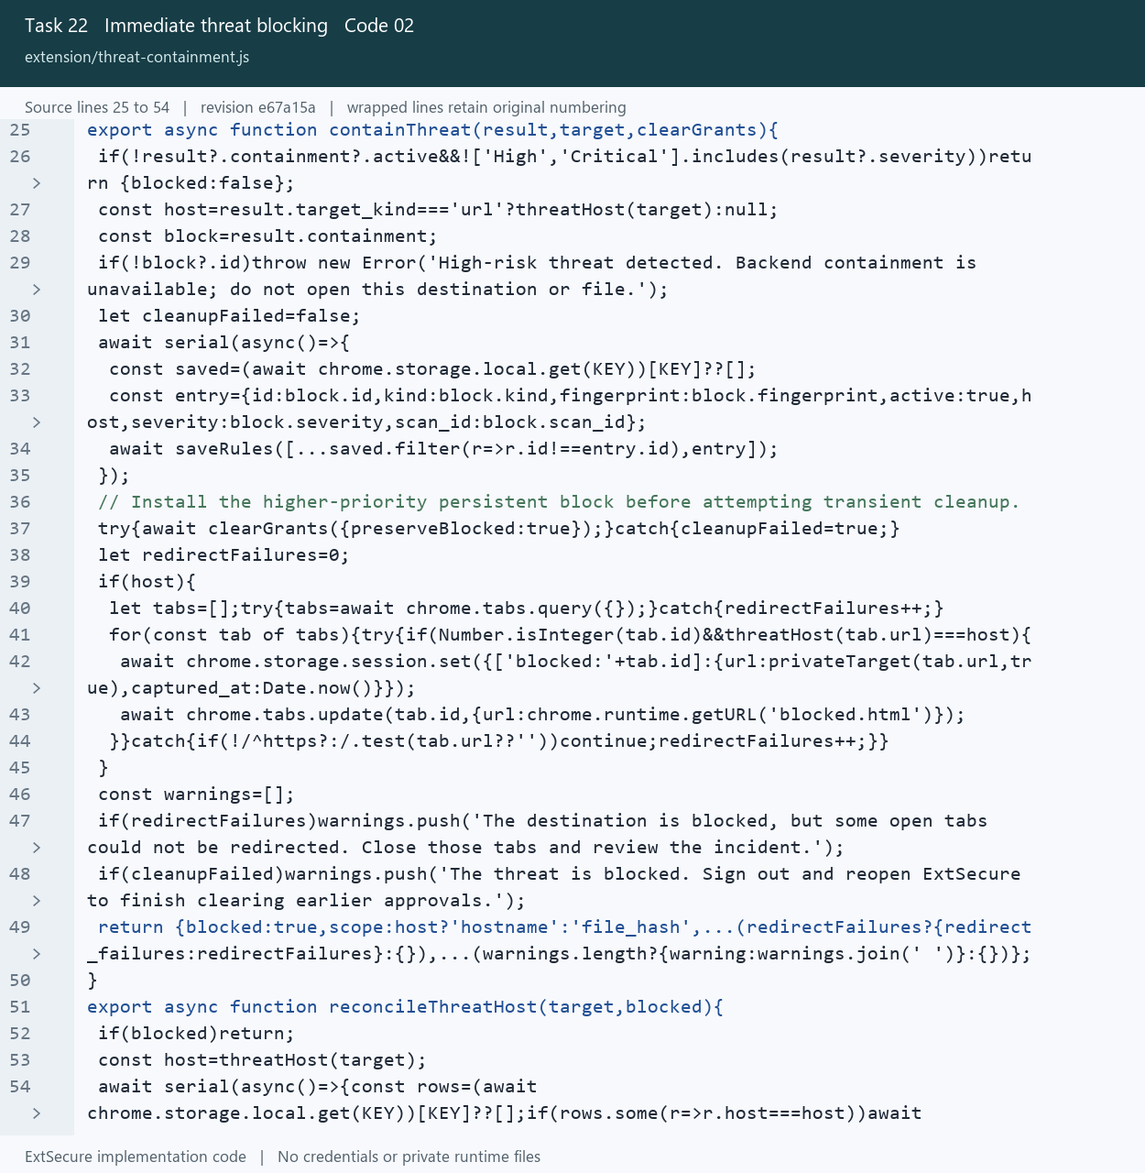
22_Immediate_threat_blocking_02_threat_containment_Lines_25_54.png
Open extension/threat-containment.js at the captured revision

23 Incident response and case management
Track investigation notes, safety actions and controlled incident removal.

Picture 23.01 governance.py source lines 470 to 496
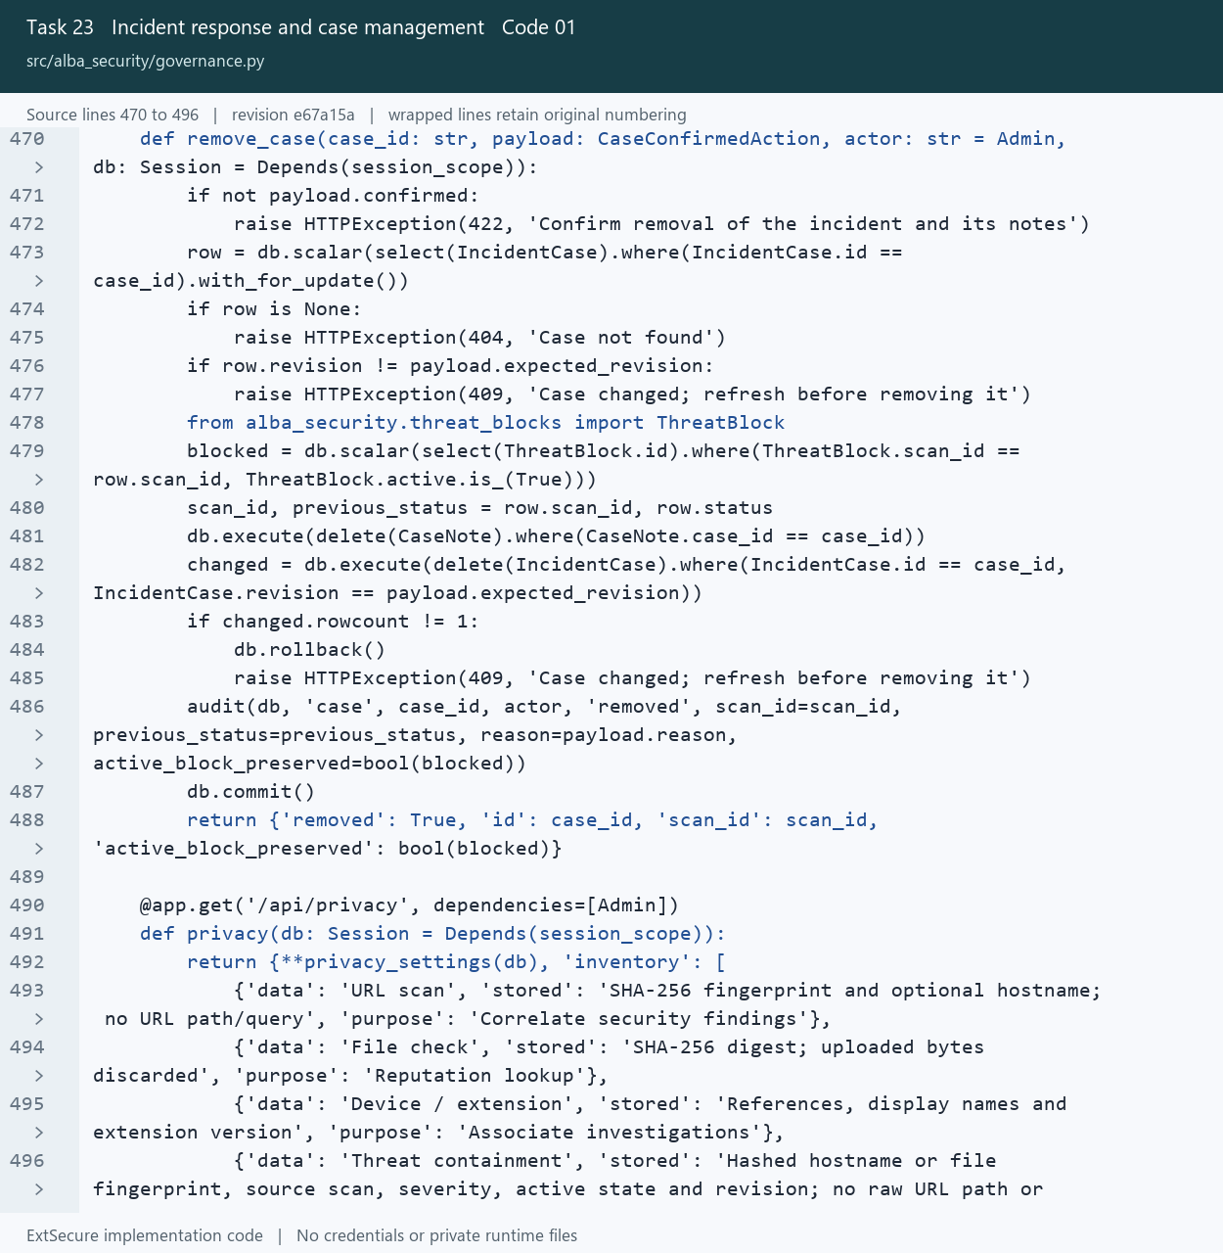
23_Incident_response_and_case_management_01_governance_Lines_470_496.png
Open src/alba_security/governance.py at the captured revision

23 Incident response and case management
Track investigation notes, safety actions and controlled incident removal.

Picture 23.02 incident-safety.js source lines 15 to 28
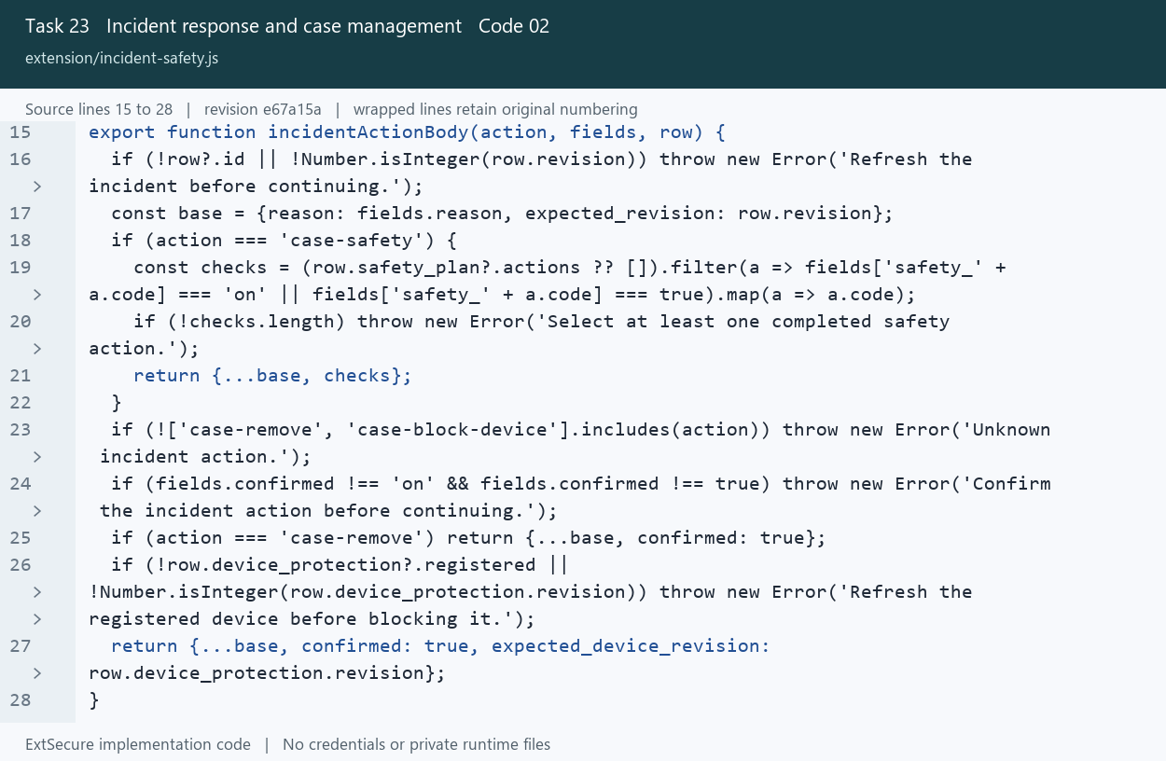
23_Incident_response_and_case_management_02_incident_safety_Lines_15_28.png
Open extension/incident-safety.js at the captured revision

24 Privacy and data governance
Limit shared URL information and protect evidence during retention.

Picture 24.01 core.js source lines 20 to 48
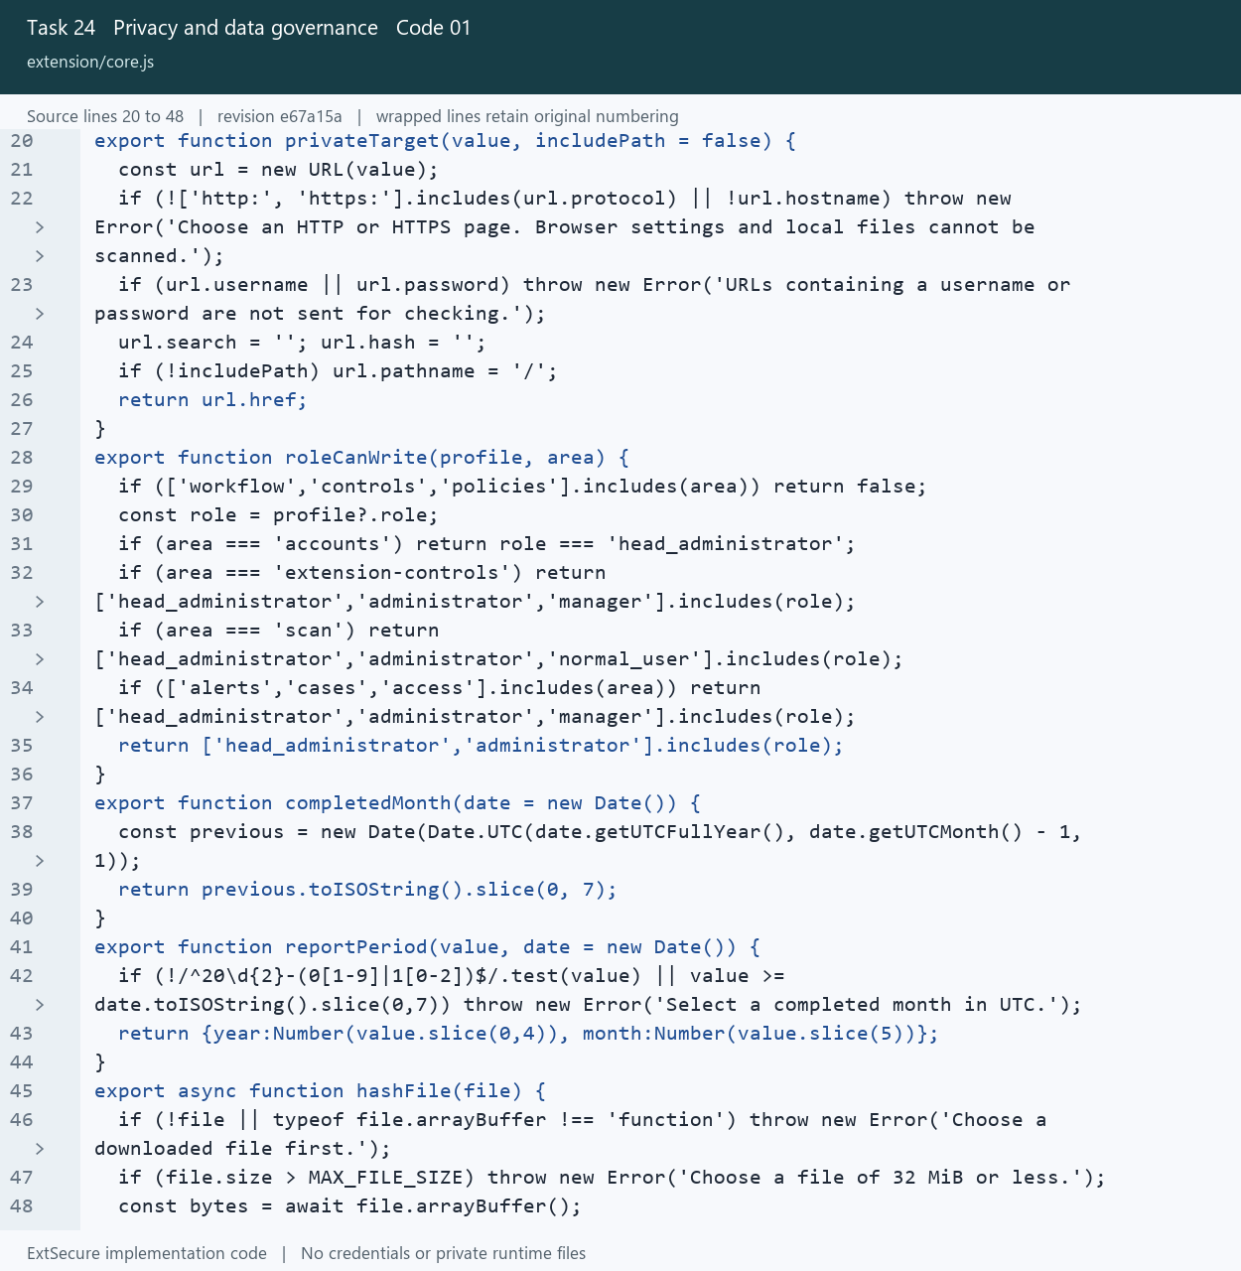
24_Privacy_and_data_governance_01_core_Lines_20_48.png
Open extension/core.js at the captured revision

24 Privacy and data governance
Limit shared URL information and protect evidence during retention.

Picture 24.02 governance.py source lines 302 to 332
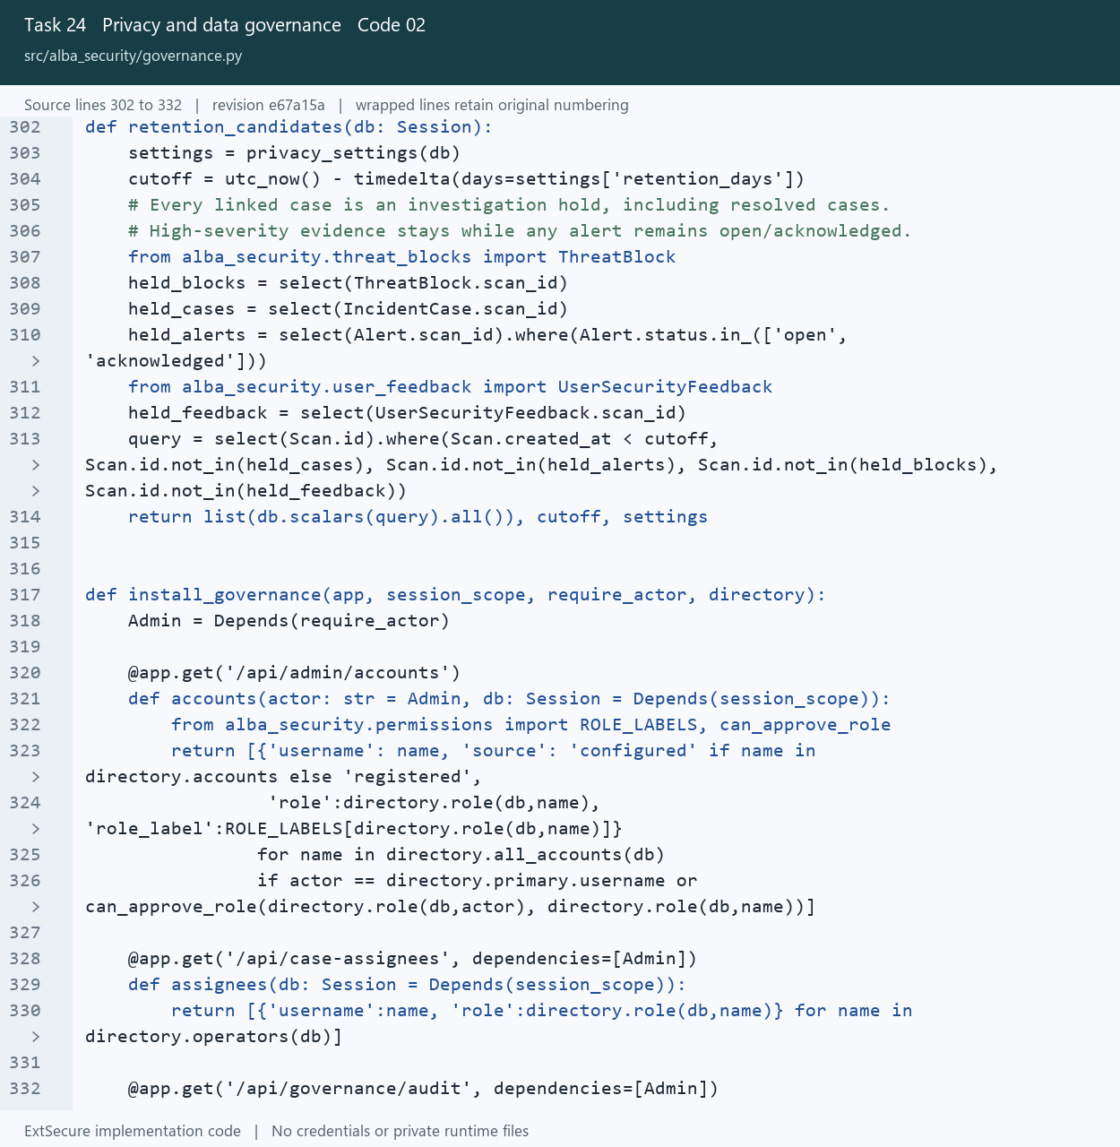
24_Privacy_and_data_governance_02_governance_Lines_302_332.png
Open src/alba_security/governance.py at the captured revision

25 Detection quality evaluation
Compare expected results with calculated risk and identify scoring issues.

Picture 25.01 governance.py source lines 246 to 273
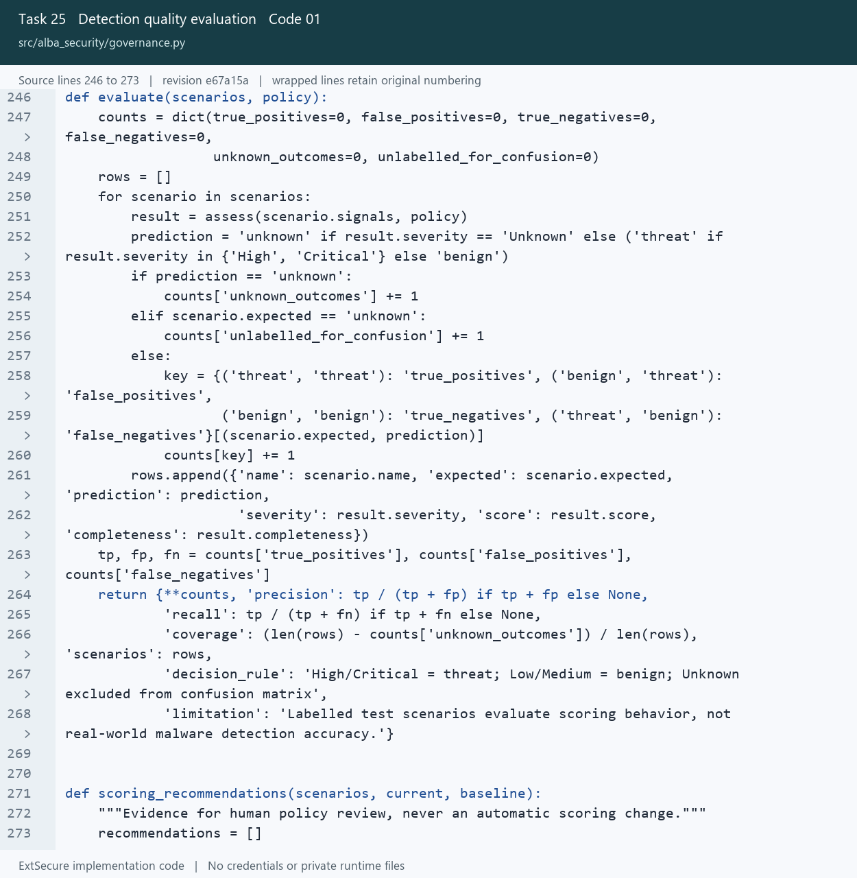
25_Detection_quality_evaluation_01_governance_Lines_246_273.png
Open src/alba_security/governance.py at the captured revision

25 Detection quality evaluation
Compare expected results with calculated risk and identify scoring issues.

Picture 25.02 governance.py source lines 271 to 296
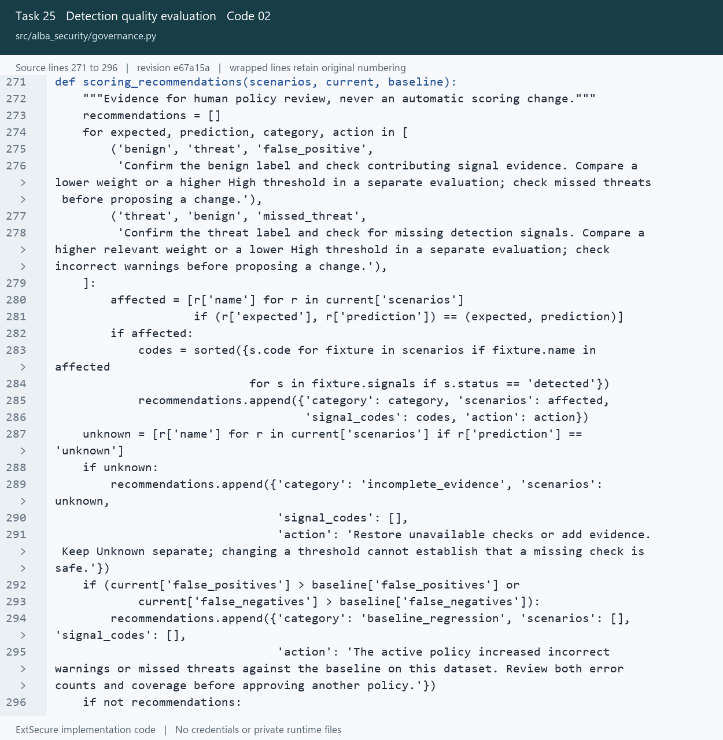
25_Detection_quality_evaluation_02_governance_Lines_271_296.png
Open src/alba_security/governance.py at the captured revision

26 Usability and accessibility
Validate form input accessibly and record usability observations.

Picture 26.01 form-validation.js source lines 1 to 28
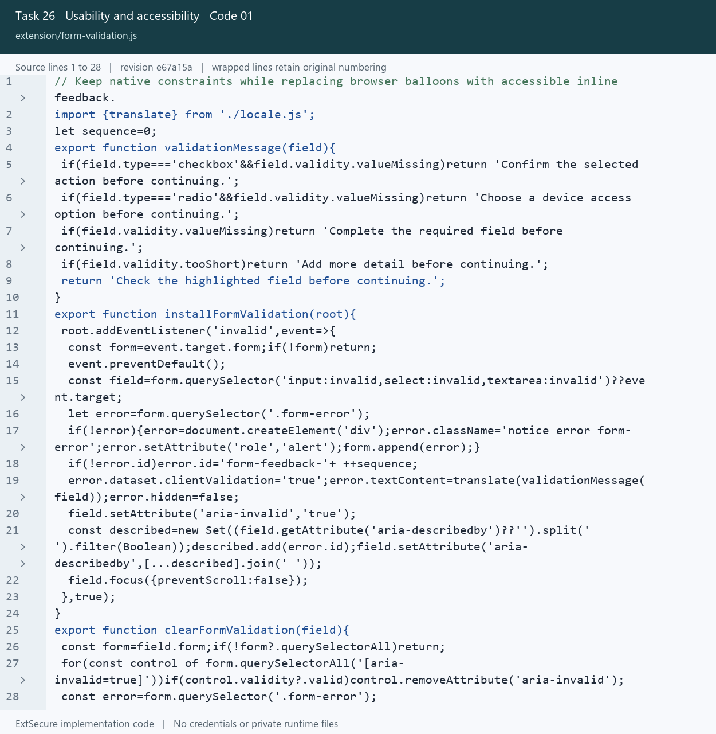
26_Usability_and_accessibility_01_form_validation_Lines_1_28.png
Open extension/form-validation.js at the captured revision

26 Usability and accessibility
Validate form input accessibly and record usability observations.

Picture 26.02 governance.py source lines 593 to 619
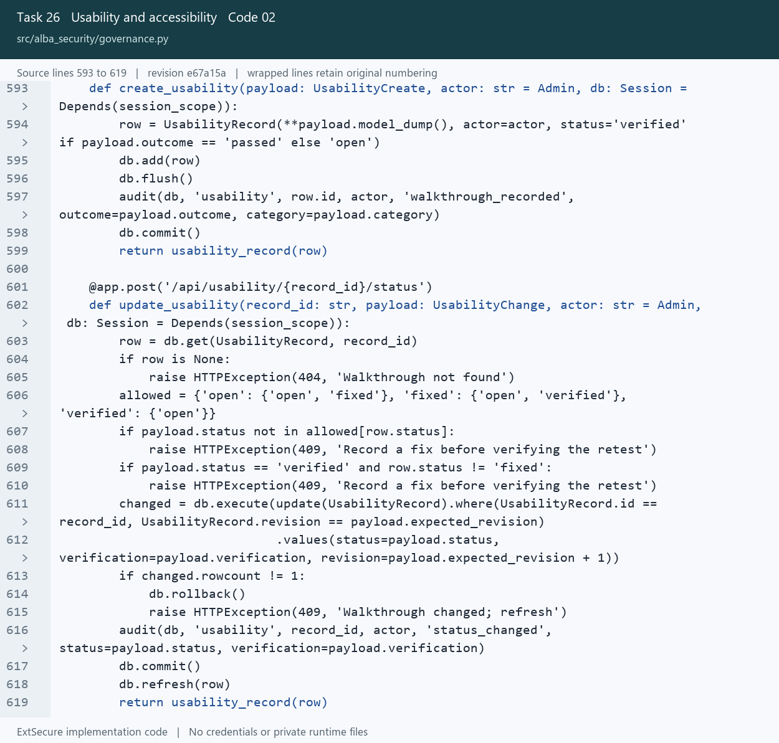
26_Usability_and_accessibility_02_governance_Lines_593_619.png
Open src/alba_security/governance.py at the captured revision

27 Security guidance
Explain missing lookup evidence and present clear connection guidance.

Picture 27.01 scan-feedback.js source lines 9 to 19
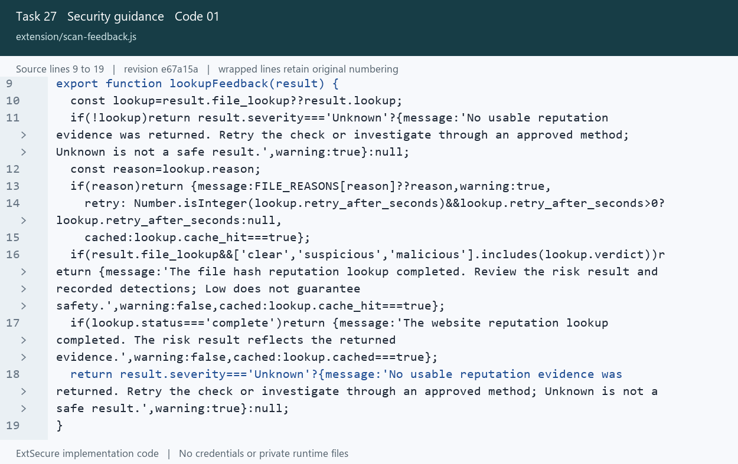
27_Security_guidance_01_scan_feedback_Lines_9_19.png
Open extension/scan-feedback.js at the captured revision

27 Security guidance
Explain missing lookup evidence and present clear connection guidance.

Picture 27.02 workspace-kit.js source lines 48 to 65
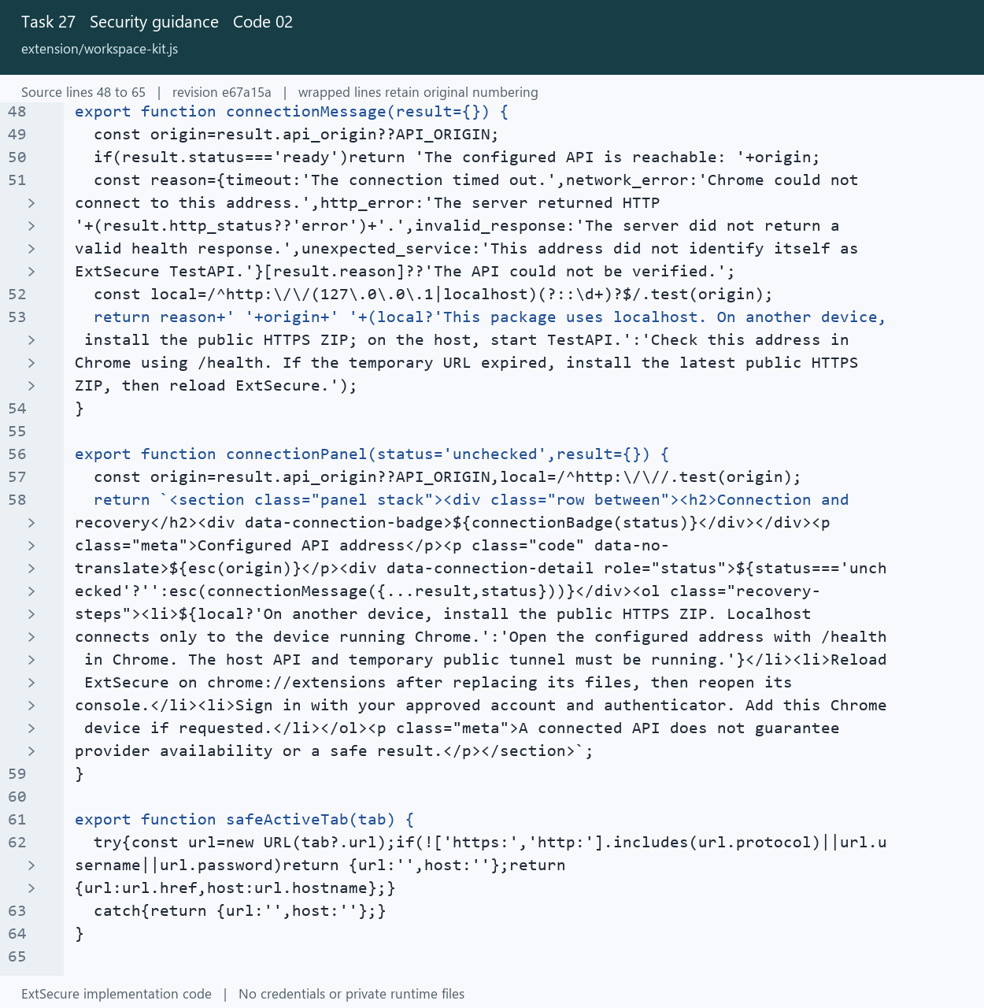
27_Security_guidance_02_workspace_kit_Lines_48_65.png
Open extension/workspace-kit.js at the captured revision

28 User security feedback
Link warning challenges to the original scan and record review decisions.

Picture 28.01 user_feedback.py source lines 78 to 110
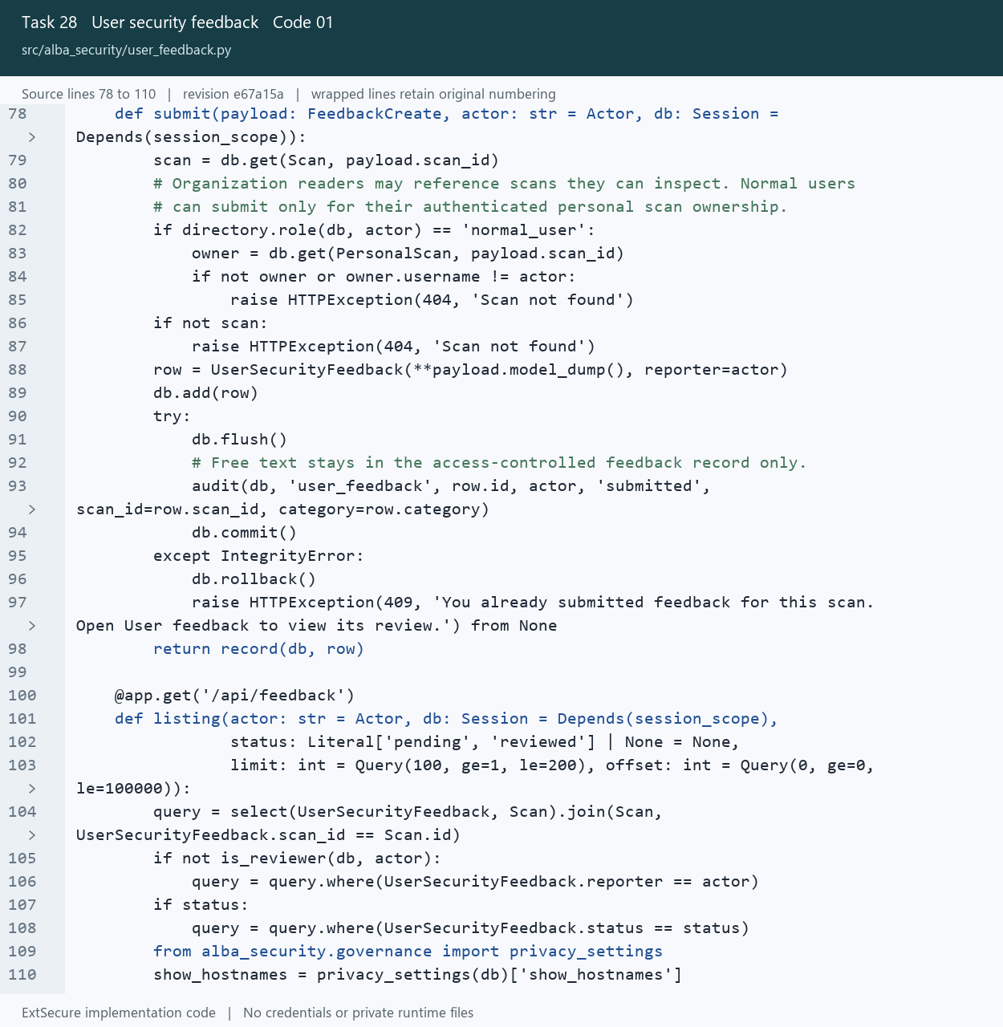
28_User_security_feedback_01_user_feedback_Lines_78_110.png
Open src/alba_security/user_feedback.py at the captured revision

28 User security feedback
Link warning challenges to the original scan and record review decisions.

Picture 28.02 user-feedback.js source lines 1 to 24
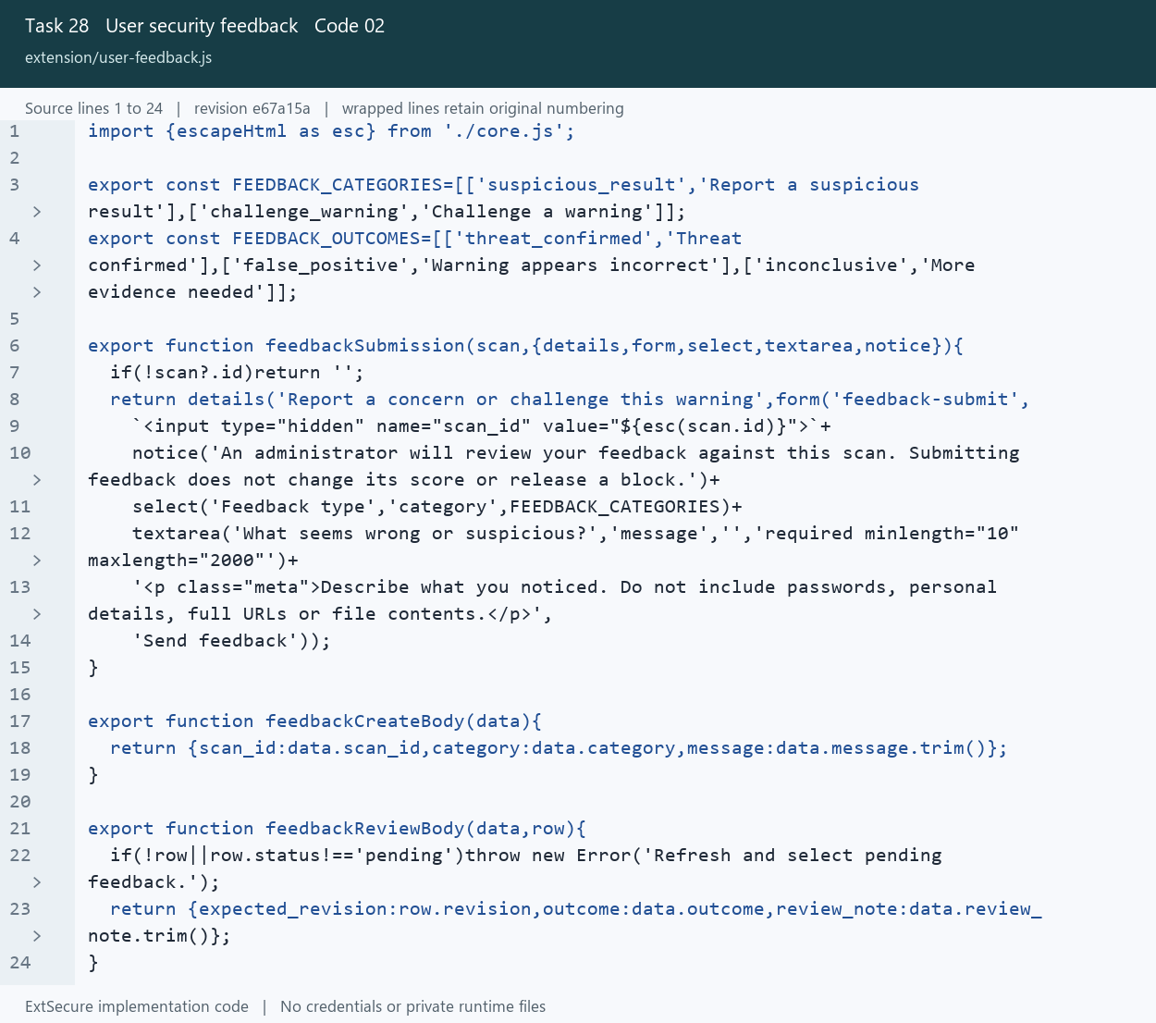
28_User_security_feedback_02_user_feedback_Lines_1_24.png
Open extension/user-feedback.js at the captured revision

29 User suggestions
Collect product improvement ideas and maintain administrator responses.

Picture 29.01 user_suggestions.py source lines 70 to 99
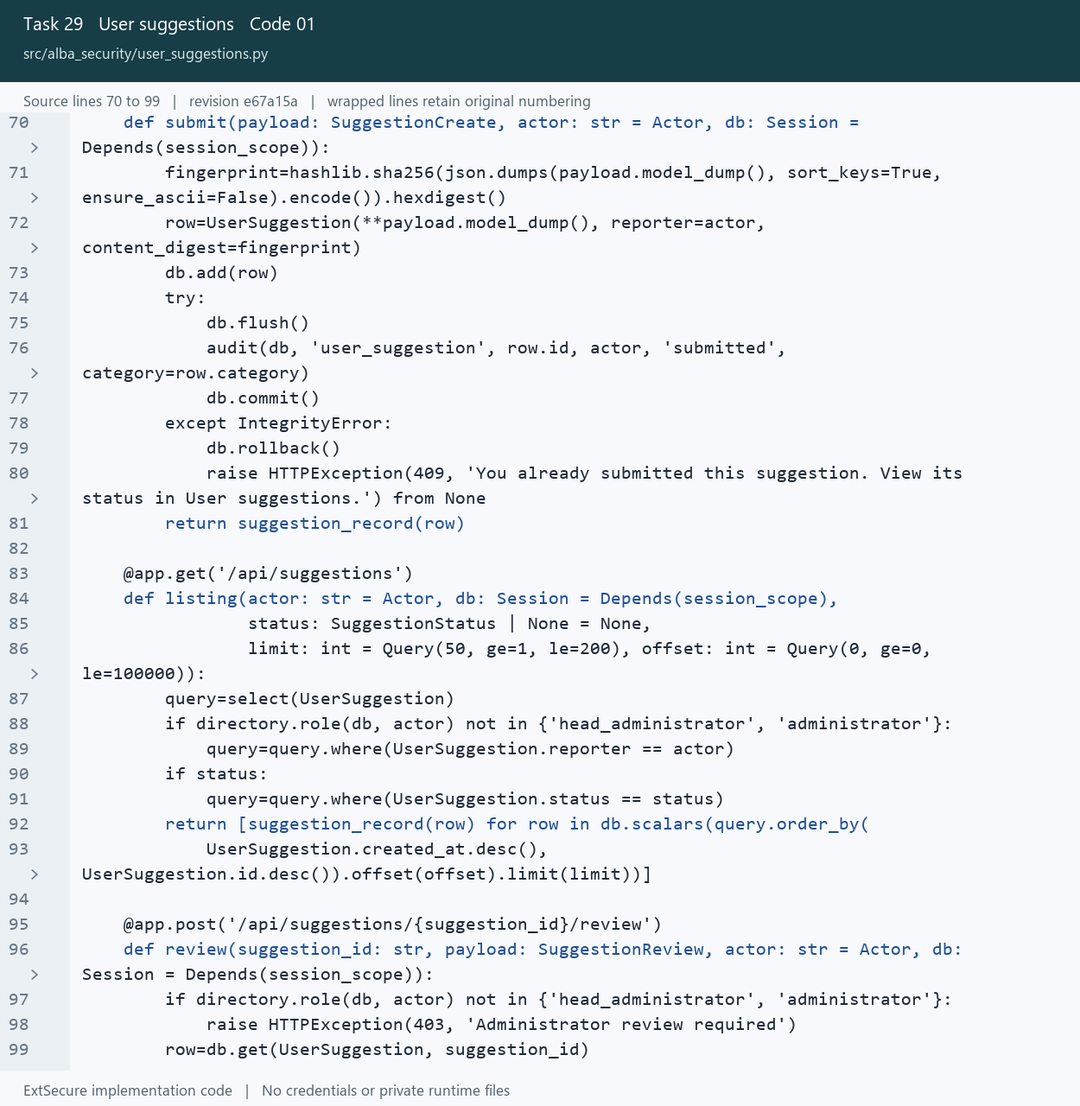
29_User_suggestions_01_user_suggestions_Lines_70_99.png
Open src/alba_security/user_suggestions.py at the captured revision

29 User suggestions
Collect product improvement ideas and maintain administrator responses.

Picture 29.02 user-suggestions.js source lines 1 to 17
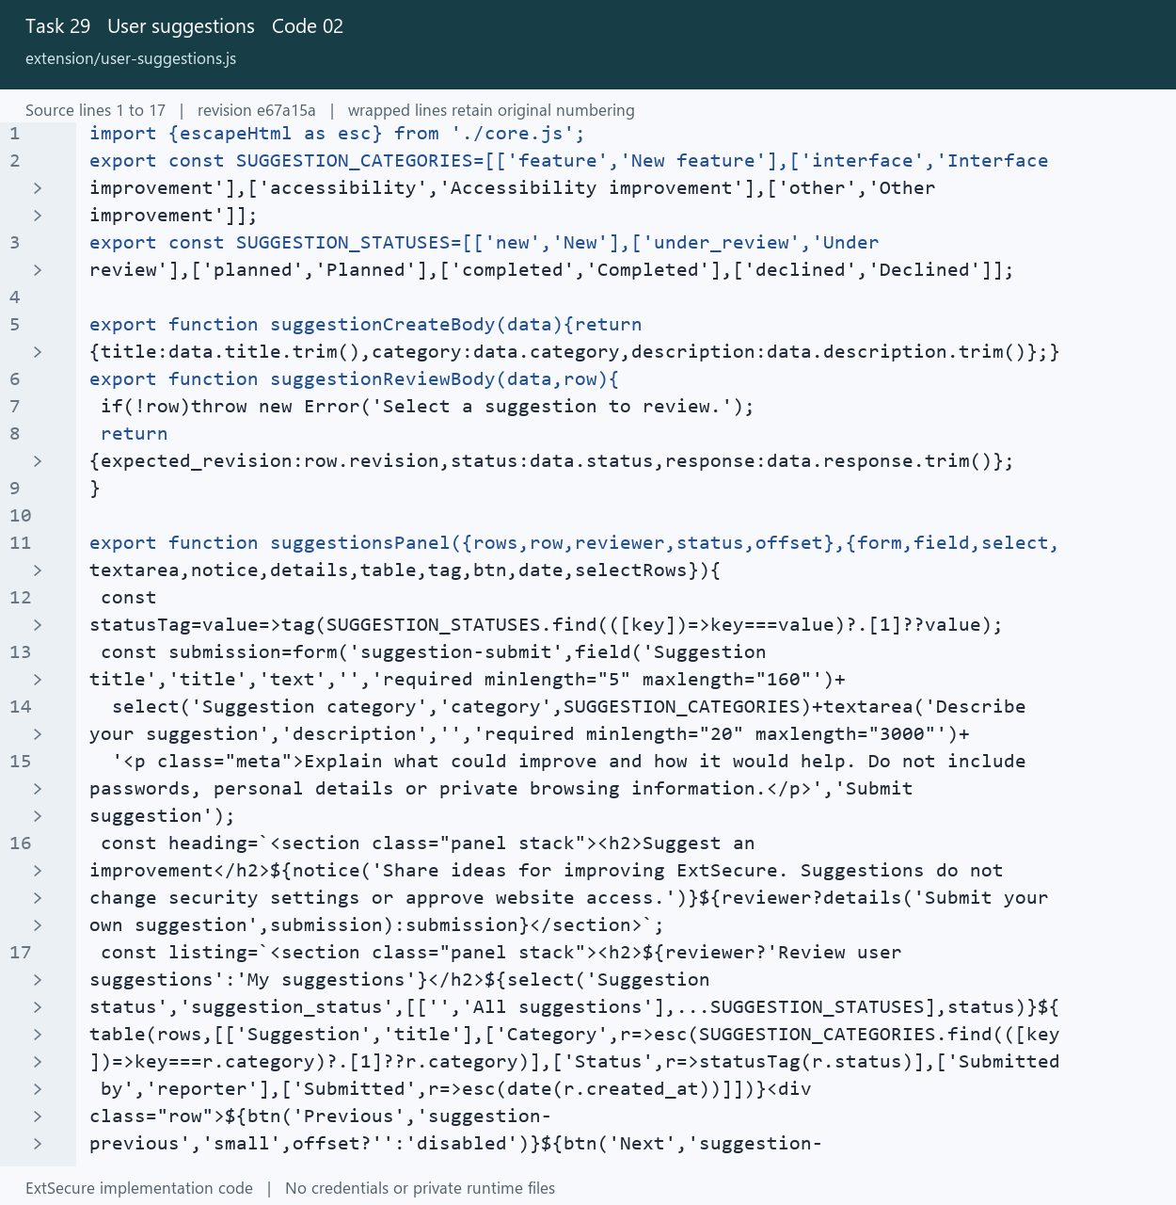
29_User_suggestions_02_user_suggestions_Lines_1_17.png
Open extension/user-suggestions.js at the captured revision

30 Personalisation and display settings
Persist theme and table preferences for the extension interface.

Picture 30.01 theme.js source lines 1 to 27
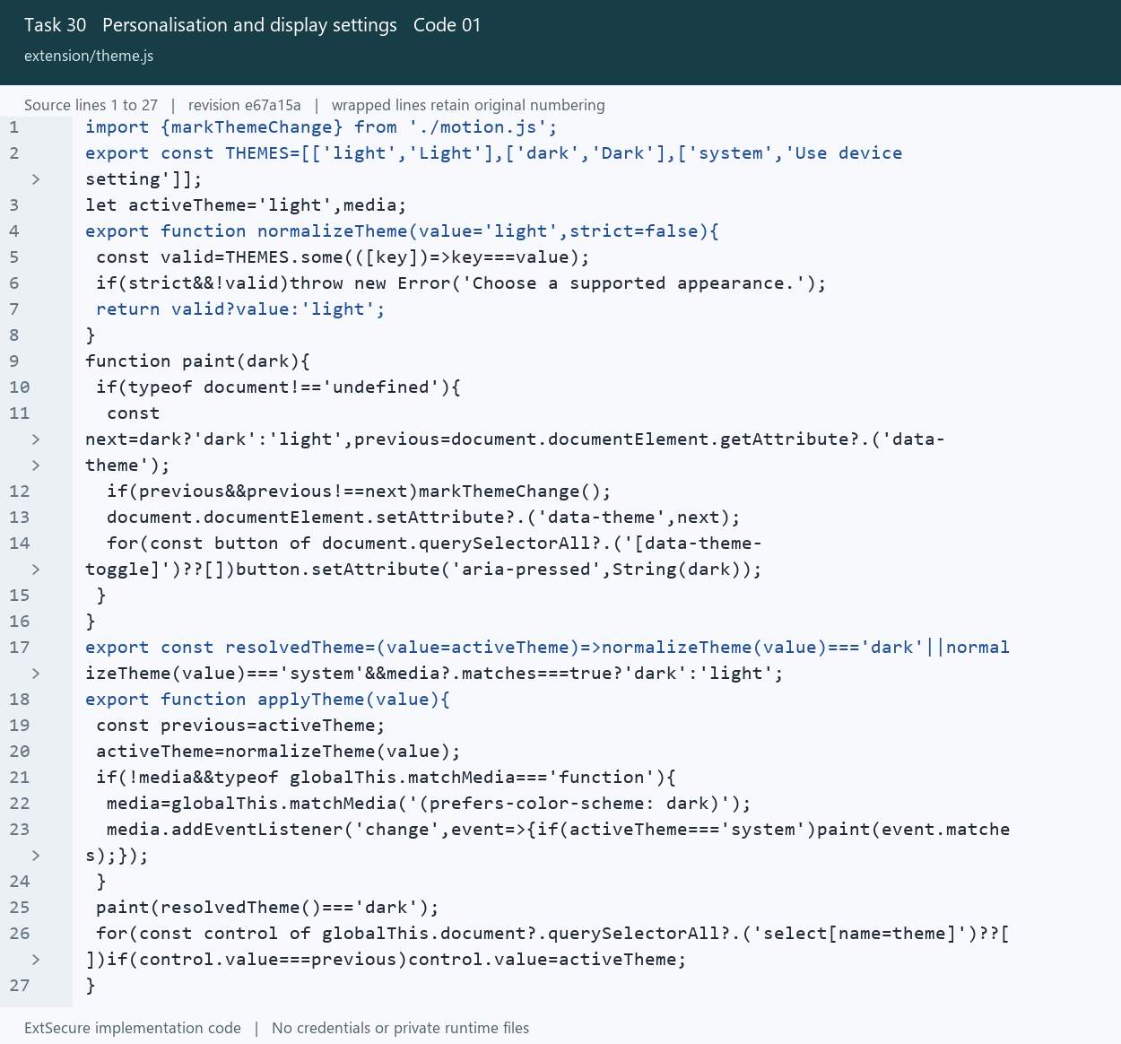
30_Personalisation_and_display_settings_01_theme_Lines_1_27.png
Open extension/theme.js at the captured revision

30 Personalisation and display settings
Persist theme and table preferences for the extension interface.

Picture 30.02 table-settings.js source lines 1 to 30
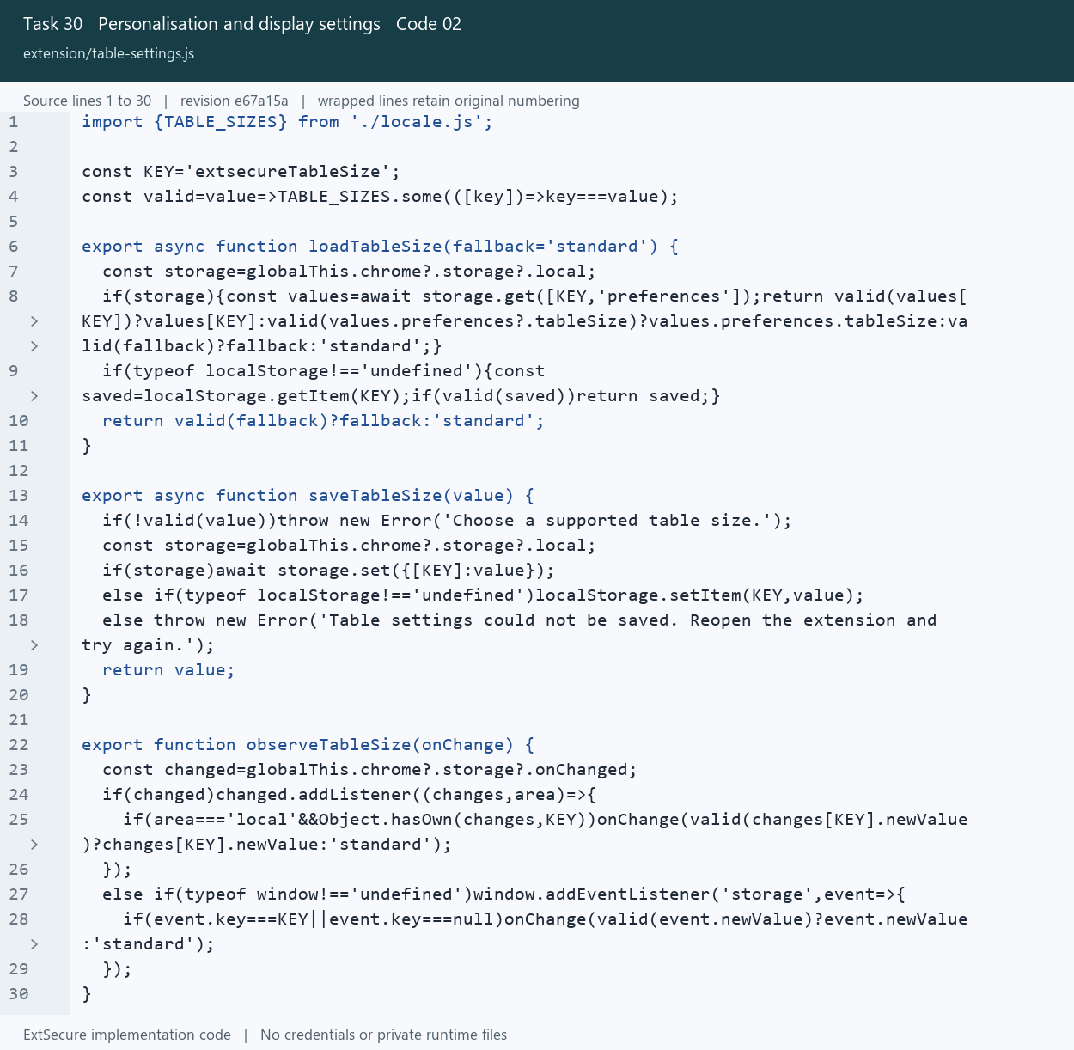
30_Personalisation_and_display_settings_02_table_settings_Lines_1_30.png
Open extension/table-settings.js at the captured revision

31 Animation and reduced motion
Respect system accessibility settings and the animation preference.

Picture 31.01 motion.js source lines 1 to 25
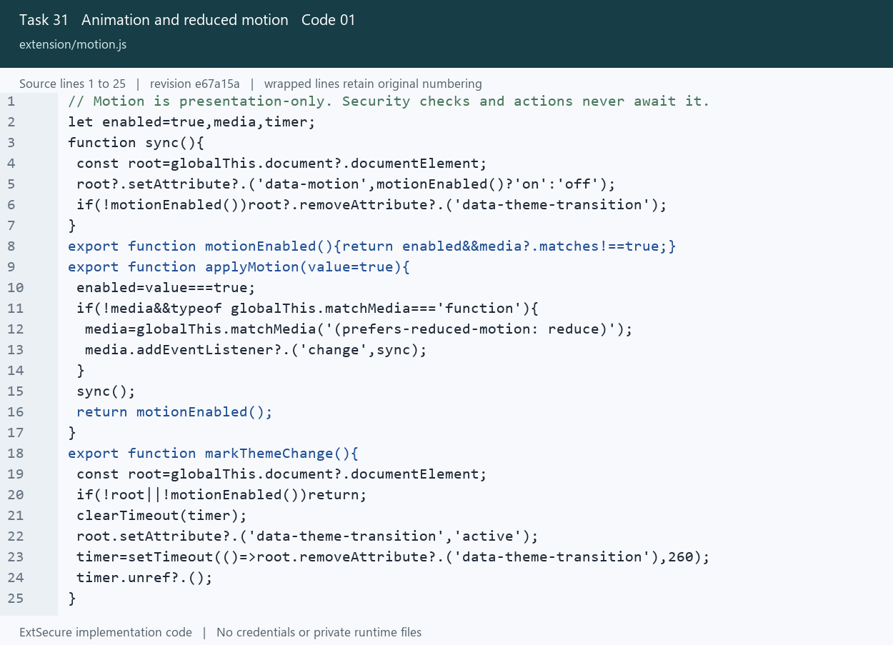
31_Animation_and_reduced_motion_01_motion_Lines_1_25.png
Open extension/motion.js at the captured revision

31 Animation and reduced motion
Respect system accessibility settings and the animation preference.

Picture 31.02 modern.css source lines 63 to 82
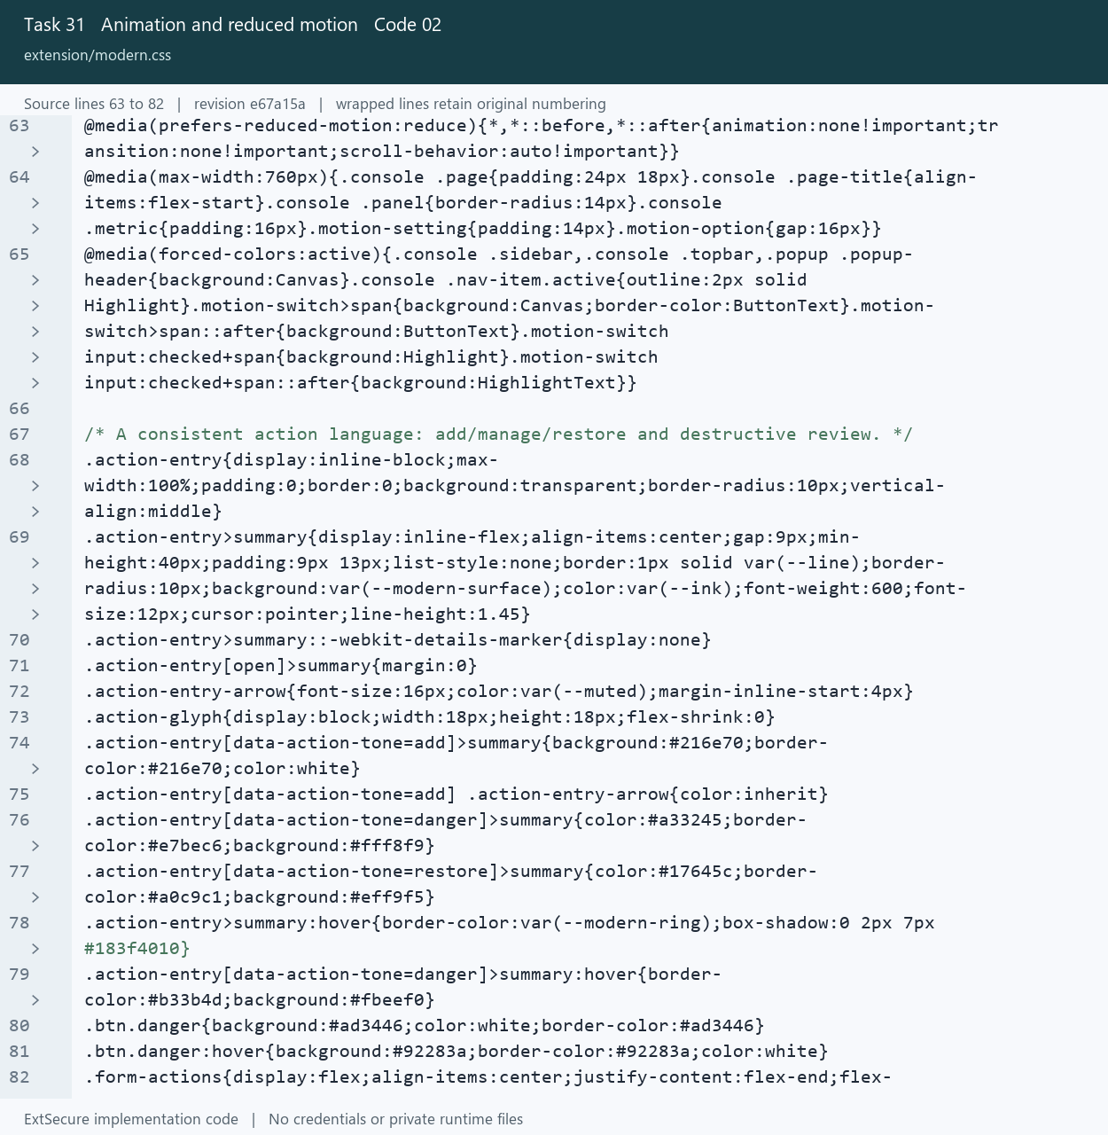
31_Animation_and_reduced_motion_02_modern_Lines_63_82.png
Open extension/modern.css at the captured revision

32 Modern add and remove controls
Use review dialogs with explicit confirmation and safe cancellation.

Picture 32.01 action-panels.js source lines 28 to 60
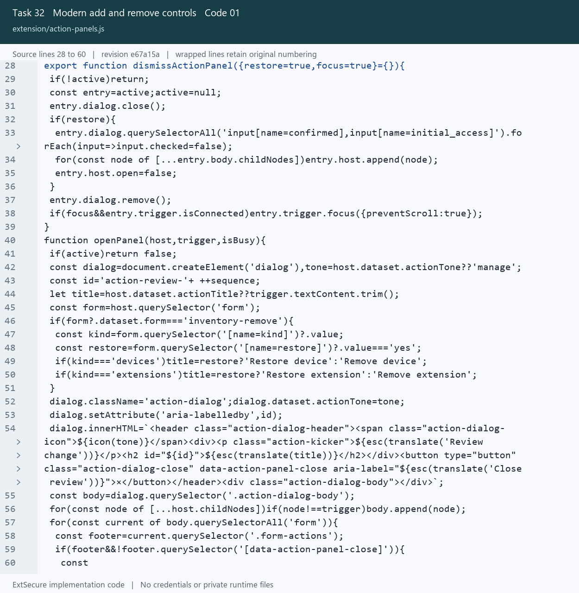
32_Modern_add_and_remove_controls_01_action_panels_Lines_28_60.png
Open extension/action-panels.js at the captured revision

32 Modern add and remove controls
Use review dialogs with explicit confirmation and safe cancellation.

Picture 32.02 action-panels.js source lines 18 to 45
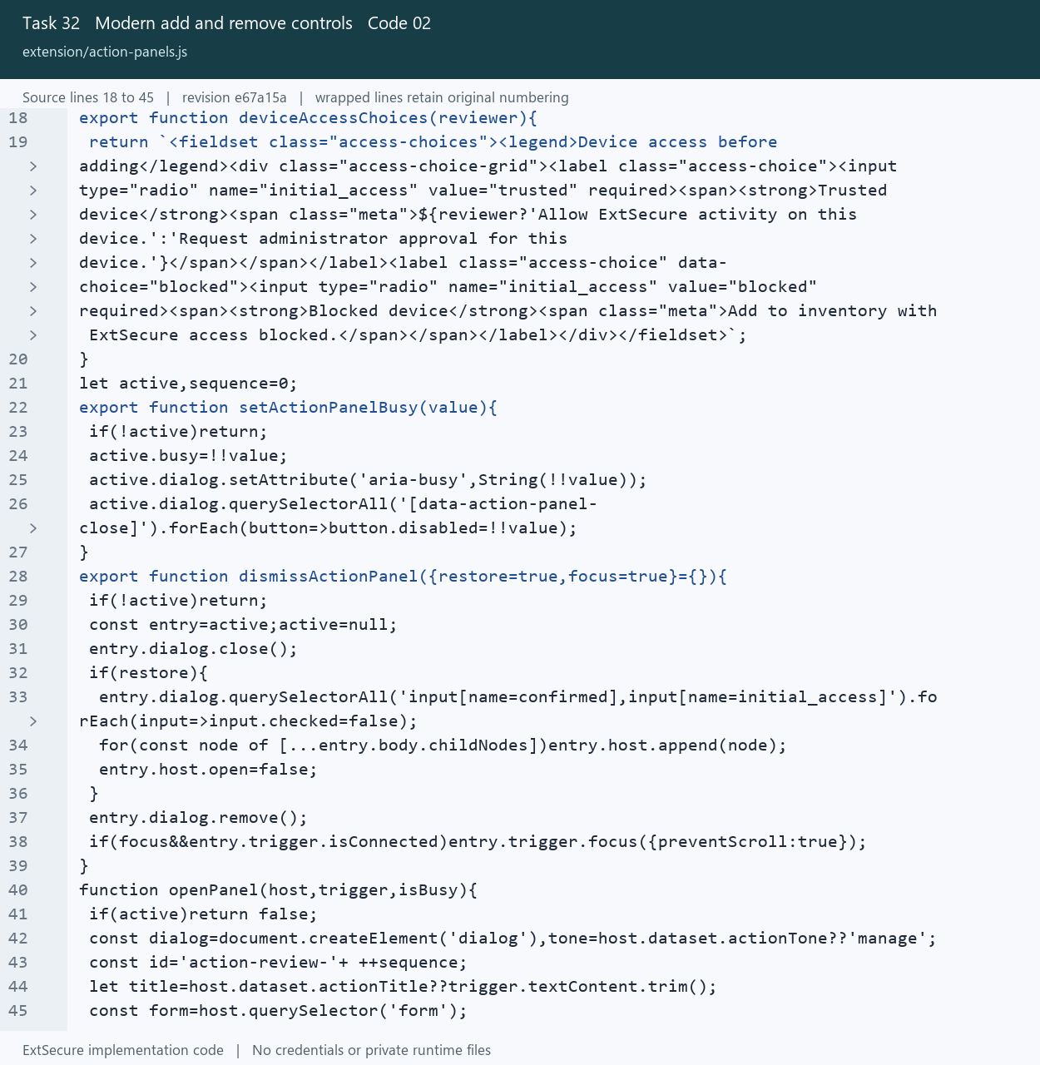
32_Modern_add_and_remove_controls_02_action_panels_Lines_18_45.png
Open extension/action-panels.js at the captured revision

Dashboard light theme
Extension interface example captured during interface verification. Displayed records are test fixtures.
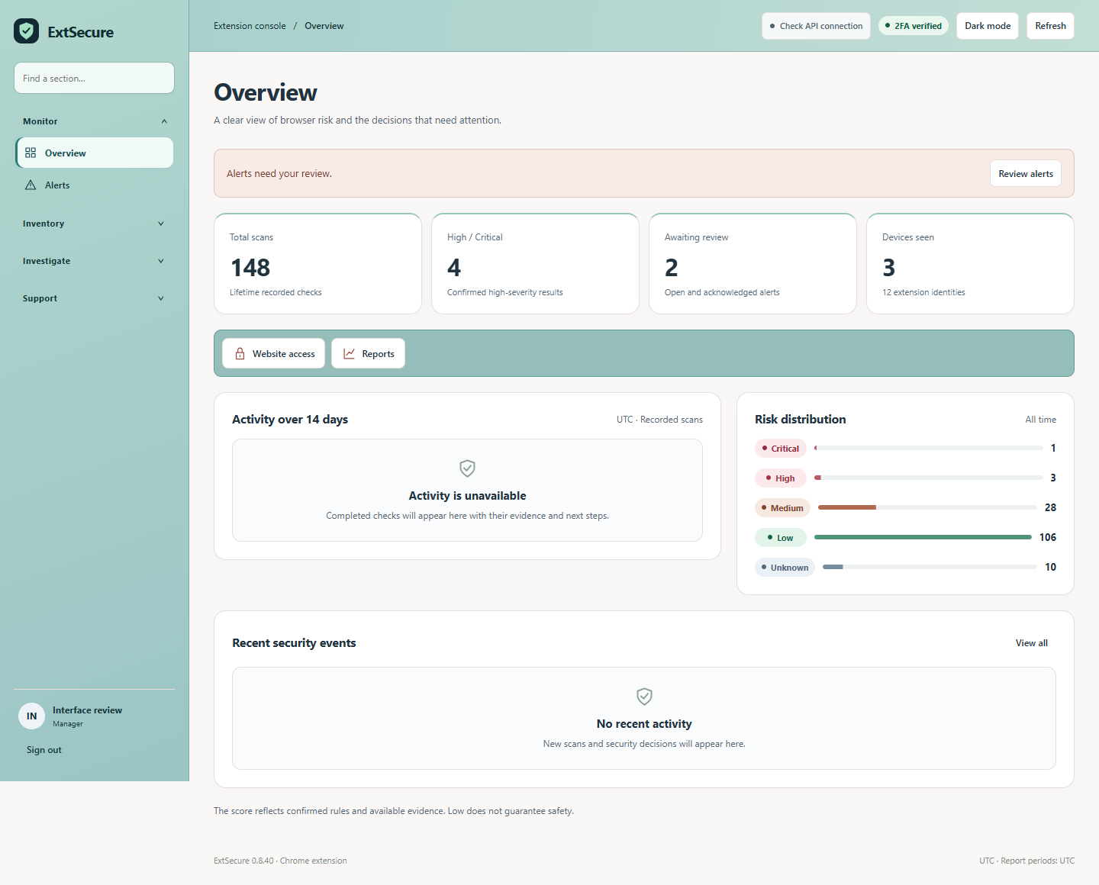
UI_01_Dashboard_light_theme.png

Dashboard dark theme
Extension interface example captured during interface verification. Displayed records are test fixtures.
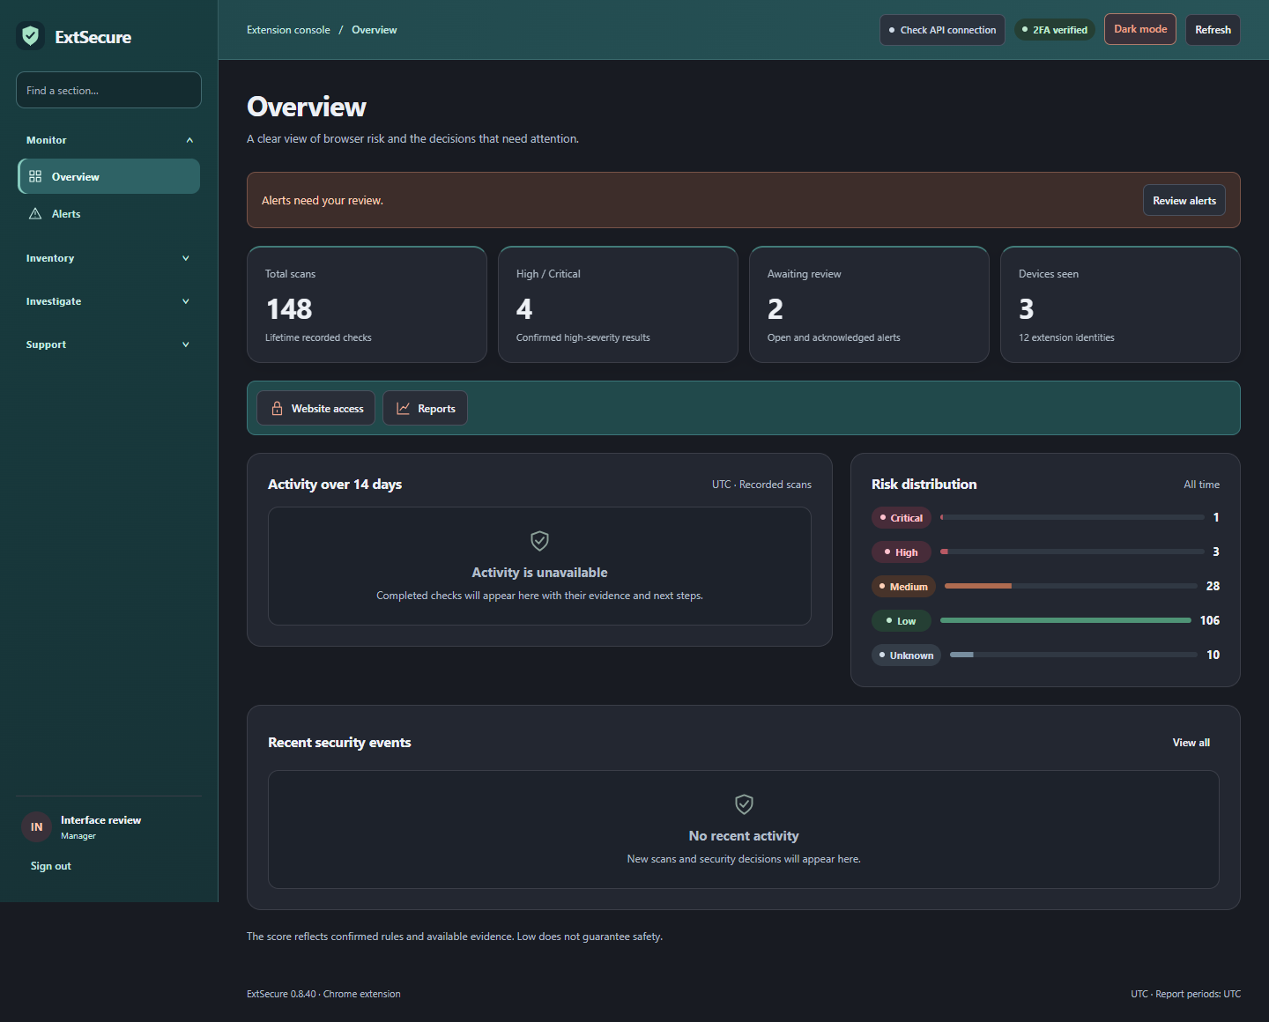
UI_02_Dashboard_dark_theme.png

Add device review and access choices
Extension interface example captured during interface verification. Displayed records are test fixtures.
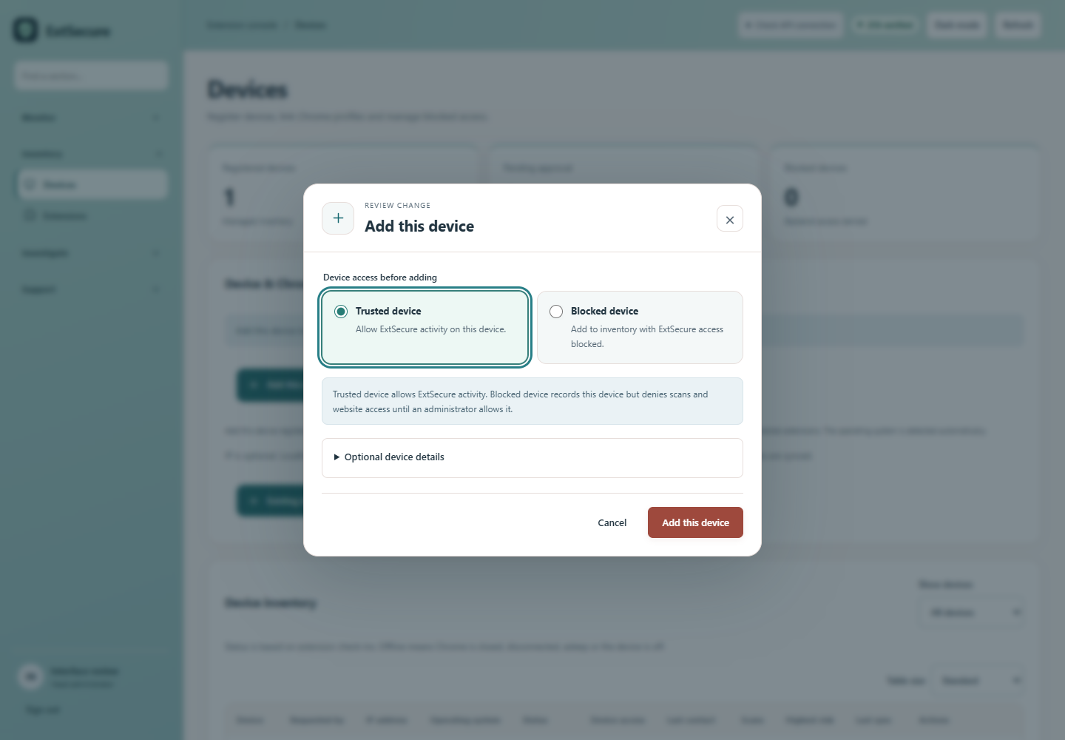
UI_03_Add_device_review_and_access_choices.png

Remove device confirmation on a narrow screen
Extension interface example captured during interface verification. Displayed records are test fixtures.
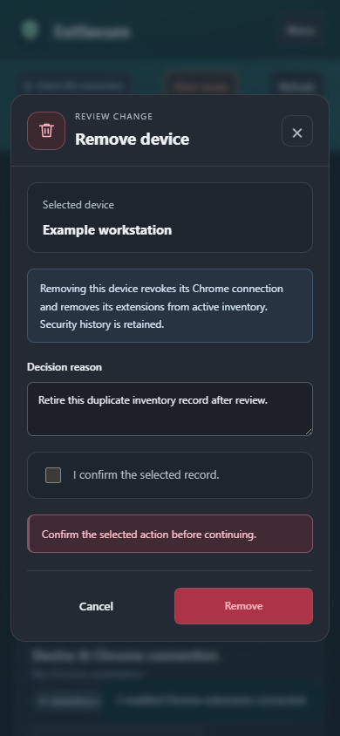
UI_04_Remove_device_confirmation_on_a_narrow_screen.png

Settings and animation preference
Extension interface example captured during interface verification. Displayed records are test fixtures.
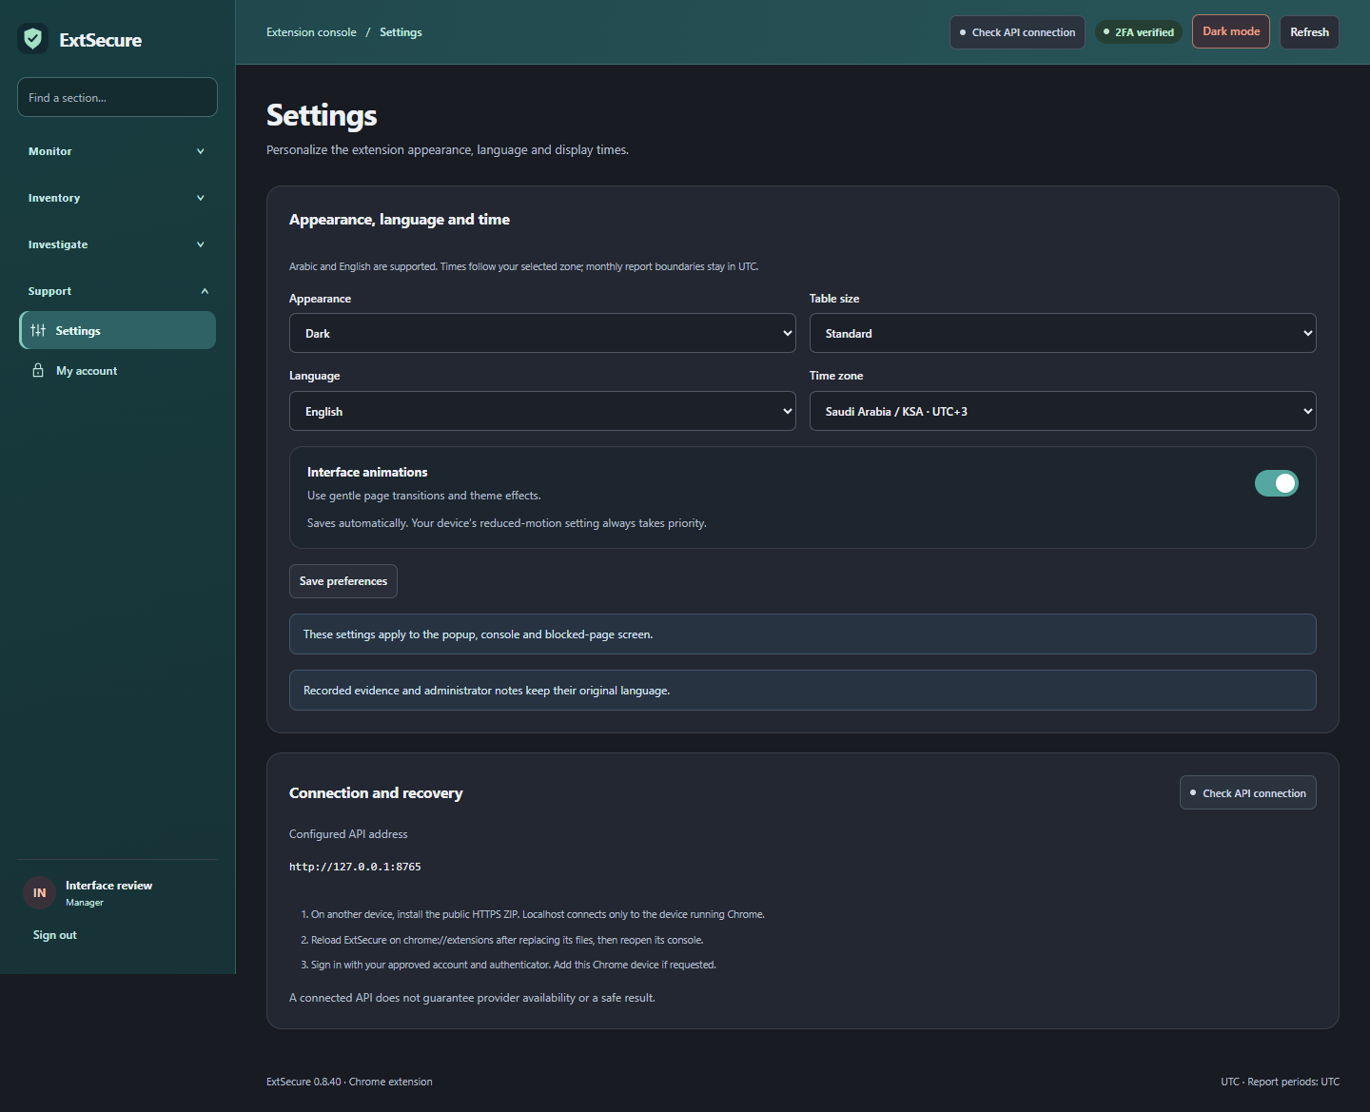
UI_05_Settings_and_animation_preference.png

